 BABEȘ-BOLYAI UNIVERSITY

Faculty of Physics

Doctoral School of Physics

Innovative processing of halide perovskites and conjugated polymers for film-based optoelectronics

Abstract

by

Ioan PETROVAI

A thesis submitted in fulfilment of requirement for the degree

DOCTOR OF PHILOSOPHY in PHYSICS

Scientific Supervisor:

Prof. dr. Leontin DAVID

Cluj-Napoca

2023

# Contents:

Introduction

Chapter 1

Perovskites and conjugated polymers as fundamental materials for optoelectronics

1.1 State-of-the-art and prospects for hybrid lead halide perovskites

1.2 State-of-the-art and prospects for conjugated polymers

Chapter 2

Materials and Methods

2.1 Researched materials

2.1.1 Perovskites

2.1.2 Polymeric systems

2.1.3 Reagents and polymeric solutions

2.1.4 Solid substrates and their cleaning

2.2 Material processing methods

2.2.1 Spin casting thin films of perovskites and conjugated polymers

2.2.2 Processing of mixed CH3NH3PbI3-xClx perovskites from precursor solutions

2.2.3 Processing of hybrid lead halide perovskites via convective self-assembly

2.2.4 Processing of thin films of conjugated polymers via illumination

2.2.5 Oxygen decontamination precautions

2.3 Material investigation methods

2.3.1 Optical microscopy

2.3.2 Scanning electron microscopy

2.3.3 Absorption and emission spectroscopies

2.3.4 X-ray photoelectron spectroscopy (XPS)

2.3.5 Franck-Condon Analysis

Chapter 3

Growth of hybrid lead halide CH3NH3PbI3-xClx perovskite crystals from precursor solutions subjected to constant solvent evaporation rates

3.1 Short summary

3.2 Processing-microstructure-related objectives

3.3 Growth of mixed lead halide perovskite CH3NH3PbI3–*x*Cl*x* crystals of six-fold symmetry and a fractal dendritic morphology at various temperature-controlled solvent evaporation rates

3.4 Growth of mixed lead halide perovskite CH3NH3PbI3–*x*Cl*x* crystals of four-fold symmetry at various processing temperatures

3.5 Conclusions

Chapter 4

Generation of hybrid lead halide CH3NH3PbI3-xClx perovskite crystals via convective self-assembly

4.1 Short summary

4.2 Fabrication of hybrid lead halide perovskite crystals via convective self-assembly

4.3 Absorption and emission properties of hybrid perovskite crystals

4.4 Conclusions

Chapter 5

Enhancing the photoluminescence of polyfluorene-based thin films through their exposure to light

5.1 Short summary

5.2 Processing-microstructure-photoluminescence-related objectives

5.3 Enhancement of PL in thin films of PFO via illumination

5.4 Monitoring structural changes in the glassy and β-phase conformations

5.5 The impact of the type of light on the PL enhancement

5.6 Is the PL enhancement mechanism based solely on structural changes?

5.7 Practical potential of thin PFO films displaying massively enhanced PL

5.8 Conclusions

General Conclusions

Perspectives

References

Annexes

List of ISI publications related to the PhD thesis

List of non-ISI publications related to the PhD thesis

List of other ISI publications

Participation in scientific conferences

Keywords: perovskites, conjugated polymers, organic solar cells, optoelectronic properties, convective self-assembly, solvent evaporation, crystal morphology, illumination, polyfullerenes, active layers, Photoluminescence quenching, spin casting, film microstructure;

# **Abstract**

Today it is well-accepted that our society desperately needs efficient solutions to the increasing demand of energy. To deal with this issue, we need to design and develop novel and better renewable energy devices such as solar cells, or electronic devices like batteries and light-emitting diodes [1]. In the same time, there is also a pressing necessity to fabricate powerful, yet highly miniaturized optoelectronic devices such as field-effect transistors, sensors, photodetectors, capacitors, memory devices, or lasers, for a plethora of applications in computing, communications, biomedicine and healthcare, housing, food industry, transportation, etc [2]. To solve both above problems, highly versatile materials exhibiting great optoelectronic properties need to be developed. In this thesis, we propose to use two such types of versatile optoelectronic materials: hybrid lead halide perovskites and conjugated polymers.

Moreover, because the optoelectronic properties of either perovskite or polymeric materials were demonstrated to strongly depend on the microstructure and molecular arrangements/conformations adopted by the constituent molecules within such materials [3]. Further manipulation of the microstructure through efficient processing paved the way towards tunable and enhanced optoelectronic properties. To further widen and explore this way, novel processing methodologies need to be continuously designed and developed both for halide perovskites and conjugated polymers [4]. That is why we have proposed in this thesis three innovative and highly efficient processing techniques to manipulate and alter the microstructure of the above-mentioned materials and thus, to optimize and enhance their final optoelectronic properties.

In this direction, by employing firstly a simple technique based on processing of perovskite precursor solutions in homemade Teflon rings, we have nucleated and grown, while controlling efficiently the rate of solvent evaporation, hybrid lead halide perovskite crystals possessing either a six-fold or a four-fold symmetry and displaying various dendritic morphologies. By using the convective self-assembly technique, at lower temperatures and low deposition speeds, large needle-like and cross-like crystals were obtained. Such crystals were to shown to exhibit different emission properties than their uncrystallized analogues.

We have implemented a novel and efficient polymer processing method based on the exposure of thin films of conjugated polymers to light in an inert environment. With this approach we were able to control the ratio between the glassy phase and β-phase of a polyfluorene-based conjugated polymer and to massively enhance its emission properties.

The here presented PhD thesis discusses the scientific advances that we have made with respect to the state-of-the-art research reported in the area of materials such as halide perovskites and conjugated polymers. These materials are utilized for the fabrication of energy devices and miniaturized optoelectronics.

The thesis is structured in five well-defined chapters. Although each of these chapters is dedicated to discuss a specific theme, as whole, they offer not only an overview of what happens today with versatile materials such as halide perovskites and conjugated polymers, but also propose novel processing tools to manipulate and tune the microstructure of such materials; with the final aim to improve and optimize their optoelectronic properties

Chapter one’s key role is to discuss the state-of-the-art and prospects for both hybrid lead halide perovskites and conjugated polymers. it introduces to two types of highly versatile materials and further provides the latest reported scientific achievements and updates relevant to the processing-microstructure-optoelectronic properties relationship. It also motivates our work by exemplifying the largest classes of optoelectronic devices and applications that are designed and fabricated through the use of halide perovskites and conjugated polymers.

Chapter two is aiming not only to describe the halide perovskite and conjugated polymer systems that we have employed in our research, but also to report on both the details of the innovative tools that we have used to process these materials, and the measurement techniques that we have used to characterize the obtained structures. This chapter contains critical data on the processing methods designed and developed in our laboratory that are needed for any future reproducibility of the here proposed scientific experiments. Such type of mixed halide perovskite systems were previously used as efficient solar cell materials [5]–[7] and were produced by the manufacturer by dissolving methylammonium iodide (MAI) and lead chloride (PbCl2) in dimethylformamide (DMF) in a 3:1 ratio [8]–[10]. Also, the conjugated polymeric system used was a conjugated poly[9,9-bis(2-ethylhexyl)-9*H*-fluorene-2,7-diyl] (PFO) of a weight-average molecular weight *M*w = 13.2 kg/mol, a number-average molecular weight *M*n= 6.8 kg/mol and a polydispersity index *Ð* = 1.94.

Chapter three is showing how to obtain hybrid lead halide perovskite crystals of controlled symmetry and morphology from perovskite precursor solutions by exposing these solutions to well-defined processing temperatures (using a simple experimental setup based on Teflon rings) and thus, by controlling the rates of solvent evaporation. It covers the processing temperature range of 40° C to 110 °C.

In this chapter, we have focused on subjecting a perovskite precursor ink to different processing temperatures, *i.e.*, to different solvent evaporation rates with the aim to facilitate the nucleation and growth of hybrid lead halide CH3NH3PbI3–*x*Cl*x* perovskite crystals. By controlling the temperature of perovskite solutions, previously placed within open-air Teflon rings in small, yet precise volumes, we have reached a good control over the rate of solvent evaporation and thus, we could tune the shape and growth rate of perovskite crystals. Utilizing diluted lead mixed halide perovskites solutions allowed us to control the nucleation process and to further favor the growth of only few perovskite crystals that were shown to exhibit a six-fold symmetry. Nonetheless, while the crystals grown at a lower range of processing temperatures (40-60 °C) exhibited a rather compact dendritic shape, crystals formed at higher temperatures (80-110 °C) displayed a fractal dendritic morphology. Moreover, crystals exhibiting a four-fold symmetry also formed and were further described (the above text was adapted from the abstract of our paper published under ref. [11]).

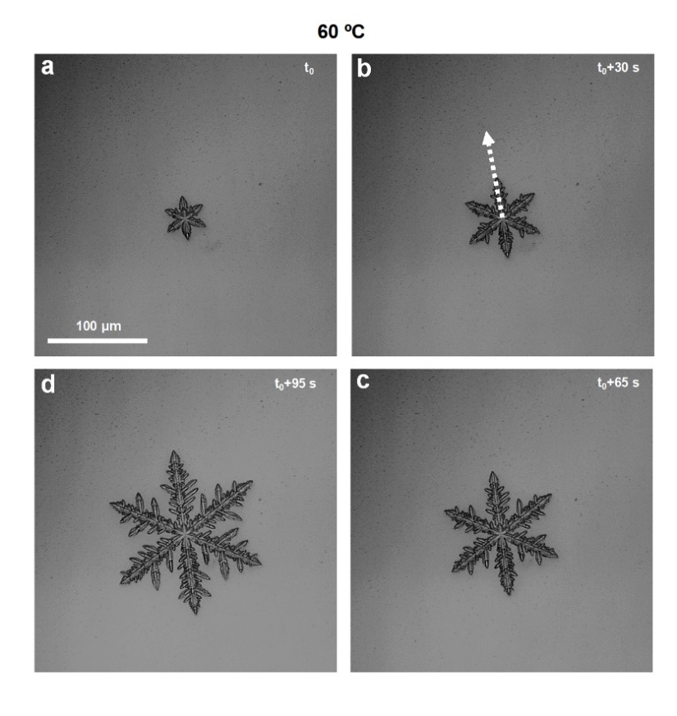

Figure 1. Optical micrographs depicting a six-fold symmetry hybrid lead mixed halide CH3NH3PbI3–xClx perovskite crystal that was grown from a perovskite precursor ink at a processing temperature of 60 °C. [11].



Figure 2. A growth rate of only 0.64 µm/s was determined for a hybrid lead mixed halide CH3NH3PbI3–xClx perovskite crystal displaying a six-fold symmetry and grown at a processing temperature of 60 °C. The dashed line represents the average crystal growth rate. [11].

Chapter four proposes the utilization of convective self-assembly technique to generate very large needle-like and cross-like hybrid lead halide perovskite crystals at lower processing temperatures of 30°C and 17°C. Additionally, the spin coating method is used to produce reference perovskite samples, while the drop casting method is being employed to produce perovskite crystals at a further lower processing temperature (*i.e.*, 0 °C). In this chapter we have made use of a film deposition technique, convective self-assembly, based on convective forces acting at the triple air-solution-substrate contact line, to exert control over the rate of solvent evaporation and thus, to manipulate the morphology of the resulting mixed lead halide perovskite CH3NH3PbI3–xClx films. By varying the speed of film deposition, while processing samples at two different temperatures, perovskite crystals possessing different shapes and various dimensions were obtained upon the crystallization of the initial perovskite precursor ink. More precisely, longer than half a millimeter 3D needle-like perovskites crystals, exhibiting sharp edges and co-existing with large cross-like 3D perovskite crystals, could be obtained upon the slow deposition of films at a low processing temperature of 17 °C, *i.e.*, in a regime characterized by a low solvent evaporation rate. On the contrary, the employment of higher film deposition speeds and/or processing temperatures led to smaller 3D needle-like or quasi-2D rectangular perovskite crystals that often appeared interconnected and (highly) coalesced. Moreover, as it was revealed by the photoluminescence measurements, the emission intensity of perovskite crystals was larger and dominated by a lower wavelength peak, as compared to the uncrystallized material that emitted much less light, but at longer wavelength (paragraph adapted with permission from ref. [12]).

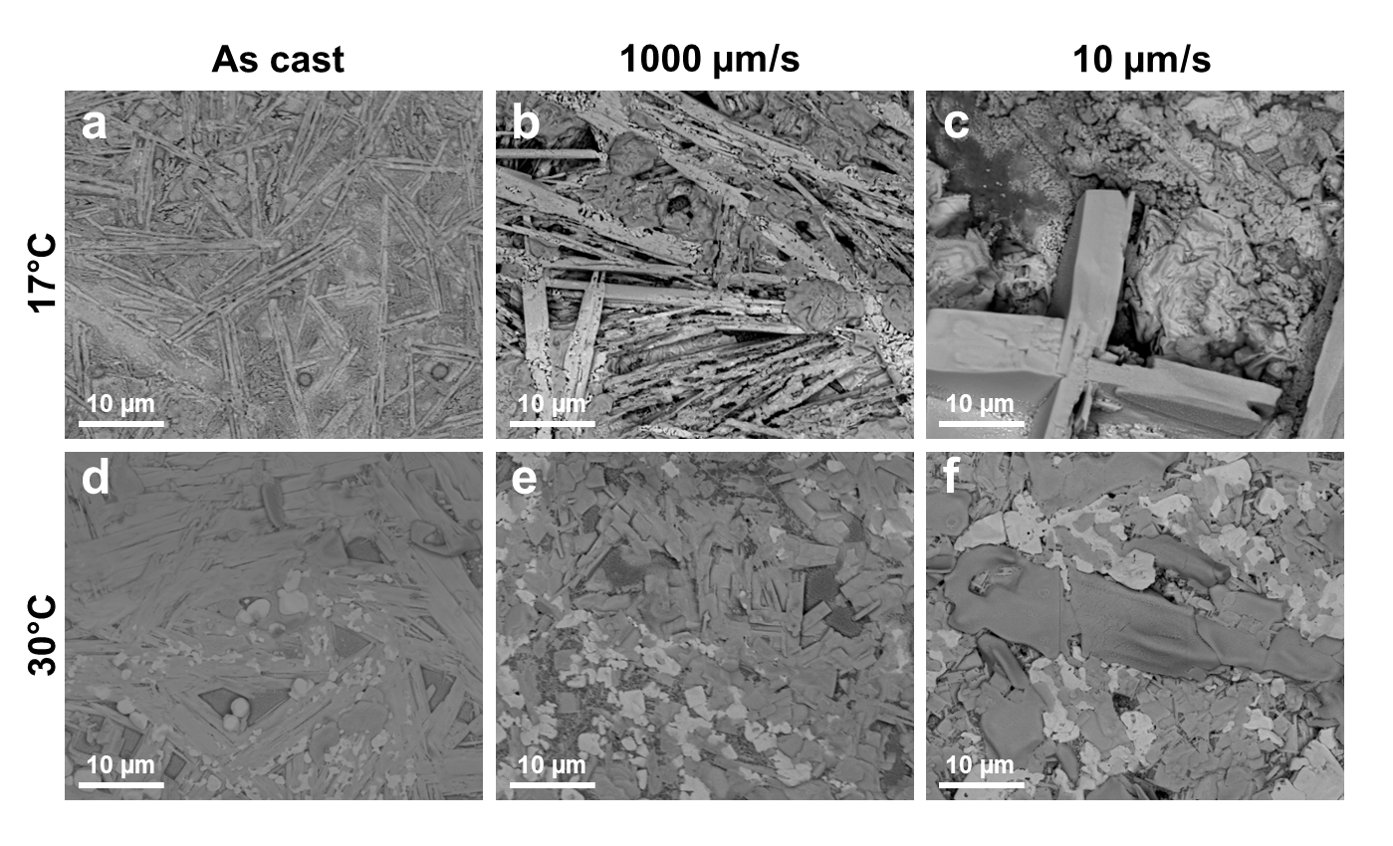

Figure 3. SEM micrographs depicting hybrid lead halide perovskite CH3NH3PbI3–xClx crystals obtained at two different temperatures by spin coating (a, d) and CSA procedure (b, c, e, f). The CSA was conducted at both high (*i.e.*, 1000 µm/s) (b, e) and low (*i.e.*, 10 µm/s) (c, f) deposition speeds. [12].

Moreover, the emission measurements have indicated that the obtained hybrid lead halide perovskite crystals were able to emit light of higher intensity, but of a lower wavelength, than the uncrystallized perovskite material. Before crystallization, only light of lower intensity was emitted at a higher wavelength. The here-reported results could be used in the future when designing and developing novel perovskite-based photodetectors, sensors, or specific energy devices such as solar cells, LEDs, or field-effect transistors (paragraph adapted with permission from ref. [12]).

Chapter five demonstrates how the illumination of a polyfluorene-based conjugated polymer (PFO), a system well-known to exhibit good emission properties, induces controllable structural changes with respect to the ratio between the glassy and β-phases, and consequently produces dramatic changes in the emission properties by massively enhancing the photoluminescence [13]-[17]. Moreover, control experiments performed upon several tens of days demonstrates that the observed enhancement of the emission properties is irreversible and thus, it exhibits a great potential in the fabrication of future organic light-emitting diodes. We demonstrate in this chapter that the exposure of thin films of conjugated PFO to light under an inert atmosphere with light of various wavelengths and output powers has led to a massive increase of the resulting PL of up to 2.2 folds. This enhancement in PL was demonstrated to be due to the appearance of structural changes in both the glassy and β-phase conformations [18]. Such changes were induced upon the illumination of thin PFO films, as it was clearly revealed by the Franck-Condon analysis (FCA) of the PL spectra. Interestingly, the emission of thin films remained at the enhanced value for 75 days after ending the illumination process, most probably due to the permanent structural changes caused upon the illumination (text adapted from the abstract of our paper paper published under ref. [19]).

The results presented in this chapter have shown that the PL intensity was increasing to a maximum while the β-phase fraction was decreasing from around 11% to about 5%, as it was revealed by the FCA. Moreover, the PL enhancement was shown to strongly depend on the processing temperature of the PFO thin films. For processing temperatures below the *Tg*, a continuous increase in PL intensity with the time of illumination was measured. For temperatures around the *Tg*, we have found an optimal illumination time at which the PL intensity was generally reaching its maximum value. At temperatures higher than the *Tg*, the enhancement of PL was found to be decreasing. This was most probably due to an increased mobility of the PFO molecules that was caused by the transition to a less glassy state (paragraph adapted with permission ref. [19]).



Figure 4. PL enhancement measured using the total area under the peak for: a spin cast reference PFO film kept in dark (square symbols), a PFO film illuminated with white light of an output power of about 200 mW for various times (star symbols) and the same PFO film monitored in dark after the illumination was stopped (spherical symbols). All films were kept at a processing temperature of 30 ⁰C in nitrogen-saturated atmosphere. This figure was adapted with permission from ref. [19].

# References

[1] Z. Zheng and S. Zhang, “The Importance of Governance Efficiency in Environmental Policy Research in Energy Shortage Period,” *j. of Sustain. bus. and econ.*, vol. 5, no. 4, pp. 1–3, Sep. 2022, doi: 10.30564/jsbe.v5i4.25.

[2] R. Sharma, A. Sharma, S. Agarwal, and M. S. Dhaka, “Stability and efficiency issues, solutions and advancements in perovskite solar cells: A review,” *Solar Energy*, vol. 244, pp. 516–535, Sep. 2022, doi: 10.1016/j.solener.2022.08.001.

[3] A. Aftab and Md. I. Ahmad, “A review of stability and progress in tin halide perovskite solar cell,” *Solar Energy*, vol. 216, pp. 26–47, Mar. 2021, doi: 10.1016/j.solener.2020.12.065.

[4] Z.-Y. Chen, N.-Y. Huang, and Q. Xu, “Metal halide perovskite materials in photocatalysis: Design strategies and applications,” *Coordination Chemistry Reviews*, vol. 481, p. 215031, Apr. 2023, doi: 10.1016/j.ccr.2023.215031.

[5] M. M. Lee, J. Teuscher, T. Miyasaka, T. N. Murakami, and H. J. Snaith, “Efficient Hybrid Solar Cells Based on Meso-Superstructured Organometal Halide Perovskites,” *Science*, vol. 338, no. 6107, pp. 643–647, Nov. 2012, doi: 10.1126/science.1228604.

[6] P.-W. Liang *et al.*, “Additive Enhanced Crystallization of Solution-Processed Perovskite for Highly Efficient Planar-Heterojunction Solar Cells,” *Adv. Mater.*, vol. 26, no. 22, pp. 3748–3754, Jun. 2014, doi: 10.1002/adma.201400231.

[7] G. E. Eperon, V. M. Burlakov, P. Docampo, A. Goriely, and H. J. Snaith, “Morphological Control for High Performance, Solution-Processed Planar Heterojunction Perovskite Solar Cells,” *Adv. Funct. Mater.*, vol. 24, no. 1, pp. 151–157, Jan. 2014, doi: 10.1002/adfm.201302090.

[8] Z.-K. Tan *et al.*, “Bright light-emitting diodes based on organometal halide perovskite,” *Nature Nanotech*, vol. 9, no. 9, pp. 687–692, Sep. 2014, doi: 10.1038/nnano.2014.149.

[9] J. Wang *et al.*, “Interfacial Control Toward Efficient and Low-Voltage Perovskite Light-Emitting Diodes,” *Adv. Mater.*, vol. 27, no. 14, pp. 2311–2316, Apr. 2015, doi: 10.1002/adma.201405217.

[10] F. Deschler *et al.*, “High Photoluminescence Efficiency and Optically Pumped Lasing in Solution-Processed Mixed Halide Perovskite Semiconductors,” *J. Phys. Chem. Lett.*, vol. 5, no. 8, pp. 1421–1426, Apr. 2014, doi: 10.1021/jz5005285.

[11] I. Petrovai, O. Todor-Boer, L. David, and I. Botiz, “Growth of Hybrid Perovskite Crystals from CH3NH3PbI3–xClx Solutions Subjected to Constant Solvent Evaporation Rates,” *Materials*, vol. 16, Art. no. 7, Mar. 2023, doi: 10.3390/ma16072625.

[12] I. Petrovai, O. Todor-Boer, L. David, and I. Botiz, “Generation of Hybrid Lead Halide CH3NH3PbI3–xClx Perovskite Crystals via Convective Self-Assembly,” *Coatings*, vol. 13, p. 1130, 2023, doi: 10.3390/coatings13061130.

[13] Q. Zhang *et al.*, “An Easy Approach to Control β-Phase Formation in PFO Films for Optimized Emission Properties,” *Molecules*, vol. 22, p. 315, 2017.

[14] T. Tromholt, M. V. Madsen, J. E. Carle, M. Helgesen, and F. C. Krebs, “Photochemical stability of conjugated polymers, electron acceptors and blends for polymer solar cells resolved in terms of film thickness and absorbance,” *J. Mater. Chem.*, vol. 22, pp. 7592–7601, 2012, doi: 10.1039/C2JM16340C.

[15] S. Alem, S. Wakim, J. Lu, G. Robertson, J. Ding, and Y. Tao, “Degradation Mechanism of Benzodithiophene-Based Conjugated Polymers when Exposed to Light in Air,” *ACS Appl. Mater. Interfaces*, vol. 4, no. 6, pp. 2993–2998, Jun. 2012, doi: 10.1021/am300362b.

[16] A. Rivaton, S. Chambon, M. Manceau, J.-L. Gardette, N. Lemaître, and S. Guillerez, “Light-induced degradation of the active layer of polymer-based solar cells,” *Polymer Degradation and Stability*, vol. 95, pp. 278–284, Mar. 2010, doi: 10.1016/j.polymdegradstab.2009.11.021.

[17] M. Jørgensen, K. Norrman, and F. C. Krebs, “Stability/degradation of polymer solar cells,” *Solar Energy Materials and Solar Cells*, vol. 92, pp. 686–714, Jul. 2008, doi: 10.1016/j.solmat.2008.01.005.

[18] I. Botiz *et al.*, “Convective self-assembly of π-conjugated oligomers and polymers,” *J. Mater. Chem. C*, vol. 5, pp. 2513–2518, 2017, doi: 10.1039/c7tc00063d.

[19] I. Petrovai, O. Todor-Boer, L. David, and I. Botiz, “Enhancing the Photoluminescence of Polyfluorene-Based Thin Films via Illumination,” *Stud. Univ. Babes-Bolyai Phys.*, vol. 67, pp. 79–90, 2022.

# Annexes

## List of ISI publications related to the PhD thesis

1. I. Petrovai, O. Todor-Boer, L. David, I. Botiz. Growth of Hybrid Perovskite Crystals from CH3NH3PbI3–*x*Cl*x* Solutions Subjected to Constant Solvent Evaporation Rates. *Coatings* 13, 1130 (2023). AIS: 0.410; IF: 3.236.
2. **I. Petrovai**, O. Todor-Boer, L. David, I. Botiz. Growth of Hybrid Perovskite Crystals from CH3NH3PbI3–*x*Cl*x* Solutions Subjected to Constant Solvent Evaporation Rates. *Materials* **16**, 2625 (2023). **AIS: 0.541; IF: 3.748.**

## List of non-ISI publications related to the PhD thesis

1. I. Petrovai, O. Todor-Boer, L. David, I. Botiz. Enhancing the Photoluminescence of Polyfluorene-Based Thin Films via Illumination. *Studia Universitatis Babes-Bolyai Physica* 67, 79-90 (2022).

## List of other ISI publications

1. R. Tarcan, M. Handrea-Dragan, O. Todor-Boer, I. Petrovai, C. Farcau, M. Rusu, A. Vulpoi, M. Todea, S. Astilean, I. Botiz. A new, fast and facile synthesis method for reduced graphene oxide in *N,N*-dimethylformamide. *Synthetic Metals* 269*,* 116576 (2020). AIS: 0.438; IF: 3.266.
2. O. Todor-Boer, I. Petrovai, R. Tarcan, L. David, S. Astilean, I. Botiz. Control of microstructure in polymer: Fullerene active films by convective self-assembly. *Thin Solid Films* 697, 137780 (2020). AIS: 0.350; IF: 2.183.
3. R. Tarcan, O. Todor-Boer, I. Petrovai, C. Leordean, S. Astilean, I. Botiz. Reduced graphene oxide today. *Journal of Materials Chemistry C* **8**, 1198 (2020). AIS: 1.253; IF: 7.393.
4. O. Todor-Boer, I. Petrovai, R. Tarcan, A. Vulpoi, L. David, S. Astilean, I. Botiz. Enhancing Photoluminescence Quenching in Donor-Acceptor PCE11:PPCBMB Films through the Optimization of Film Microstructure. *Nanomaterials* 9, 1757 (2019). AIS: 0.671; IF: 4.324.
5. O. Todor-Boer, I. Petrovai, R. Tarcan, A-M. Craciun, L. David, S. B. Angyrus, S. Astilean, I. Botiz. Altering the optoelectronic properties of neat and blended conjugated polymer films by controlling the process of film deposition. *Journal of Optoelectronics & Advanced Materials* 21, 367 (2019). AIS: 0.064; IF: 0.631.

## Participation in scientific conferences

1. I. Petrovai, O. Todor-Boer, R. Tarcan, L. David, S. Astilean, N. Stingelin, I. Botiz. Poster entitled "Processing of thin films of perovskites using convective self-assembly” and presented at *National PhD Student Conference and the TIM18 Physics Conference*, hosted by the West University of Timisoara (Romania) on 24th of May 2018.
2. **I. Petrovai**, O. Todor-Boer, R. Tarcan, L. David, S. Astilean, N. Stingelin, I. Botiz. Poster entitled "Processing of thin films of perovskites using convective self-assembly by changing the crystallization properties” and presented at *12th International Conference on Physics of Advanced Materials (ICPAM)* held at Technological Educational Institute of Crete in Heraklion (Greece) in between 22nd and 28th of September 2018.
3. **I. Petrovai**, O. Todor-Boer, R. Tarcan, L. David, S. Astilean, I. Botiz. Poster entitled “Crystals of Perovskites Prepared Via Convective Self-assembly" and presented at *Interfaces in Organic and Hybrid Thin-Film Optoelectronics (INFORM Final Meeting)* held in Adeit Funcadción Universidad Empresa de Valencia (Spain) in between 5th and 7th of March 2019.