Babeș-Bolyai University Cluj-Napoca
Faculty of Physics

Development of gold nanoparticles with applications in drug delivery

PhD Thesis Summary

Oana Teodora Marișca

Scientific supervisor
Prof. Dr. Vasile Chiș

2020

Table of Contents
Acknowledgement
1. Introduction 6
1.1. Outlook 6
1.2. Thesis structure 7
2. Theoretical aspects 9
2.1. Methods in gold nanoparticle synthesis 9
2.1.1. Turkevich method 9
2.1.2. Brust-Schiffrin method 11
2.1.3. Seed-growth method 12
2.2. Surface plasmon resonance 16
2.3. Optical characteristics 21
2.4. Gold nanoparticles in biospace 38
3. Gold nanoparticle synthesis development 44
3.1. Synthesis of C7- AuNPs 44
3.2. Synthesis of PMA-Au NPs 45
3.3. Synthesis of C11-AuNPs 55
3.4. Synthesis of C60-AuNPs 59
3.5. Conclusions 67
4. In vitro effects of AuNPs 70
4.1. Spherical AuNPs 70
4.1.1. Methods 70
4.1.2. Cellular Internalization 71
4.1.3. Cellular Biocompatibility 74
4.1.4. Conclusions 76
4.2. Anisotropic AuNPs 76
4.2.1. Methods 77
4.2.2. Cellular biocompatibility 78
4.2.3. Cellular internalization 80
4.2.4. Conclusions 82
5. Polymeric microcapsules-a light responsive drug delivery platform 83
5.1. Methods 84
5.2. Characterization of PEMs 88
5.3. In vitro evaluation of PEMs 94
5.4. Conclusions 99
6. Final conclusions 101
References 104
Appendix 1 List of abbreviations 110
Appendix 2 List of Software resources 112
Appendix 3 List of figures 113
Appendix 4 List of tables 117
Appendix 5 Scientific achievements 118

Introduction

Outlook

The world of nanomaterials consists of matter with dimensions between 1 and 100 nanometers and the phenomena associated with them. Size plays an important role in drug design, efficacy and biodistribution. The cellular and subcellular domains lay in the micro-size space, so having smaller drugs, for example, can only help with better targeting and uptake.
Among the multitude of nanoparticles generated, gold nanoparticles, AuNPs, stand out through a suite of unique features. Key properties observed by scientists regarding AuNPs are stability, bio-compatibility, non-toxicity, distinct optical properties and surface plasmon resonance behavior. Colloidal AuNPs systems are easy to synthesize with high reproducibility and capability of going as small as 1.5 nm size. The different sized AuNPs systems have various colors because different particle sizes emit visible light at different wavelengths, thus a colloid of AuNPs can look anywhere from pink to red, blue and yellow.
The purpose of this thesis is to expand on the “cause and effect” behind gold nanoparticles, to create a road-map for anyone who wants to develop a nanoparticle and bring it to its utmost applications. This thesis aims to answer the following questions:
- How can a gold nanoparticle synthesis method be simplified?
- How can one achieve biocompatible gold nanoparticles?
- How do the reaction parameters influence the features (size and shape) of the gold nanoparticles obtained?
- How do these features affect the gold nanoparticles in vitro potential use?
- How to use the unique gold nanoparticles properties for developing a drug delivery system?

Thesis structure

The present thesis details the development process behind the synthesis of gold nanoparticles stabilized with collagen, followed by an in vitro characterization of these nanoparticles. Lastly, a light responsive drug delivery system that benefits from the collagen gold nanoparticles’ properties is detailed. The thesis is structured into six chapters, including the present introduction.
Chapter 2 presents theoretical aspects regarding gold nanoparticle synthesis processes developed by scientists. It focuses on the relationship between nanoparticle characteristics and reaction parameters. Also, this chapter highlights applications of gold nanoparticles in the bio-medical field again as a function of the nanoparticles size, shape and surface coating.
Chapter 3 focuses on the results obtained through the experimental procedures behind the developed synthesis methods, followed by characterization of the so obtained gold nanoparticles. Moreover, it exposes the different types of nanoparticles obtained by varying reaction factors.
Chapter 4 highlights the in vitro biocompatibility and internalization of the collagen gold nanoparticles with respect to their size and aspect ratio. Chapter 4’s main scope is to demonstrate the role of surface coating in the nanoparticle cytotoxicity and internalization, when size is kept constant. Moreover, the role of size and anisotropy’s effects on cellular interactions is tested.
Chapter 5 comprises the development of a novel light-responsive drug delivery system made of polymeric layers and collagen gold nanoparticles. It presents the synthesis, characterization and proof of concept behind the design rationale. Also, Raman mapping is introduced as a new approach to discriminate between the polymeric capsules and the cellular components.
Chapter 6 presents the final conclusions of the study in respect to the major findings of the thesis while bringing this work in perspective of current developments in the field. Lastly, several appendixes are added that include the list of abbreviations, figures and tables and the software resources used, followed by a summary of the scientific achievements of the author.
Key words: Gold naoparticles, Drug delivery, Raman mapping, biocompatibility, collagen, polymeric microcapsules

Theoretical aspects

Methods in gold nanoparticle synthesis

AuNPs synthesis methods can be categorized into two big groups, “top-down” and “bottom-up” methods. For the “top-down” approach, bulk gold is broken down to nanometric dimensions, by using a matrix. The “top-down” methods present a series of draw-backs such as limited control over size, shape and functionalization of the particles obtained [1].
“Bottom-up” methods have as starting material gold atoms and usually involves some sort of chemical or biological reduction of these atoms to become nanometric Chemical reduction of gold nanoparticles involves two major components: reducing agents and stabilizing agents. Examples of reducing agents from literature are: citric acids, hydroxylamine, borohydrides, hydrogen peroxide, sulfites, polyols, sugars etc. Popular examples of stabilizing agents are trisodium citrate, thiolates, phosphorus ligands, nitrogen-based ligands, dendrimers, polymers, and surfactants like cetyltrimethylammonium bromide, CTAB.

Turkevich method
The most popular AuNPs are known to be citrate AuNPs, where citrate is both reducing and stabilizing agent [2]. They were first introduced by Turkevich in 1951. The method is simple and can be summarized as follows: gold salt, HAuCl₄ solution is boiled; when boiling is reached, trisodium citrate dihydrate is quickly added while the mixture is vigorously stirred. After few minutes, the solution transforms from clear to a ruby-red color, indicating that the AuNPs are formed. This method yields 20nm size AuNPs.

Brust-Schiffrin method
Brust-Schiffrin method is an in situ synthesis method using a two-phase process and produces thiolated stabilized gold nanoparticles. This method has high success among the community because the synthesis is facile under ambient conditions, produces highly thermal and air stable nanoparticles with small size and very narrow distribution, as well as easy functionalization and modification by ligand substitution. The gold core is stabilized by Au-S bonds and the diameters obtained are in between 2 and 5 nm. The mechanism behind this reaction resides in thiol group losing the Hydrogen atom and Au-S bond formation[3]. Recently, it was demonstrated by Raman spectroscopy that the Au-S bonds are formed only after NaBH₄ is added to the solution[4].

Seed-growth method
Compared to in situ methods, seed mediated growth methods allow for the particles to grow step by step in a controlled fashion. This method is widely used for highly monodispersed and shape-controlled processes. Seed-growth method involves two steps: seed preparation and growth. Most of the anisotropic shaped gold nanoparticles are obtained by using this seed growth method.

Surface plasmon resonance
A unique property of nanosized gold that is not present in microsized or larger gold is surface plasmon resonance, SPR. This resonance can be excited at the metal-monochromatic light interface; thus, it generates a plasmon. The plasmon then propagates among the surface as an electromagnetic field, Figure 1 presents a schematic overview of this phenomenon.
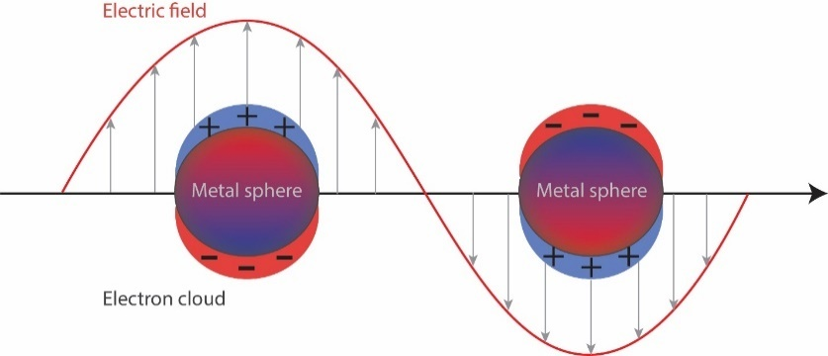
Figure 1. Plasmon generation as an electron cloud upon electromagnetic irradiation
Surface plasmons can be divided into two categories: localized plasmon resonances and surface plasmon polaritons [5]. For localized plasmon resonances, the incident light is scattered or absorbed by the oscillating electric dipoles whereas, for surface plasmons polaritons, they propagate along metal surfaces in a wavelike fashion until release at some distant point from their origin. The surface plasmon waves are important in enhancing optical effects near the metal surface. Both of these surface plasmons happen simultaneously and it is difficult to decouple them, however, they allow for unique optical phenomena to happen, such as surface plasmon resonance and surface enhanced Raman scattering.

Size confinement effects
Gold nanoparticles, compared to other inorganic or organic chromophores, have larger extinction cross section, high efficiency in converting light into heat, high photostability and capabilities to enhance the electromagnetic field around their surface.

Factors that influence plasmon resonance
Environmental dielectric and physical-chemical properties.
Due to the nanometric effects, the AuNP is very sensitive to changes in environmental dielectric properties, like density, pH, surface adsorption. This property enables nanoparticles to be engineered into exquisite sensors.
Surface chemical modifications
Chemical modifications on the nanoparticle surface, such as adding thiolated ligands, adsorption of molecules etc, can change the LSP in several ways:
- Chemical interface dampening: the newly adsorbed molecules introduce a new relaxation pathway for electrons.
- The newly formed shell of non-metallic Au atoms leads to a reduction in the metallic core.
The importance of the chemical effects depends strongly on the nanoparticle size, shape and the adsorbent.

Optical characteristics
Unique optical properties of AuNPs have enabled the development of sensing and imaging platforms with diagnostic and medical applications. While these applications are varied and versatile, as detailed below, they take advantage of AuNP’s high optical extinction coefficient and the ease of modulating the SPR response of the particles. In addition, optical extinction of AuNPs can be easily measured with a UV-VIS spectrophotometer
As a result, AuNPs have served as ideal platforms for the development of a) sensitive and selective optical sensors; b) cellular imaging technologies and c) clinical therapeutic applications involving photothermal effects of AuNPs.

AuNPs as optical sensors
There are two main classes of optical sensors based on AuNPs: colorimetric and applications involving the SPR spectral shift.
Colorimetric sensing
Since the SPR position is so sensitive to the homogeneity of the colloid, an aggregation in the nanoparticles state is easily mirrored in a SPR shift towards higher wavelengths. A sensing platform can thus be developed if an analyte binds selectively to the nanoparticle surface and induces aggregation. The colorimetric assays developed so far are able to detect metal ions, small organic molecules, proteins and DNA [6]
SPR shift sensing
Another way to sense the binding of an analyte on the surface of the nanoparticle is by monitoring the local change in the refractive index of the surrounding media. The relationship between SPR maximum and environment refractive index is:
Λ_{max} = 2πc/ω_{p} $√({2n}^{2}$+1) (1)
Biosensing
A sensor has two components: a recognition element for target binding and a transduction element for signaling of the binding event. In the case of AuNPs, the element of transduction is the SPR band, which is sensitive to the environment and surface modifications and is able to shift with any small change in the nanoparticle’s proximity [7].

Photothermal effects of AuNPs.
AuNPs possess a high ability to transform light into heat efficiently. The reason for this is that AuNPs have SPR wavelengths in visible and NIR regions, low luminescence yield and rapid relaxation times of SPR. Moreover, they have high photostability compared to organic dyes.
There were distinguished several steps that happen during this energy transfer, steps illustrated in Figure 2:
- A transient thermal expansion when the lattice suffers acoustic vibrations
- This expansion leads to a melting phase. In this phase most of the anisotropic nanoparticles, like nanorods, change their shape towards more energetically favorable structures, like spheres.
- By continuing the irradiation, there was observed a vaporization effect. Nanoparticle’s size is reduced and new smaller nanoparticles are formed
- The latest step is fragmentation, and is believed to be caused by boiling or “nano-explosions”

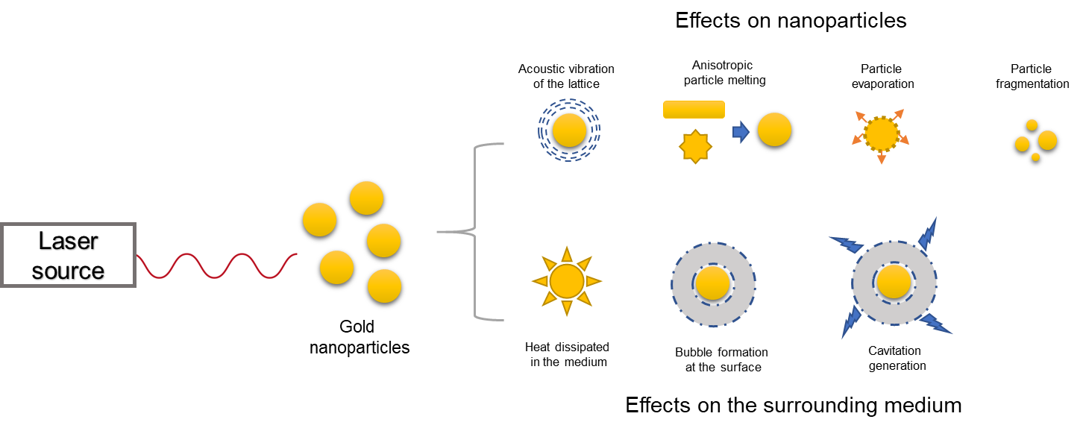
Figure 2. Effects highlighted in AuNPS after laser exposure

Photothermal effects in drug delivery platforms
Delivery platforms for drugs and nutraceuticals have been developed in order to mitigate some disadvantages of classical drug delivery. Polymeric microcapsules are actively studied as delivery platforms in many fields like medicine, cosmetics, pharmaceutics, nanophotonics, etc. To confer such capsules the ability to release the cargo, optical active adjuvants, like nanoparticles, are added to the walls of the capsules. This way they become light responsive vehicles [8], that are able to absorb light and convert it into heat to degrade the vehicle walls and release the cargo [9].

Field enhancement effects
The ability of the nanoparticles to amplify any electromagnetic field near their surface led to the development of many types of optical phenomena like Raman scattering.
There are two ways acknowledged by the scientific community that describe this local-field enhancement:
- Because of irradiation, a dipole is generated in the nanoparticle which can be described as a mass spring oscillator. The mass displacement that corresponds to the charge density accumulated at the edge of the nanoparticle is responsible for the instantaneous generation of an electrostatic field, which leads to electromagnetic enhancement.
- The field generated by the electron oscillations propagates through the medium as waves.

Surface enhanced Raman Spectroscopy
Surface Enhanced Raman Scattering (SERS) was first observed in 1973 and for a single molecule was observed in 1997. SERS require the presence of metal nanostructures as integral component. The SERS effect is composed of two interactions: monochromatic light-molecule and monochromatic light-nanoparticle[10]. SERS is a truly surface selective effect. It is a molecular spectroscopic technique based on plasmon assisted scattering of molecules which are on or near the metal nanostructure. SERS is best described as a dramatic amplification of the electromagnetic field in NP assemblies.
Multivariate data analysis of SERS
SERS spectra often contain too much information that can be lost using simple analysis techniques. Means of statistical methods can provide maximum analytical data about a molecule, comprised in such spectra. SERS spectra contain key information about molecular structure and molecular orientation at the nanoparticle surface. Principal component analysis, PCA, is a well -established chemometric technique of factor analysis that yields two matrices, a score and a loading matrix which are complementary to each other in terms of information featured about the whole dataset [11]. Spectroscopic imaging benefits from PCA technique by reducing both spatial resolution and molecular information to a 2D plot. A series of SERS spectra are recorded for every spatial point or pixel, so an object to be analyzed becomes a spatially distributed series of acquired spectra. Using PCA these spectra are processed for commonalities and the plots are generated based on the spatial presence of that common profile. For example, SERS imaging can be used to analyze pharmaceutical tablets, coatings, polymeric integrity, cells[12] and drug cellular distribution[13].

Gold nanoparticles in biospace

Having a nanosized platform for drug delivery brings significant advantages compared to conventional delivery methods, such as, improved stability of the drug, prolonged retention times in the bio-systems, higher transport of the drug into tissues or cells, higher drug loading thus fewer doses, controllable release at the site and customizable surface to control target delivery and minimize off-target effects.
Taking advantage of all of the unique properties of AuNPs, scientists have created the so called “nanovector”, where AuNPs system is capable of being both a delivering tool and a tracking platform. The multivalent characteristics of a “nanovector” are depicted in Figure 3.
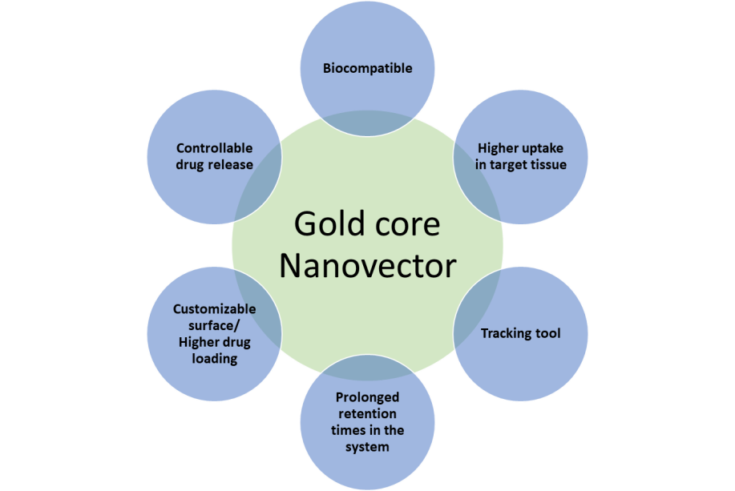
Figure 3. The multivalencies of a "Nanovector"

Protein corona
Biological corona is the layer of organic molecules, usually proteins, derived from biological systems that bind to the nanoparticle surface when nanoparticles are exposed to biological environments[14]. It was determined that protein corona affects cellular uptake and toxicity. Also, it gives a nanoparticle a biological identity since the protein corona constituents are directly related to the nanoparticle size, shape, surface chemistry and charge.

Cellular interactions
Uptake
After exposure to biological fluids and the changes suffered by the nanoparticles associated with such exposure, next in the nanoparticle’s journey to the target is the cellular membrane. The cell membrane acts as a barrier that modulates all of the cell’s exchange with the extracellular environment. The fate of the uptake is mainly dependent on the surface that is presented to the cell, which in turn is dependent on the size and shape of the particle.
Cytotoxicity effects
Toxicity induced by the AuNPs was found to be governed by the AuNPs characteristics like size and shape. Even small changes in size can cause big differences in in vitro effects. Citrate-capped AuNPs were found to be more toxic at 5nm than at 15 nm. In another study, 13 nm AuNPs stabilized with citrate showed less toxicity than 45 nm ones. The 45 nm were uptaken in vacuole-like organelles which once broken inside the cells it causes cells to enter apoptosis faster and at a higher rate than the 13 nm ones [15].
Intracellular AuNPs can generate reactive oxygen species, ROS. PEG functionalized AuNPs were shown to create ROS, which disturbed mitochondrial membrane potential and elevated intracellular Ca²⁺ levels. Other nanoparticles induced oxidative stress in the endoplasmic reticulum which resulted in autophagy[16].

Gold nanoparticle synthesis development

Below there is a summary of the components used for generating gold nanoparticle in this study:
Table 1 Summary of AuNPs developed and characterized in this study
Nanoparticles ID | Reduction agent | Reaction factors | Stabilizing agent | AuNPs size | AuNPs shape
C7-AuNPs | Collagen + ethanol | 100°C, pH 7 | Collagen | 7-8 nm | shperical
PMA AuNPs | TOAB+NaBH₄ |  | Polymaleic acid, PMA | 4-5 nm | spherical
C11-AuNPs | Ions and ROS from plasma discharge | pH 11, 40°C | Collagen | 11 nm | Mainly spherical with triangular and rhomboidal
C60-AuNPs | Hydrogen peroxide + collagen | RT, pH 9 | Collagen | 60 nm | “raspberry”

Synthesis of C7- AuNPs

A synthesis procedure for AuNPs in which collagen acts both as a reducing and as a stabilizing agent was developed. The one-step synthesis of protein-coated Au NPs prevents the use of reducing agents and stabilizers of a chemical nature. Thus, no surface modification step is required, and the synthesized Au NPs are exclusively covered by a protein layer, which in principle could be an advantage in terms of biocompatibility.
A stock solution of gold salt was prepared by dissolving 1 g hydrogen tetrachloroaurate (III) hydrate (99.9% metal basis, Alfa Aesar, Karlsruhe, Germany) in 50 mL ultrapure water. A solution of collagen was prepared by mixing 10 mL ultrapure water with 0.02 g of collagen from bovine Achilles tendon (Sigma-Aldrich) in the presence of 500 µL hydrochloric acid 37% (Sigma-Aldrich). One-point-five milliliters of collagen solution (0.02 g collagen in 10 mL water) was mixed with 0.5 mL ethanol. Subsequently, 90 mL of ultrapure water were added to the collagen-ethanol solution, which was then mixed with 1 mL of gold salt solution. The mixture was heated and stirred until boiling. When it started to boil, the solution was neutralized by quickly adding 2 mL of 1% sodium hydroxide, and the heating was turned off. Instantly, the solution turned into a wine-red color, and its pH was 7. Sodium hydroxide (Fluka, The Netherlands), ethanol and sodium chloride (Merck, Darmstadt, Germany) were of analytical grade. All solutions were prepared in ultrapure water with a resistance higher than 18 MΩ (Direct-Q 3 UV, Millipore.

Synthesis of PMA-Au NPs

Hydrogen tetrachloroaurate (III) hydrate (Alfa Aesar), sodium borohydride (Sigma-Aldrich) and tetraoctylammonium bromide (TOAB; Sigma-Aldrich) were used to synthesize AuNPs (4–5 nm in diameter) according to previously published protocols [17]. Briefly, an aqueous solution of HAuCl₄ was transferred to toluene to form an ionic pair with TOAB (4.5 eq.), which also acts as a stabilizing agent. In the organic phase, sodium borohydride (NaBH₄, 10 eq.) was added to reduce Au³⁺ to Au⁰, leading to the formation of colloidal AuNPs. The NPs were then washed to remove the excess of ions with HCl, NaOH and, finally, Milli-Q water. Each time, the added aqueous phase was discarded. Ostwald ripening, facilitating the formation of a monodisperse suspension, occurred during an overnight incubation. 1-dodecanethiol was added to replace the surfactant ligands on the particle, rendering the NPs more stable. NPs were further purified with methanol and finally re-dispersed in chloroform. It must be noted that upon ligand exchange of TOAB to 1-dodecanethiol, part of the original TOAB molecules may be left on the Au surface. Ligand exchange processes are known to be not always 100% complete [18]. After ligand exchange, the NPs were washed several times. The hydrophobic Au NPs were then transferred into an aqueous solution by coating them with 1-dodecylamine-modified poly(isobutylene-alt-maleic anhydride (PMA, Sigma, Darmstadt, Germany; M_{w} = 6000 g mol⁻¹), as described previously [19-21].

Synthesis of C11-AuNPs

For the synthesis of C11-AuNPs, in a glass beaker there were added 300 µl of collagen solution, 150 µl gold solution and 1 ml of NaOH 1 % in 15 ml of ultrapure water. After this mixture was made, the solution was exposed to plasma for 10 minutes. After 10 minutes the solution turned light red indicating that a gold nanoparticle colloid was formed and this colloid has a pH value of 11. Figure 4 shows a schematic overview of the synthesis process.
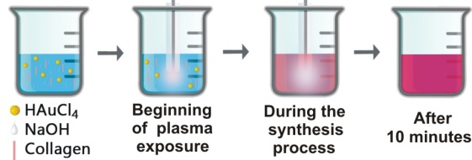
Figure 4. A schematic overview of C11-AuNPs synthesis process

Synthesis of C60-AuNPs

The materials used for the AuNPs synthesis are: a stock solution of gold salt (1g, 99.9% hydrogen tetrachloraurate hydrate metal basis (Alfa Aesar) in 50mL ultrapure water); a stock solution of collagen (0.02g collagen type I from bovine Achilles tendon (Sigma-Aldrich) in the presence of 500µL, 37% hydrochloric acid (Sigma Aldrich) was prepared by mixing with 10mL ultrapure water); 1% Sodium hydroxide (Fluka) and 3% hydrogen peroxide solution (AppliChem). Further, the mixing steps will be detailed below. All solutions were prepared in ultrapure water with a resistivity higher than 18 MΩ (Direct-Q 3 UV, Millipore). Figure 5 provides a schematic overview of the above described synthesis procedure.
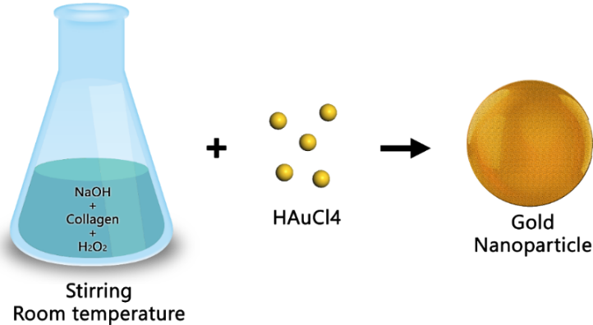
Figure 5. A schematic overview of the C60-AuNPs synthesis process.
C60-AuNPs present a degree of anisotropy with some spiky spots on the surface almost like a raspberry [22]. According to the nanoparticle distribution, calculated with ImageJ software from TEM images, their diameter distribution peaks around 60 nm, with 80% of the population being in the 60 to 80 nm range.

Conclusions

This chapter focused on exposing how slight changes in synthesis methodology can result in bigger than anticipated changes in the characteristics of AuNPs. Starting with the same raw ingredients, by varying the temperature and ion composition available to reduce Au atoms, different sized and shaped AuNPs coated with collagen are obtained.
At a first glance, temperature seems to be a main driving force for the difference in particle size. The lower the temperature, the larger the particle obtained. Not only size is affected, but also the shape. The shapes seem to transition from spherical towards anisotropic, again with the decrease in the reaction temperature. These changes in size and morphology are highligted in Figure 6. The SPR position doesn’t comprise all the information about the nanoparticle characteristics. It is merely a good indicator for approximate size and shape, however, imaging techniques are necesarry to confirm such features.
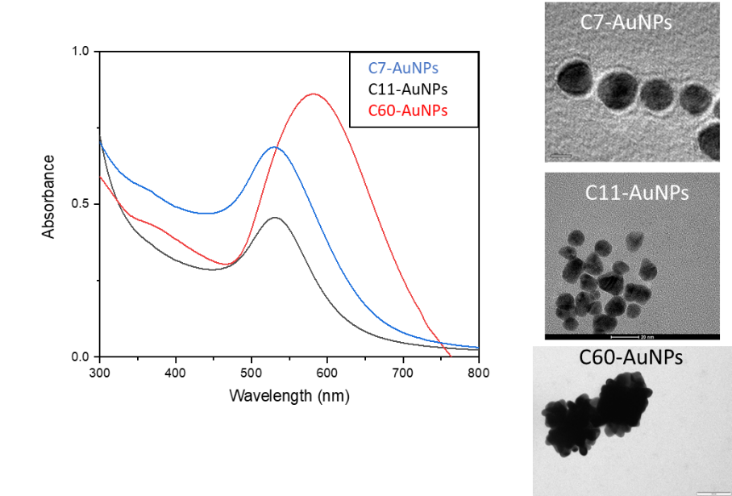
Figure 6. Left. SPR position; Right. TEM images for C7-AuNPs, C11-AuNPs and C60-AuNPs.

In vitro effects of AuNPs

Spherical AuNPs

Methods

Cell Culture
Cervical carcinoma (HeLa) and adenocarcinoma alveolar basal epithelial (A549) cells were cultured in Dulbecco’s Modified Eagle’s culture medium (DMEM, Sigma-Aldrich) supplemented with 2 mM glutamine (Sigma-Aldrich), 10% FBS (fetal bovine serum) and 100 U/mL penicillin/streptomycin (Sigma-Aldrich). The cells were grown at 37 °C in a humidified atmosphere containing 5% CO₂. Cells were seeded on 96-well plates at a density 5000 cells/well 24 h before experiments.

Particle Internalization and Sample Preparation for ICP-MS Measurements
ICP-MS methods were employed to quantitatively measure the internalization of AuNPs in the cell lines described above. A detailed ICP-MS protocol is previously described. This treatment ensured sample decomposition to near atom size and allowed for more accurate measurements [23].

Cell Viability
Toxicity induced by gold NPs was evaluated with the MTT assay [24]. The assay is based on the reduction of the tetrazolium salt MTT to formazan by metabolically-active cells. An MTT assay was then performed according to the manufacturer’s instructions (Roche, Germany).

Cellular Internalization
In the following section, a comparison in terms of uptake and cytotoxicity is conducted. The uptake of NPs was visualized with fluorescence microscopy. For this purpose, cells were incubated with AuNPs, which were labelled in their collagen or PMA shell with Dy647. In Figure 7, fluorescence microscopy images of HeLa cells after 4 h of incubation with the C7-AuNPs and PMA-AuNPs are shown. In these qualitative images, it can be seen that the NPs (red fluorescence due to the Dy647) are located in grainy structures around the nucleus (blue fluorescence due to staining with 4',6-diamidino-2-phenylindole (DAPI)).
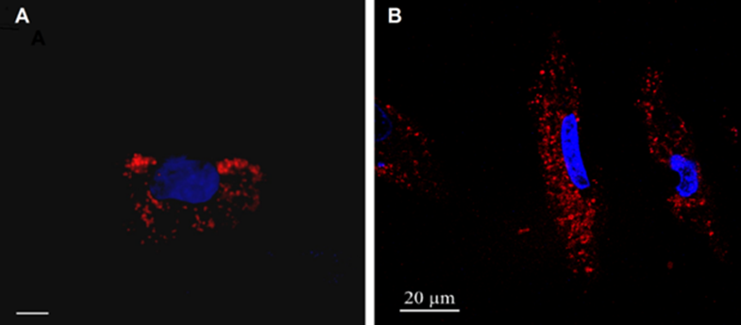
Figure 7 Internalization of Au NPs by HeLa cells. Images of HeLa cells as incubated with fluorescence-labelled Au NPs. (A) C7-Au NPs; the scale bar corresponds to 20 µm. (B) PMA-AuNPs. The NPs were labelled with DyTM647 and, thus, appear in read. The nuclei were labelled with DAPI and, thus, appear in blue.
For quantitative uptake studies, the cells were incubated with the Au NPs in the absence of serum, as well as in serum-supplemented media, and NP uptake was quantified as the amount of internalized Au atoms via ICP-MS.
At equal incubation concentrations of collagen- and PMA-coated Au NPs, the C7-AuNPs were internalized to a much higher extent than PMA-AuNPs. Thus, it appears that collagen versus PMA surface coating may have a direct effect on the extent to which NPs are taken up.

Cellular Biocompatibility
We assessed the impact of collagen- and PMA-Au NPs on the viability of A549 and HeLa cells. As expected, the most toxic effects were observed at the highest concentration tested (200 nM). Under those conditions, cell viability was reduced to around 80% for C7-Au NPs and around 60% for PMA-Au NPs. The higher toxicity of PMA-Au NPs could be related to the presence of residual TOAB on the NPs surface [25]. The low toxicity of collagen-coated Au NPs is not surprising, since collagen is a protein that forms an integral part of biological systems.

Conclusions
Internalization and toxicity of collagen-coated Au NPs were tested in A549 and HeLa cells. The results presented here support the notion that the material employed for the original coating of Au NPs plays a role in their biocompatibility and the pattern of internalization. In this context, naturally-occurring macromolecules, such as collagen, may represent a group of interesting stabilizing agents to be used for future biomedical applications.

Anisotropic AuNPs
In the following study, the uptake and potential toxic effect induced by C60-AuNPs is evaluated.

Methods
Similar methods were used in this chapter as in Chapter 4.1

Cellular biocompatibility
Cellular viability tests on two cell lines show that C60-AuNPs are well tolerated and do not cause significant toxicity. This is very encouraging and not surprising, since the surface coating of these nanoparticles is collagen, a naturally existing protein. However, this data needs to be corelated with uptake experiments.

Cellular internalization
Quantitative uptake experiments were performed by incubating the cells with selected concentrations based on the MTT assay. 20, 40 and 60 nM were chosen since these concentrations showed a statistically significant effect on viability compared to control. Figure 8 presents the levels of uptake in both HeLa and A549s cell lines. The concentration measured by ICP-MS increase with the concentration of AuNPs used for treatment.
Figure 8. Uptake levels of C60-AuNPs in Hela and A549 cells
The maximal uptake levels of C60-coated Au NPs by both HeLa and A549 cells were 3324 ppm and 1404 ppm respectively; cf. Figure 8.

Conclusions
Our findings indicate that these anisotropic gold nanoparticles might not have an advantage over spherical gold nanoparticles for delivery purposes, however, their value resides in their unique optical properties. Applications for anisotropic gold nanoparticles are described in several publications [26, 27].

Polymeric microcapsules-a light responsive drug delivery platform

Polyelectrolyte microcapsules, PEMs, are known to be a good carrier for hydrophobic drugs. However, in order to release the encapsulated drug, the microcapsule needs to be responsive to an external trigger. Thus, for this particular study, C7-AuNPs were loaded in the walls of the capsules. As shown previously, gold nanoparticles have the capability to transform the light into heat, so, based on that principle, these microcapsules were designed as a proof of concept for drug delivery.

Methods
PSS/PAH microcapsules synthesis
The poly (allylamine hydrochloride), PAH, Mw 900000 g/mol and poly (sodium 4 - styrenesulfonate), PSS, Mw 70000 g/mol microcapsules were prepared by depositing polymers by LBL technique on the surface of CaCO₃ particles followed, at the end, by the dissolution of the CaCO₃ core. Initially, the template of calcium carbonate is synthesized by vigorously mixing 1:1 molar ratio of CaCl₂ and Na₂CO₃ according to the following reaction:
CaCl₂ + Na₂CO₃→ CaCO₃ + 2NaCl
The so obtained CaCO₃ spheres are used to build the microcapsules. The spheres are suspended alternatively in PAH (0.2 mg/mL) or PSS (0.2 mg/mL). Each immersion step is followed by centrifugation and the excess unbound polymer is discarded. Since the gold nanoparticles are negatively charged, they are added after the positive PAH layer is added so they can electrostatically attach to the previous layer of polymer. The concentration of C7-AuNPs is 1,82 10⁻⁷ M. In the last two layers of polymers (PSS/PAH), 200 µl rhodamine 6G (10‾⁴ mM) was added to make these capsules fluorescent. After the desired number of layers is added, in this case 8 total layers of polymers, the CaCO₃ needs to be removed. This step is performed by adding a metal chelator, Ethylenediaminetetraacetic acid, EDTA, at 0.2M. after this step the microcapsules are finally washed and suspended in water. A summarized illustration of this process is resented in figure 9.
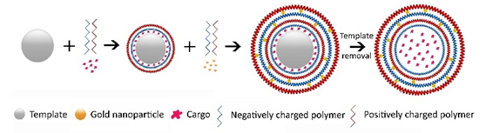
Figure 9 Schematic representation of PEMs synthesis process
Physical characterization of PEMs
The PEMs were imaged using TEM and SEM techniques. Their size distribution and surface charge were measured by dynamic light and electrophoretic light scattering.
Raman spectroscopy and mapping
A Renishaw inVia Reflex Raman Spectrometer (Renishaw, United Kingdom), equipped with an upright Leica microscope was used for Raman spectra acquisitions. This equipment also has the option of sample area mapping through an 1800 lines/mm grating and an automated step motorize stage to raster scan the sample area during the mapping experiments. The spectra were recorded using the 532 nm excitation laser line with a spectral resolution of 4 cm⁻¹
In vitro experimental parameters
The cellular model used in the current experiments was a human retinal pigmented epithelial D407 cell line. This is a transformed cell line, which keeps all the human retinal pigmented epithelium characteristics. D407 cell line keeps its characteristics up to 500 passages. Cells were cultured in Dulbecco’s Modified Eagle medium containing 1g /L glucose, with 10% fetal bovine serum at 37◦C, 5% CO2, and relative humidity of 95%. A mix of antibiotics was used in medium.
Cell proliferation assay (WST-1)
The Cell Proliferation Reagent WST-1 is used for spectrophotometric quantification of cell proliferation for 96-well-plate format. The assay is based on the cleavage of the tetrazolium salt WST-1 to formazan by cellular mitochondrial dehydrogenases.
Cell imaging-TEM and Confocal microscopy
The in vitro cellular uptake was studied by confocal laser scanning microscopy and transmission electron microscopy.

Characterization of PEMs

PEMs were successfully synthesized with an average diameter of 868nm TEM imaging is particularly useful to observe the distribution of C7-AuNPs when they are added to the polymeric wall. The polymer layer doesn’t offer sufficient contrast in TEM technique, whereas the gold nanoparticles would have the appearance of black dots. That’s why we can use this method to asses if the C7-AuNPs are attached to the polymer layer. Figure 10 shows TEM and SEM image of PEMs containing C7-AuNPs. When the gold nanoparticles are added to the polymeric wall, they distribute evenly across the layer.
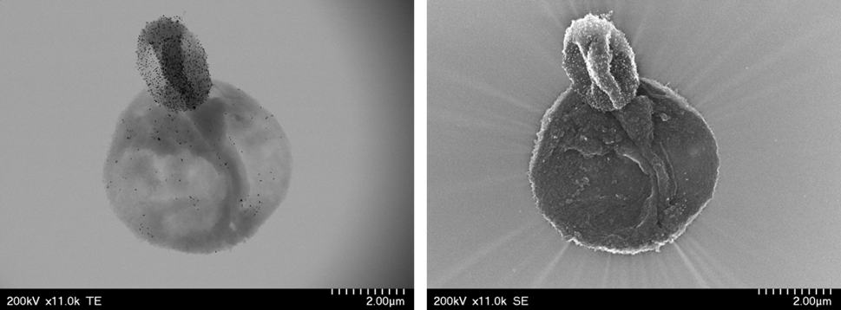
Figure 10. TEM, left, and SEM, right, of C7-AuNPs containing PEMs

Raman mapping of PEMs
Raman mapping is a false-color score plot coming from loading plots after multivariate analysis using PCA. Blue color is arbitrarily attributed to most negative values in the loading plots, while red corresponds to most positive values in the loadings. PCA results in several significant principal components which carry all the information significant to on the analyzed samples[28].
Figure 11 shows the Raman map of PEMs and the corresponding loading vector associated with the first PC. The loading vector of PC1 contains the characteristic Raman bands of PSS/PAH, at 1126 cm⁻¹ and 1597 cm⁻¹. The Raman figure in figure 11 top left corner is colored in blue for the regions with low and negative intensities of the loading vector and with red are areas with high intensities of the loading vector. In figure 11 top right corner is an optical microscope image of PEMs. The highlighted in red area is the one mapped. By comparison, the Raman mapping successfully recreated the optical image of the capsule by using the PSS/PAH characteristic signal.
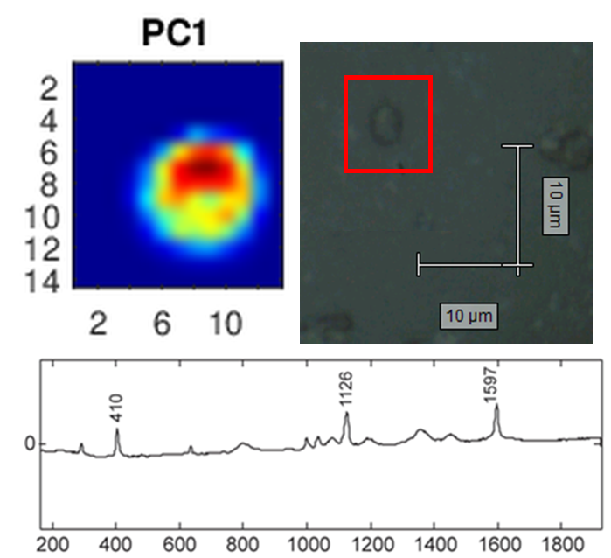
Figure 11. Top left: The false color Raman map of PEMs. Top Right: Microscopy image of PEMs, bottom: The corresponding loading plot of the relevant principal component PC1.
Raman mapping proved to be a powerful technique to spatially identify the PEMs and the composition of their walls.
Next, we performed a study on the ability of these C7-AuNPs loaded PEMs to generate heat and eventually alter their wall integrity. The capsules were irradiated with 532 nm laser having an intensity of 2.5*10⁶ W/cm² for various amounts of time, ranging from 0.01 seconds to 3 seconds. Compared to the non-irradiated sample, the most striking observation is that with an increase in exposure time, the space around the capsules starts to become positive for the polymer’s PSS/PAH signal, indicating that some of these are leaking into the surrounding environment. For times of exposure from 0 to 0.2 s these images do not indicate precisely that these capsules are physically broken, but it definitely suggests that the capsule’s membrane suffers damage due to the polymer’s diffusion in the surrounding environment. For 3s exposure time, the Raman map generated from PC1 component suggests that the capsule is disintegrated. This is the first proof of concept that the C7-AuNPs generate enough heat to start producing changes in the PEM’s structure

In vitro evaluation of PEMs

The polymeric capsules have a rational design to facilitate uptake in the cells. The last layer is positively charged in order to promote an electrostatic interaction with the cellular membrane which is negatively charged
D407 cells were treated with different doses of capsules. These doses are expressed in the number of capsules intended per cell. According to the WST1 cell proliferation assay results, the capsules are not inducing any significant toxic effect on the cells, for the range of doses tested.
Microscopy analysis of PSS/PAH microcapsules internalized in D407 cells
The intracellular localization of PSS/PAH microcapsules in D407 cell line was monitored by confocal scanning laser microscopy. The most representative images are shown in Figure 12. A closer look at these confocal images highlights that around 2-3 capsules are internalized per cell. The images on the right indicate that the PEMs are internalized since they are in the same focal plane as the cells and nucleus
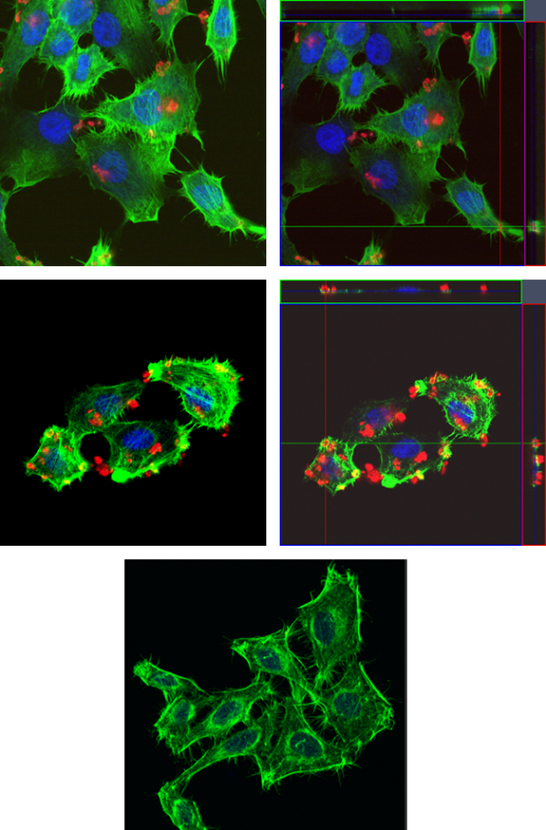
Figure 12. Confocal microscopy of D407 cells non-treated and treated with PSS/PAH microcapsules for 24 h. Cytoskeleton of D407 cells is shown as green stained by phalloidine, nuclei are stained in blue with Draq5 and the microcapsules are stained in red.

Raman mapping of D407 cells loaded with PEM capsules
The D407 cells were exposed to PEMs for 24 hours and then they were imaged and analyzed. By using the technique of Raman mapping it was possible to image the microcapsules inside D407 cells. Moreover, in vitro Raman mapping performed on D407 cells showed successful localization of the capsules in the cellular cytoplasm and to discriminate the microcapsules from other cellular components.

Conclusions

Successful 868 nm C7-AuNps loaded PEMs were synthesized. Raman mapping proved to be a strong technique to spatially identify the PEMs. When comparing to the microscopy image of the capsules, it can be observed that the Raman map replicates the image and easily allows for discrimination of the capsules analyzed. Using Raman mapping, changes in PEM’s wall structure were monitored after laser irradiation, to determine if C7-AuNPs that were loaded in the PEM’s membrane are light-responsive. After 0.2 seconds of laser irradiation, changes in Raman maps start to point towards the wall’s composition being disintegrated.

Final conclusions

The present study focuses on method development for gold nanoparticle synthesis and characterization of the obtained gold nanoparticles. The pursuit of obtaining the “perfect” gold nanoparticle culminates with achieving a successful drug delivery platform. The design rationale for the drug delivery platform is a light responsive polymeric capsule suitable for hydrophobic drugs and nutraceuticals. Taking advantage of gold nanoparticles’ unique biophysical characteristics, and especially their excellent light-to-heat conversion, allows the design of a delivery vector with controllable release of its cargo.
The collagen AuNPs obtained in this study range from 7 nm and spherical to 60 nm and anisotropic. The SPR for C7-AuNPs is 520 nm and for C60-AuNps is 582 nm. The size distribution for C7-AuNPs is narrow, spanning from 5 to 10 nm. For C60-AuNPs the distribution is quite broad, from 20 to 100 nm. Both types of nanoparticles are stable in the synthesis buffer for extended periods of time. They show stability in cell culture media that is typically used in in vitro experiments and are unstable in environments that have high ionic strength. The C7-AuNPs and C60-AuNPs show high biocompatibility, as evidenced by the minimal toxic effect on cellular viability for the doses tested.
The major conclusion here is that surface coating is the driving factor for toxicity and that size regulates the uptake rates.
To engineer a biocompatible delivery platform taking advantage of the properties of C7-AuNPs, our vision was to employ a polymeric microcapsule synthesized through a layer-by-layer technique to encapsulate hydrophobic drugs and decorate its walls with the C7-AuNPs. Upon laser irradiation, enough heat can be generated, in theory, to disintegrate or expand the capsule and release the drug.
Following this design, we successfully synthesized PEMs with 8 layers of polymers and C7-AuNPs. The average size of PEMs is 868 nm and the last layer was chosen to be positively charged so that it would electrostatically interact with the negatively charged cellular membrane to facilitate uptake. The PEMs didn’t show any significant cytotoxic effects and the average uptake probed by fluorescence and TEM imaging indicated around 2-3 PEMs per cell out of 10 PEMs treated per cell. By testing different laser irradiation times, we show that laser exposure times as low as 0.2 seconds cause structural damage of the PEMs, and at 3s of laser irradiation the PEMs were completely disintegrated. These findings indicate that such a delivery platform would be a potentially successful strategy to deliver hydrophobic drugs to a localized target of interest.
Another significant component of this thesis was the confirmation of Raman mapping as a powerful technique to spatially identify structures. This method was used to detect the effects of laser irradiation on the structural integrity of PEMs. Moreover, Raman mapping was used to image the PEM capsules and to help discriminate them once inside cells.
Conclusively, the present thesis presents a robust method development of gold nanoparticle synthesis, which furthers our scientific understanding of the effect of synthesis parameters on nanoparticle characteristics. One step further was taken in the assessment of the behavior of these nanoparticles in vitro, where the nanoparticle size and shape had a great impact on their cytotoxicity and uptake. Lastly, a successful drug delivery platform was designed by using the light to heat conversion capacity of gold nanoparticles. These findings uniquely contribute to the expansion of gold nanoparticle application in the biological field.

References
1. Jimenez-Ruiz, A., et al., Nonfunctionalized Gold Nanoparticles: Synthetic Routes and Synthesis Condition Dependence. 2015. 21(27): p. 9596-9609.
2. Turkevich, J., P.C. Stevenson, and J. Hillier, A study of the nucleation and growth processes in the synthesis of colloidal gold. Discussions of the Faraday Society, 1951. 11(0): p. 55-75.
3. Brust, M., et al., Synthesis of thiol-derivatised gold nanoparticles in a two-phase Liquid–Liquid system. Journal of the Chemical Society, Chemical Communications, 1994(7): p. 801-802.
4. Perala, S.R.K. and S. Kumar, On the Mechanism of Metal Nanoparticle Synthesis in the Brust–Schiffrin Method. Langmuir, 2013. 29(31): p. 9863-9873.
5. Zhang, J., L. Zhang, and W. Xu, Surface plasmon polaritons: physics and applications. Journal of Physics D: Applied Physics, 2012. 45(11): p. 113001.
6. Seferos, D.S., et al., Nano-Flares: Probes for Transfection and mRNA Detection in Living Cells. Journal of the American Chemical Society, 2007. 129(50): p. 15477-15479.
7. Zheng, D., et al., Aptamer Nano-flares for Molecular Detection in Living Cells. Nano Letters, 2009. 9(9): p. 3258-3261.
8. Krug, P., et al., Polypyrrole microcapsules loaded with gold nanoparticles: Perspectives for biomedical imaging. Synthetic Metals, 2019. 248: p. 27-34.
9. Geints, Y.E., E.K. Panina, and A.A. Zemlyanov, Shape-mediated light absorption by spherical microcapsule with gold-nanoparticles-dope. Journal of Quantitative Spectroscopy and Radiative Transfer, 2019. 236: p. 106595.
10. Schlücker, S., Surface-Enhanced Raman Spectroscopy: Concepts and Chemical Applications. 2014. 53(19): p. 4756-4795.
11. Shinzawa, H., et al., Multivariate data analysis for Raman spectroscopic imaging. 2009. 40(12): p. 1720-1725.
12. Kamińska, A., et al., Detection of Circulating Tumor Cells Using Membrane-Based SERS Platform: A New Diagnostic Approach for 'Liquid Biopsy'. Nanomaterials (Basel, Switzerland), 2019. 9(3): p. 366.
13. Veloso, A.B., et al., SERS Investigation of Cancer Cells Treated with PDT: Quantification of Cell Survival and Follow-up. Scientific Reports, 2017. 7(1): p. 7175.
14. Wang, P., et al., Interaction of gold nanoparticles with proteins and cells. Science and Technology of Advanced Materials, 2015. 16(3): p. 034610.
15. Choi, S.Y., et al., In vitro toxicity of serum protein-adsorbed citrate-reduced gold nanoparticles in human lung adenocarcinoma cells. Toxicology in Vitro, 2012. 26(2): p. 229-237.
16. Abdal Dayem, A., et al., The Role of Reactive Oxygen Species (ROS) in the Biological Activities of Metallic Nanoparticles. International journal of molecular sciences, 2017. 18(1): p. 120.
17. Brust, M., et al., Synthesis and reactions of functionalised gold nanoparticles. Journal of the Chemical Society, Chemical Communications, 1995(16): p. 1655-1656.
18. von Holt, B., et al., Ligand exchange of CdSe nanocrystals probed by optical spectroscopy in the visible and mid-IR. Journal of Materials Chemistry, 2008. 18(23): p. 2728-2732.
19. Piella, J., N.G. Bastús, and V. Puntes, Size-Controlled Synthesis of Sub-10-nanometer Citrate-Stabilized Gold Nanoparticles and Related Optical Properties. Chemistry of Materials, 2016. 28(4): p. 1066-1075.
20. Brown, K.R. and M.J. Natan, Hydroxylamine Seeding of Colloidal Au Nanoparticles in Solution and on Surfaces. Langmuir, 1998. 14(4): p. 726-728.
21. Jana, N.R., L. Gearheart, and C.J. Murphy, Seed-Mediated Growth Approach for Shape-Controlled Synthesis of Spheroidal and Rod-like Gold Nanoparticles Using a Surfactant Template. 2001. 13(18): p. 1389-1393.
22. Raula, M., et al., In situ formation of chiral core-shell nanostructures with raspberry-like gold cores and dense organic shells using catechin and their catalytic application. Journal of Materials Chemistry, 2012. 22(35): p. 18335-18344.
23. Tan, G., et al., Conjugation of Polymer-Coated Gold Nanoparticles with Antibodies—Synthesis and Characterization. 2015. 5(3): p. 1297-1316.
24. Mosmann, T., Rapid colorimetric assay for cellular growth and survival: Application to proliferation and cytotoxicity assays. Journal of Immunological Methods, 1983. 65(1): p. 55-63.
25. Feliu, N., et al., Nanoparticle dosage—a nontrivial task of utmost importance for quantitative nanosafety research. 2016. 8(3): p. 479-492.
26. Huang, X., et al., Gold nanoparticles: interesting optical properties and recent applications in cancer diagnostics and therapy. 2007. 2(5): p. 681-693.
27. Chen, N., et al., Small, 2014. 10(null): p. 3603.
28. Maslova, O.A., et al., Raman imaging and principal component analysis-based data processing on uranium oxide ceramics. Materials Characterization, 2017. 129: p. 260-269.

Scientific achievements
Thesis related articles
- Marisca, O.T.; Kantner, K.; Pfeiffer, C.; Zhang, Q.; Pelaz, B.; Leopold, N.; Parak, W.J.; Rejman, J. Comparison of the in Vitro Uptake and Toxicity of Collagen- and Synthetic Polymer-Coated Gold Nanoparticles. Nanomaterials 2015, 5, 1418-1430.
- Marișca, O.T.; Leopold, N. Anisotropic Gold Nanoparticle-Cell Interactions Mediated by Collagen. Materials 2019, 12, 1131.
- Leopold, L.F.; Marișca, O.; Oprea, I.; Rugină, D.; Suciu, M.; Nistor, M.; Tofană, M.; Leopold, N.; Coman, C. Cellular Internalization of Beta-Carotene Loaded Polyelectrolyte Multilayer Capsules by Raman Mapping. Molecules 2020, 25, 1477.
- Vlad, I.E., Marisca, O.T., Vulpoi, A. et al. Simple approach for gold nanoparticle synthesis using an Ar-bubbled plasma setup. J Nanopart Res 16, 2633 (2014).
Other articles ISI
- Tódor, I.S., Szabó, L., Marişca, O.T. et al. Gold nanoparticle assemblies of controllable size obtained by hydroxylamine reduction at room temperature. J Nanopart Res 16, 2740 (2014).
Oral presentations
- Oana T. Marisca, Joanna Rejman, Nicolae Leopold. Evaluation of the cellular biocompatibility of collagen- and synthetic polymer-coated gold nanoparticles 2015 Western Regional Meeting, San Diego, Sept. 2015
- Oana T. Marișca, Nicolae Leopold. “Biocompatibility studies of collagen synthesized gold nanoparticles”, Young Researchers in BioSciences International Symposium, Cluj-Napoca, Romania, July 2014.,
- Oana T. Marișca, Nicolae Leopold. “Biocompatibility studies of collagen synthesized gold nanoparticles”, Advanced Spectroscopies on Biomedical and Nanostructured Systems, Cluj-Napoca, Romania, 7-10 September 2014
Poster presentations
- O. Marișca, Rugină Dumitrița, An alternative diabetic retinopathy therapy: a laser triggered microsystem for controlled release of Resveratrol 2nd International Conference on Current Trends in Mass Spectrometry July 2016 Chicago, USA
- Rugină Dumitrița1*, Coman Cristina, Marișca Oana, Copaciu Florina, Diaconeasa Zorița, Leopold Loredana, Leopold Nicolae, Pintea Adela, An alternative diabetic retinopathy therapy: a laser triggered microsystem for controlled release of ECIS Rome 2016
- Monica Florescu, Adrian Șerban, Nicoleta Elena Dina, Oana Teodora Marişca, Oana Maria Buja, Alia Colniță, Nicolae Leopold. Evaluation of Gold Nanoparticles-Based Electrochemical Sensors for Bioactive Substances Detection CNB Cluj-Napoca June 2016
- I.E. Vlad, O. T. Marisca, A. Vulpoi, S. Simon, N. Leopold, S. D. Anghel, In-liquid plasma application for gold nanoparticle synthesis, Advanced Spectroscopies on Biomedical and Nanostructured Systems, Cluj-Napoca, Romania, 7-10 September 2014.
- Iulia-Elena Vlad, Oana Teodora Marișca, Nicolae Leopold, Sorin Dan Anghel, Collagen Coated Gold Nanoparticle Synthesis Using an Innovative Plasma Assisted Approach, Young Researchers in BioSciences International Symposium, Cluj-Napoca, Romania, July 2014.

