Babeş-Bolyai University, Cluj-Napoca
Faculty of Psychology and Education Sciences
Doctoral school Education, Reflection, Development

Enhancing Oral Communication Performance of Young Pupils by "Selfie Champ" Program
Using the Smart-Devices' Video Feature as a Teaching Tool

PhD Thesis-Long Abstract

PhD Coordinator
PROF. DR. ION ALBULESCU

Doctoral student
Ilan Bar Shalom

CLUJ-NAPOCA, 2019
Table of Contents

Table of Contents 2
Introduction 4
General 4
Gap in Knowledge 5
Research Questions 5
Research Hypotheses 5
Chapter I: Literature Review 5
I.1 General view of the literature review 6
I.2 The Zone of Proximal Development 6
I.3 Theory of Language and Culture 7
I.4 The sociocultural theory 7
I.5 Mediated Learning Experience (MLE) 8
I.6 Language and learning in the digital age 9
I.7 Presentation literacy 11
I.8 Agency Learning versus Disciplinary Learning 11
I.9 Video's Role in the Instruction of Presentation Literacy 12
I.10 Feedback 12
I.11 Futurology of Education and Oral Communication 13
Chapter II. Research Design 14
II.1 Research Objectives 14
II.2 Research Variables 14
Chapter III: Findings 17
III.1 Quantitative 17
III.2 Qualitative Inquiry-Categories and Sub-Categories 20
III.3 Testing and Analyzing 21
Chapter IV: Discussion 24
IV.1 Quantitative Findings 24
IV.2 Qualitative Findings 25
IV. 3 New kind of the Zone of Proximal Development 25
Chapter V: Research Conclusions 26
V.1 Factual Conclusions 26
V.2 Conceptual Conclusions 27
V.3 Research Contribution to Knowledge 27
V.4 Further Research 27
References 29
Appendix 1. Assessment grid checklist for non-biased assessor 33

Introduction
General
This research aims to explore an educational coping method with the difficulties of young pupils to phrase and to deliver coherent oral message. The foundation of this research lays on a widespread phenomenon, observed by the researcher, of ‏‎inarticulation of language among elementary school pupils while performing simple assignments of talking about a subject or even describing an object. Difficulties in linguistic articulations-phrasing coherently were found also in expressing feelings and reasoning of the pupils' affiliations. As an attempt to cope with this problem, this research suggests an intervention program called "Selfie Champ" (Champion) to enhance oral communication performance using a common instrument – smartphone video camera - to create a pedagogical environment of short "talks".
Since smartphone is presumed to be a common device in most of the world, it is assumed that every teacher in most of the world has a kind of a smart phone or other smart device, therefore, owning an available video camera. The research suggests making use of this tool as a stimulator of short oral performance and a device of mirroring for the assessment of pupils' oral performance skills. The parameters of the research included also active thinking and accuracy of following given instructions.
The intervention program was implemented on first grade pupils, assuming that it would be better to start this kind of pedagogical action as early as possible. There is an amount of research claiming that the tendency of first grade teachers to concentrate on teaching reading and writing, hinders the development, or at least the maintenance of what Gee and Hayes (2011) called "school talk".
Developing of extended discourse was defined of one of the goals of the Common Core State Standards (USA), (and in the Israeli curriculum). Therefore, there is a need to provide supportive learning environment to achieve the extended discourse demands. According to the Israeli curriculum of first language pedagogy, this environment consists of exposure to varied vocabulary, opportunities to be part of conversations and home and classroom environments that are cognitively and linguistically stimulating (The official learning curriculum in Hebrew language instruction 2014).
Gap in Knowledge
Much has been researched on video as a teaching and reflecting tool, mostly in high schools and in teachers’ training. Little has been researched in elementary schools especially for first grade pupils.
Research Questions
- What is the contribution of "Selfie Champ" to the following aspects of the quality of presentation, by first grade pupils:
  - Fluency and Clarity of Speech
  - Active Thinking-reducing the dependency on instructor's intervention in conversation
  - Accuracy in Response to Instructions
  - Awareness Level of Audience or Camera
- What is the role of feedback in the pupils' progression?
Research Hypotheses
- systematic use of smart-device’s video camera by "Selfie Champ” intervention program can contribute significantly to the development of first grade pupils' oral performance skills.
- The ability to orally phrase correctly in both presentation test and feedback analysis can improve.
Chapter I: Literature Review
In general, the literature review is concentrating at the beginning of this research on main theories of learning and cognitive development of the 20th century, theories by Vygotsky (1978), Bandura (1986) and Feuerstein (1980). At the second part of the theoretical review, theories of language and learning in the 21st century is discussed. Other issues raised as theoretical background are:
- Theories about video role in education and video as an instruction tool
- Theories about agency learning and pupils' agency in transition from kindergarten to public school
- Theories about feedback, it's types and its impact
- Presentation literacy, a term set by Chris Anderson the principal of TED.
- The aspect of drawing as a communication mean
- A short review on the aspect of debate in education
- Key concepts in emotional functioning and their linkage to learning, and
- Futurology of education and oral communication.

I.1 General view of the literature review
Several reasons are leading the choice of constructing the theoretical review this way. Learning, as Vygotsky (1978) indicated, is a process of social interactions. A process in which the interactions of teacher–learner and learner–learner are the keys for all learning, and for the development of the mind. The role of the teacher is more of a mediator and a mentor in the learning process. In an attempt to observe instructor-learners' interaction on the subject of pupils' trusting themselves in the difficult learning process, the research discusses self-efficacy and socio-cultural theory of learning by Bandura (1986). Learning, according to Bandura (1986) is the acquisition of knowledge through cognitive processing of information. Moreover, social reinforcement such as attention, smiles, and praise from others are particularly influential, and the principles of operant conditioning (Skinner, 1988) can be applied successfully to nonessential behaviors.
Many cases of pupils' seeking for help were answered by the instructor during the intervention program and during testing with mediation. The theory of mediation that was defined by Feuerstein (1980) who gave further insight to Vygotsky's (1978) theory on cognitive functioning. Insights such as logical memory, voluntary attention, categorical perception and self-regulation of behavior. Feuerstein filled a theoretical gap with his theory of mediated learning experience (MLE), in which he assigns the major role to a human mediator. Feuerstein maintained that, all learning interactions can be parted into direct learning and mediated learning. Learning mediated by another person is unreplaceable for a child because the mediator helps him to develop essentials that then make direct learning effective.
I.2 The Zone of Proximal Development
Vygotsky characterizes the "Zone of Proximal Development” (ZPD) as the gap between a child’s "actual developmental level as determined by independent problem solving" and stepping up to level of "potential development as determined through problem solving under adult guidance or in collaboration with more capable peers" (1978, p. 86). A more abled individual joins the child to help him move from where he is at the moment to where he may be, with knowledgeable person's help
(Miller 2011). Such a process, as Vygotsky stated, occurs only when the child is interacting with people of his environment and in cooperation with peers. The instructor, e.g. the more skilled adult and/or peer, builds on the abilities the child already owns and generates activities that reinforce a level of competence slightly above that level. The more skilled adult is engaged in "building bridges" (Miller 2011).
I.3 Theory of Language and Culture
Vygotsky (1978) maintains that language is the most important psychological tool. Language carries the human mind from the concrete to the abstract. Therefore, it frees us from our immediate perceptual experience to allow us to represent the unseen, the past, and the future. Thoughts and language are related dynamically; understanding and formulating language are processes not only influence, but also remodel the mechanism of thinking. In Vygotsky’s words, "Just as a mold gives shape to a substance, words can shape an activity into a structure” (1978, p. 28).
I.4 The sociocultural theory
Both Vygotskian–sociocultural theory and social learning theory stressed environmental, nonbiological effect on behavior and the relevance of learning from looking at other persons in this surrounding. Vygotsky and Bandura defined development as enclosed in accepted cultural faith systems, which are perceived by pupils by looking at other persons and sharing activities with them (Miller, 2011). To understand why bringing Bandura's theory of self-efficacy to this research one must look later at the findings in the qualitative section. The empowerment and up-lifting of self-efficacy is taking a major role in the "Selfie Champ" intervention program. Self-efficacy i.e. the faith in one-self was a main issue in several aspects of the intervention. The feedback sessions, analysis of video clips-instructor and pupil together and conversations while testing between pupils' trials were shown as effective actions elevating pupils' abilities by, among other factors, the encouragement of pupil's self-efficacy. To understand better the meaning of efficacy in instructor-pupil interaction Bandura illustrated on it with the following table.

Table. 1: Types of reinforcement/punishment
Reinforcement
Direct-Reinforcement  Reinforcement pupils get from their environment after behaving positively. Aim: To increase popularity of behavior. | Vicarious-Reinforcement  Reinforcement received by others, learners are expected to copy and accustomed the desired behavior | Self-Reinforcement  Reinforcement an individual gives him/her self after achieving a goal or meeting standards
Punishment
Direct-Punishment  Punishment pupils get from the environment after behaving negatively. Aim: To decrease popularity of behavior. | Vicarious-Punishment  Punishment received by another, for learners to refrain from copying this behavior to avoid it. | Self-Punishment  Punishment an individual gives him/herself after failing to reach a goal or meet a standard.

Bandura (1997) argued that the principal predictor of successful learning that influences self-image, fears, and academic achievements results mainly from feelings of self-confidence with which learners address academic tasks. Other researchers have supported Bandura's arguments and pointed out that the self-efficacy component is the variable that has a direct influence on their performance (Pajares, 1999; Pajares & Valiante, 1999).
I.5 Mediated Learning Experience (MLE)
In an attempt to give an overview to the mediation and other instruction actions that occurred in a duration of "Selfie Champ" intervention program a large part of the theoretical review of this research is occupied with the theory of mediation. Feuerstein (1980) gave further insight to Vygotsky's (1978) theory on cognitive functioning. Insights such as logical memory, voluntary attention, categorical perception and self-regulation of behavior. Feuerstein filled a theoretical gap with his theory of mediated learning experience (MLE), in which he assigns the major role to a human mediator. Feuerstein maintained that, all learning interactions can be parted into direct learning and mediated learning. Learning mediated by another person is unreplaceable for a child because the mediator helps him to develop essentials that then make direct learning effective.
Feuerstein promoted teaching how to learn. The main objectives of teaching according to him are:
- To develop an active structural approach which is effective for learning
- To encourage habits for a continuous exploration to identify flexible strategies when facing new and complex problems, and
- To continue the process of self-expansion of a person’s intellectual potential.
Feuerstein’s concept of Mediated Learning Experience is defined as a unique mode of interaction between the mediator (e.g., parent, teacher or peer) and the learner. It starts from a very early age in the spontaneous interactions between parents and their children, or grandparents with grandchildren and continues later with peers and in more structured interactions with teachers. (Tzuriel, 2014). Feuerstein’s theoretical and applicative approach became globally renowned following the development of two methods:
- LPAD (Learning Potential Assessment Device) an assessment tool that evaluates learning potential.
- IE (Instrumental Enrichment) an intervention method that improves an individual’s ways of thought and function.
These methods are derived from Feuerstein’s original theoretical approach, the
Structural Cognitive Modifiability Theory. It is based on an optimistic concept (Zuriel, 1998, p. 25-26) that claims significant cognitive change is possible throughout a person’s life and man has the potential to change even when functioning on a low level, due to lack of meditated learning experience. This potential may be realized and developed through appropriate intervention based on meditated learning principles. This concept is based on clinical and research foundations (Egozi & Feuerstein, 1987). According to Feuerstein, there are two types of learning: learning directly from the environment and learning through another person – mediator.
I.6 Language and learning in the digital age
After covering some of the main theories of education and psychological development of the 20th century, the theoretical review turns to discuss 21st century theories of education and communication. This section begins with an overview of language and learning in the digital age.
Today’s generation of children are surrounded by digital environment. Traditional media, such as radio, television, and have been switched by new digital technologies that encourage interactive and social engagement and allow children instant access to information, knowledge, entertainment, social contact and marketing (Reid Chassiakos, Radesky, Christakis, Moreno, & Cross, 2016). A recent data presented by the Israeli Central Bureau of Statistics reveals that 85% of the Israeli households, own computer, 77% are connected to the internet. More than 95% of the households with children have at least 2 cellphones. In addition, television, cable TV connection, tablet and other digital devices are common among more than 90% (Israeli Central Bureau of Statistics, 2017). This increased exposure of children to digital media forces the education system to adjust to new challenges. Some of these challenges are related to language and learning in the digital age. Most of the would agrees that competence in oral communication is prerequisite to personal, academic, and professional success. In-spite of that, while humans are born with the ability to vocalize, like other mammals, they are not born with a full mechanism of the knowledge, attitudes, and skills that constitute communication competence. The ability to communicate effectively and appropriately is learned and, therefore, can and should be taught (Morreale & Pearson 2008).
According to Gee & Hayes (2011), every human is both a producer (a talker) and a consumer (a listener) when it comes to oral language. Furthermore, they claim that our modern society allows for the break of the classes. A person is free to choose his/her trajectory and school must provide the opportunity for that choice. Hence, this current research claims that speaking and presenting is and should be a tool for every pupil. A tool that will enable the graduate of school to be well absorbed in our digital age. The best predictor of a child’s success in school, including learning to read, is the child’s oral vocabulary around the age of five (Dickinson & Neuman 2006; Gee 2004; Hart & Risely 1995).
Oral language development is the foundation for success in school and in school-based literacy. Literacy is a special tool. When humans combine language with literacy they can do things that they could not with just language itself (Gee & Hayes 2011). Every child who goes to school already knows some version of an oral language. Nonetheless, there are many varieties of oral language that children do not know. These include the varieties of oral language associated with academic books and content. These varieties of language are sometimes called "academic language” (Gee, 2004; Schleppegrell, 2004).

I.7 Presentation literacy
For more substantiations about the necessity to instruct oral communication performance skills, A chapter about TED world endeavor and the term presentation literacy set by it appears as a continuation for language and learning in the digital age. TED is a nonprofit organization that is devoted to spreading ideas, usually in the form of short, powerful talks (18 minutes or less). TED covers almost all topics from science to business to global issues in more than 100 languages. Many TED lectures are videotaped and uploaded to the internet publicly. TED has a section devoted to young people bringing youth to share their inventions, enterprises and ideas. This section is called Young TED. The current principal of TED Chris Anderson published a book about the organization forming the term: "Presentation Literacy" (2016). Anderson explains that literacy basically defined the knowledge of reading and writing but currently literacy is adopted to many other purposes. In TED's case literacy of presentation defines a chunk go skills attributed to oral performance.
I.8 Agency Learning versus Disciplinary Learning
The choice of addressing age of the population (first grade) derived from the researcher belief that it would be beneficial for the young pupils to begin drilling in oral communication performance at the same time that they learn to read and write. In order to describe a part of the conditions from which the children admitting school for the first time in their life, agency learning defines a behavior of the permission to act not according to the norms of society. A child admitting school underwent over five years in which adults allowed him/her to not keep strict rules. When reaching school age about the age of 6, the demands to keep the rules increases. Bandura (1999) formulates his view of agency as a socio-cognitive one, where children are self-organizing, proactive, self-regulating, and engage in self-reflection, and are not just reactive organisms shaped and shepherded by external events. People own the possibility to influence their own actions to produce particular results. Some researches claimed that the transition to school causes the first and one of the biggest changes that the children undergo in their life: The transition from agency learning to disciplinary learning. Agency has been studied as a phenomenon of active participation of the person in his/her life decisions (Biesta & Tedder, 2006). Other researches states that nothing engages and motivates students more deeply than enabling them to become the active agents in the process of learning. These researches have demonstrated overwhelmingly that students who have agency, experience greater satisfaction in their learning, and, consequently, are more likely to achieve academic success (Xiaodong, Dweck, & Cohen, 2016).
I.9 Video's Role in the Instruction of Presentation Literacy
A major part of smart-devices and most common smartphones is the camera. Based on some theories illustrate the justifications to use the smart-devices video features as an instructional tool. Formal video review has been found to be effective in improving communication skills learning in professionals with frequent client contact (Fukkink, Trienekens, & Kramer, 2011).
Video review has some aspects concerning difficulties that interfere and are being an obstacle to better performance. any reports support the idea that students, and adults in general, are anxious about public speaking (Lucchetti et al., 2009). As Smith, & Sodano (2011) report stresses: around half of students say they are anxious during the preparation process and feel tense and tongue-tied during the presentation itself. Ritchie (2016) maintains that Video recording has been used for many decades to allow students to watch and assess their performances. Quoting a list of researches, he lists several uses for video technology in education: In speech/communication classes and during career building of teachers, medical health professionals, social workers and lawyers. The use of video technology during a performance allows students to gain the observers’ perspective (Quigley & Nyquist, 1992). Having students engage in self-assessment is widely held to have the benefits of self-reflection and engagement in meta-cognitive activity that encourages the development of a life-long learner (Falchikov & Boud, 1989; Yoo et al., 2009).
I.10 Feedback
A significant part of the current research made use of video feedback and analysis to enhance pupils' oral communication performance skills. The feedback conversations both in sessions of the intervention program and in the mid and end terms, were recorded and transcribed for qualitative content analysis. A significant amount of pedagogical time in the intervention program was devoted to the action of feedback giving in 3 channels: a. Instructor's feedback b. Peer's feedback and
c. Self - feedback. Several researches on language instruction, whether teaching of first or second language, make use of reflection and corrective feedback as one of the most valuable tools for enhancing progress.

I.11 Futurology of Education and Oral Communication
In an attempt to justify oral communication education for the future of the children that underwent "Selfie Champ" intervention program, the researcher found it proper to investigate what the theory of futurology has to say about the component of oral communication in the life of the children in their adulthood life in approximately 20 years. A recent meta-analysis (Morreale, Valenzano, & Bauer 2017) listed themes stating various reasons for the importance of communication education. This research was based on 679 documents published between the years 2008-2015, that were dealing with implications of communication education, trying to predict what will be the future of the pupils that are currently attending the formal education systems. Several important themes mentioned in this meta-analysis were found by the researcher to be very significant to indicate future needs in communication education in general and for "Selfie Champ" intervention program in particular. From the overall looking at this article, it appears that communication education has a major centrality in education goals of the 21st century.
When attempting to look at the job market of the world that is going to exist at the time when the current school attenders i.e. pupils of today, will confront in the future when they graduate the school system and admit the adult life including meeting the job-market, they will have to be able to have oral communication skills that are sufficient and high enough to be accepted in the job-market. One can see that even engineering students are identified as requiring more training in communication skills (Kelly, 2008). Understanding the need for communication education, the Kern Entrepreneurial Engineering Network (KEEN, 2016) is awarding grants for college courses that, aid engineering students develop communication skills. Business and commerce also have long recognized the importance of communication training. Employers promote its importance as a skill for prospective employees (Crosling & Ward, 2002; Hart Research Associates, 2009), with some evidence depicting that 93% of employers consider clear communication skills as even more valuable than a student’s major area of study. In terms of communication education in elementary school i.e. K-12 education, competent communication skills lead to more powerful instruction and higher student engagement with information. It helps students to learn to be better communicators themselves and increases that range of communication that helps them to be more successful in academic environments (Thatcher et al., 2008).

Chapter II. Research Design
The current research is done on an intervention program that was conducted in a duration of 22 weeks between October 2017 until February 2018. Once a week, first grade pupils were given one lesson of the program in group of about 6-7 pupils. Each session extended for approximately 40 minutes. Tests were performed three times: first test at the first session, second test at mid-term after ten sessions and the last test at end-term after the 21st session. The program was split into two major pedagogical paths: a. group discussion about a subject, pupils drawing about the subject discussed, individual video clip taking of the pupils giving short speech explaining what they drew and about the subject to the instructor's smartphone video camera. b. the next session after clip taking session was devoted to group discussion about the clips taken at the previous session mainly analyzing and feedback giving. These two paths were the basis for a mix-method research paradigm and supplied two kind of data: a. data from video observations for 2 unbiased assessors to check with a grid Likert checklist described here and b. text retrieved from session long recording of feedback sessions and mid-experimental and post experimental tests' discussions. The check list for the assessors is listed in appendix 1.
II.1 Research Objectives
- To examine the contribution of "Selfie Champ" intervention program to the enhancement of pupils' oral communication performance skills.
- To examine the role of self, peer and instructor's feedback and reflection in enhancing pupils' oral communication performance skills.
- To inquire the educational processes that take place during the program, which assisted in elevating the oral communication performance.
- To provide some applicable practice suggestions for improving the young pupils' communication skills based on the results of this research.
- To explore educational processes via synthetic research methods to provide scientific validations.
II.2 Research Variables
There are five main dependent variables: 1. number of fillers, 2. flow of speech, 3. active thinking-dependency on instructor's guidance 4. level of accuracy in following instructions and 5. fear of giving a speech to others/camera. All of these parameters maybe directly influenced by the intervention program.
The dependent variable of the number of fillers used during the oral performance in the clip, is the actual count of the fillers (a… am… rr… mm…etc.) and can be any number between 0 and above. This parameter was not specifically addressed in the duration of the intervention program nevertheless, it is assumed to be improved as a result of the progress of flow of speech and confidence.
Flow of speech includes the following parameters: a: clarity of speech, b: speech volume, c: varying the tone of voice, d: pace of speech (not too fast/too slow) and e: appearance-standing straight seems confidant. The intervention program including the dimension of feedback addressed these components systematically as they were essential part of the pedagogical vision of the program.
Active thinking-dependency on instructor's guidance: One of the goals of the intervention program was to lessen the pupils' dependency in instructor's guidance in building a story. The more the instructor had to interfere to progress the flow of speech delivery, the lesser score the pupils got, and the lesser active thinking was supposed to occur. Practicing active thinking is one of the main issues which the program consists on.
Level of accuracy in following instructions is important for ensuring that the pupil's speech is as relevant as much as possible to the presented subject. This is to prevent a situation in which the pupil is speaking fluently but with no connection or relevance to the subject.
Fear of giving a speech to others/camera, includes the following parameters: 1. eye contacts, 2. fear of audience and 3. silence between expression of words. All of these components relate directly to ability to overcome audience-anxiety and the program addressed them directly in-order to develop a fearless attitude to the camera.
Scores for each one of these variables (except for the number of fillers), are ranged on a Likert scale between 1-5.
The independent variable is the "Selfie Champ" intervention program as described in figure 8.

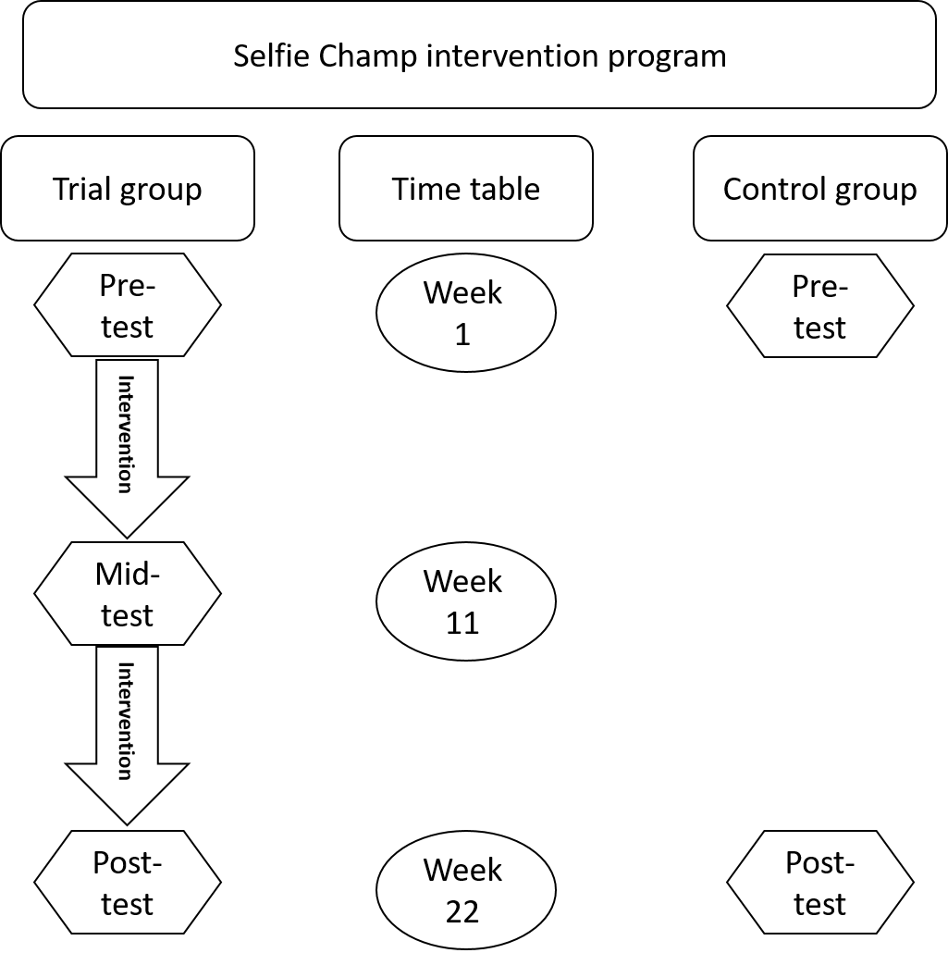
Figure 1: Intervention program’s testing times for trial and control groups

The control group did not receive the intervention program. Pupils of the control group, first grade pupils (N=13) were tested at the beginning of the school year at the same school time as the trial group about a month after school began. After being tested at the same conditions as the pupils of the trial group the control group continued with their regular curriculum without any characters of the "Selfie Champ" intervention program. A post-experimental test was held on the 22nd week, at the same time-period as the trial group.
The pupils of the control group came in pedagogical touch with the instructor but in a different interaction.
II.3 Research Population
Table 1: Research population
Variables | Categories | Research Group |  | Control Group
 |  | N | % | N | %
Gender | Female | 7 | 36.8% | 7 | 53.84
Gender | Male | 12 | 63.1% | 6 | 46.15
Educational background | Kindergarten | 19 | 100% | 13 | 100
Spoken language at home | Hebrew | 10 | 52.6% | 12 | 92.3
Spoken language at home | Russian | 6 | 31.5% | 2 | 15.38
Spoken language at home | Amharic | 2 | 10.5% | Non | Non
Spoken language at home | Arabic | 1 | 5.2% | Non | Non
Participated in pre-test (stage A) |  | 16 | 84.2% | 13 | 100%
Participated in the first part of the intervention program (stage B) |  | 20* |  | 0
Participated in the mid-term test (stage C) |  | 20 |  | 0
Participated in the second part of the intervention program (stage D) |  | 19 |  | 0
Participated in post-test (stage E) |  | 19 | 100% | 11 | 93%

* One pupil joined the trial group after the first test (stage A) and another one left it after the mid-term test (Stage C).

Chapter III: Findings
III.1 Quantitative
The data retrieved from 79 clips (29 clips of both trial and control groups from the pre-experimental tests, 20 clips of the trial group from the mid-experimental tests, and 30 clips of both trial and control groups from the post-experimental tests) that were checked by two unbiased assessors, was statistically analyzed by SPSS software. The first action was to convert the data of three questions (7, 10, 11) that were negatively phrased. Three new variables were created to meet the same scale aa the other variables (which means a higher result=a better performance). In the second action two new variables were calculated: the first was named "speech flow" and it was calculated from the five questions that were related to this aspect (question 2, 3, 4, 5, 6). The second new variable was named "performance" (questions 9, 10, 11) and it dealt with the aspects of behavior in-front of the smart-device's video camera. Means were calculated for each variable.
Two main questions led the analysis: A-is there a positive change in the different aspects of oral communication performance between the beginning of the intervention and the end of the program (research group), B-is there a difference between the pupils who underwent intervention and the pupils of the control group who did not.

III.1.1 Base-line: Pre-Experimental Tests
The mean scores for the pre-experimental tests of both trial group and control group are presented in chart 1.

Chart 1: Pre-experimental means

Independent t test showed that there was no difference in the baseline measurements, which means the pre-experimental status, between research group and control group. Table 4 demonstrates the means of the baseline (pre-experimental) measurements.

III.1.2 Post Experimental Results
Post-experimental results for both trial group and control group are presented in chart 2. Means for the trial groups were higher in all the checked parameters except for the "number of fillers". A higher number of fillers reflects a poorer performance, that means that the lower mean of the trial group reflects a better result. Independent t test (df=58) showed significant differences in all parameters except for one ("The pupil is varying his tone"), in which the mean for the post-experimental test was higher than the pre-experimental test but with no statistical significance.

Chart 2: Post-experimental performence

III.1.3 Analysis of Variances
One-way analysis of variances was performed on trial group only, in order to examine the differences between pre-mid-posttests (pre-experiment, mid-experiment and post-experiment). Results are presented in chart 3.
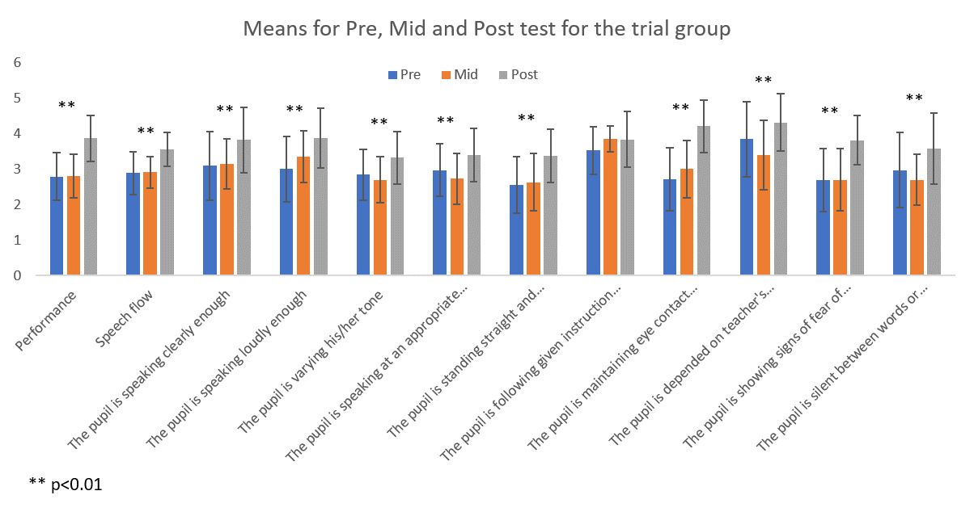
Chart 3: Means for pre, mid and post experimental tests for trial group

There was a significant change in all parameters except for the "accuracy in following instructions parameter". Means for the main parameter "Performance" started with 2.7917 at the pre-experimental test, continued with 2.800 at the mid-experimental test and ended with an increased mean of 3.8684 at the post-experimental test {F(2,107)=34.230, p<0.01}.The means for the second main parameter, "Speech Flow", started with pre-experimental test of 2.8938, continued with mid-experimental test of 2.9100 and increased at the post-experimental test to 3.5526 {F(2,107)=20.173, p<0.01}. The means for the third main parameter, "Active thinking" (The pupil is depended on teacher's leading questions to transfer the idea of what he/she has to say to the camera) showed a decrease between pre-experimental test and mid-experimental test from 3.8438 to 3.4 respectively and increased to 4.3158 at the post-experimental test {F(2,107)=9.105, p<0.01}.
Most of the differences in all tested parameters are between pre-and post-tests and mid and posttests (see table 6). None of the parameters showed differences between pre-and mid tests.
III.2 Qualitative Inquiry-Categories and Sub-Categories
The analyses of the transcribed text from the session-long recordings of several feedback-giving sessions of the experimental phases, emerged the following Themes: a. Learning and Instructing, b. Behavior, c. Ethics.
These themes are divided into several categories:
Theme No. 1 - Learning and Instructing. The theme was analyzed into 6 categories as following: a. organizing issues, b. learning discourse. c. informational talk, d. rubric e. flexibility (in instruction), f. instructor-Pupil's video analysis (together in the classroom).
Theme No. 2 – Behavior The category was divided into 2 categories as following: a. discipline problems, b. behavioral rules. Theme No. 3 - Ethics The category was divided into 5 categories as following: a. confidence, b. safe atmosphere, c. beginning with positive feedback, d. criticism e. sharing issues.
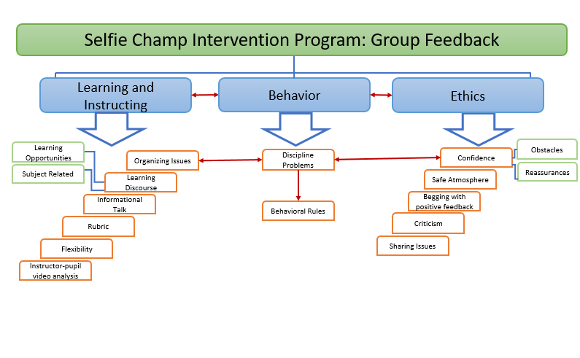
Figure 2: Group feedback sessions qualitative findings

Three tests examining the progress of the participants were done in "Selfie Champ" intervention program. The first test was only recorded in video clips. The other 2 tests: Mid-experimental test and post-experimental test were recorded with audio recordings, in-order to retrieve texts of the interactions between the pupil and the instructor within the duration of the test itself. These interaction texts is the data for qualitative findings.
III.3 Testing and Analyzing
The interactions between the instructor and the pupils in the duration of the mid-experimental test and the post-experimental test created two main categories: Instructor, and pupils.

III.3.1 Instructor
The following categories were found under the "Instructor" theme:
- Instruction,
- Mediation and modeling, which is divided to 2 parts: a: conversations to build a story, and b: Generalizing and Reminding
- Feedback, which is divided to 2 parts: a: Instructor's feedback, and b: pupil's self- feedback
- Encouragement
- Error acceptance
- Agreed rubric, which deals with the internalization of agreed rubric among other issues and:
- Environmental difficulties.

III.3.2 Pupils
The following categories were found under the "Pupils" theme:
- Following instructions, that is divided to 3 parts: a: Performing, b: Reaction, and c: Higher Performance
- Getting started
- Seeking for assistance
- Self-Assessment
- Reflections
- Fear to fail

III.3.3 Categories and Sub-categories in Mid and End-Experimental Tests
In this section the research examines the change that occurred between mid-experimental test and end-experimental test. It also follows the inter-relationships between the occurrences of behavior of the pupils and the instructor's reactions towards them. In some cases, the findings are quantitative, results that immerge from measuring number of utterances of the same category in both tests. An improvement can be considered by lessening the numbers of features that are attributed to less appropriate behavior (for example: seeking for assistance by a pupil), or increasing the number of desired behaviors such as accuracy in following instructions and higher performance. In the next several tables, the research describes actions and reactions of the instructor to pupils' expressions of: a. Needs of instructor's assistance visa vie acting independently; b. Fears to fail; c. Hesitations; d. Confusions and getting stuck; e. Building the story to tell at the clip; f. Generalization and self-thinking visa vie imitating the instructor; g. Remembering/forgetting the set of rules in making a good video (rubric); h. Encouragement when needed, i. Instructor's "setting a stage for the pupils' success"; j. Pupils' reflections.
The instructions to the pupils for the mid-experimental test were as follows:
- Take the drawing that you drew last week and look at it carefully,
- Learn what you drew by heart as much as you can,
- Tell the instructor what you drew and prepare your talk to the camera,
- Say in the clip what you drew and for what,
- Tell a short story about what you did in the holiday vacation.
The instructions for the post experimental test were designed as an authentic assignment as follows: The pupils were told that in order to make a promotion film about our school in general, our first-grade experience and especially about the pupils' experience in "Selfie Champ", they were supposed to give a short talk about the specifications of "Selfie Champ" program in comprising with other learning experiences during first grade.
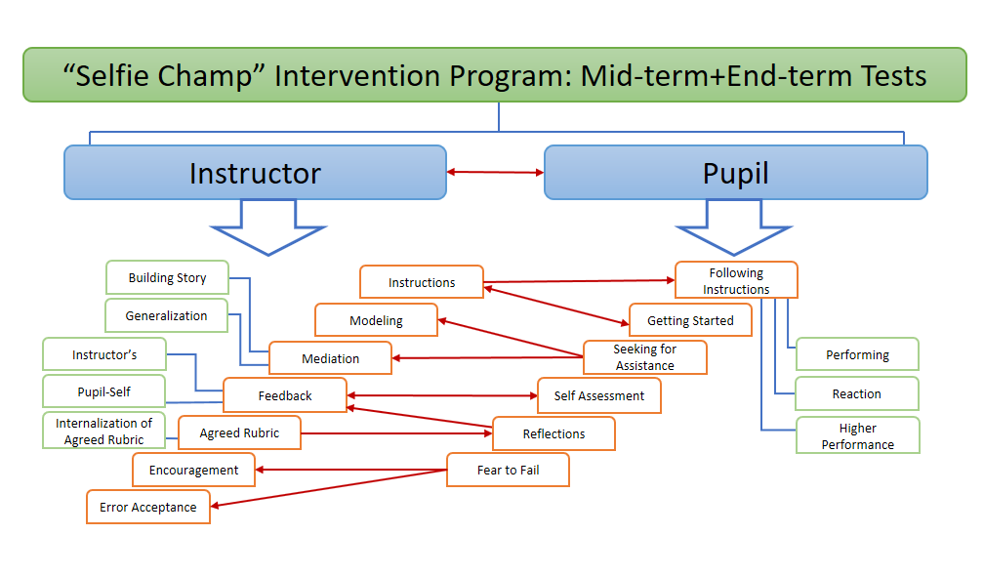
Figure 3: Mid and Post experimental tests categories and themes

Chapter IV: Discussion
The problem that "Selfie Champ" intervention program attempted to address, was the pupils' difficulties to phrase coherently and manage "school talk". These difficulties were examined not from the perspective of physiological impairment, but as an educational case to be addressed pedagogically.
IV.1 Quantitative Findings
Statistic results showed significant change between pre-experimental and post-experimental tests of the trial group. Post Hoc tests revealed that the change emerged from the time period between mid-experimental test and post-experimental test (which means from the second experimental phase) or from pre-experimental test to post-experimental test period (which means all the experimental period). There was no change between pre-experimental and mid-experimental tests (which means – the first experimental phase). This finding may suggest that all twenty weeks of intervention (experimental) program were necessary in order to achieve change. It appears that the process of constant feedback/discourse between learner and mediator (Tzuriel, 1998) that was important component in this desired change, required the full duration of the intervention program. Half time of the program (10 weeks) was not enough to create and demonstrate a significant change.
Results showed a significant difference in all the examined parameters between trial group that underwent "Selfie Champ" intervention program, and control group that did not. In a duration of 22 weeks from the beginning of the school year, both groups were tested with the parameters mentioned: a. speech flow b: accuracy of following instructions c: active thinking c: awareness of audience-camera. These results can provide a positive answer to the research question concerning the contribution of the intervention program to the enhancement of the mentioned parameters. Although little was researched about video feedback as an instruction tool for first grade pupils, results are consistent with former researches (Fukkink, Trienekens, & Kramer, 2011; Gwee & Toh-Heng, 2015), that concluded the positive effectivity the use of video in oral language enhancement. The common video camera existing in almost every teacher's pocket, may be confirmed as a useful teaching tool of oral language enhancement.

IV.2 Qualitative Findings
Any educational activity can display results that appear among the participants and do not exist among those that did not participate. Qualitative research paradigm was conducted to provide some aspects of explanation to the quantitative findings.
The qualitative findings concentrated on the research questions as following:
- what is the role of feedback in pupils' progression?
- What is the kind of mediation conducted in the program?
- What is the character of empowering and supporting self-efficacy given to the pupils?
The first part of the research findings elaborates on the second aim of the "Selfie Champ" intervention program, which was to instruct and learn how to use feedback as a tool to progress. On the way to achieve these goals, the pupils underwent a process of acquiring a kind of a language that was, at that time of their lives, not familiar and very new for them: the language of neutral unbiased feedback. That means for instance that a pupil who does not like one of his/her peers, is not allowed to give negative feedback based on their prior feelings toward the pupil receiving the feedback about their performance on the observed video clip. Feedback was specifically instructed to stay neutral and un-biased.
The text of the instructor-pupil interaction in the feedback sessions, presented several cases to explore:
- The inter-relation between learning and instructing and behavior and the inter-relation between behavior and ethics.
- Findings showed cross relation between organizing issues and behavior.
- Findings showed cross relation between behavior and ethics.
IV. 3 New kind of the Zone of Proximal Development
Video observation evidences in this case, the exact action of video clip taking and re-projecting the clips at the next meeting, for group and instructor's assessment, creates the new kind of the Zone of Proximal Development (Vygotsky 1978). In Vygotsky's time, (app. 1920), the technology of video was unknown. The motion picture technology was very awkward and unreachable to schools. That means that at Vygotsky's era no one thought about the possibility of video-taping pupils to achieve pedagogical purposes. The most available video device enabled a new kind of ZPD described in the following figure
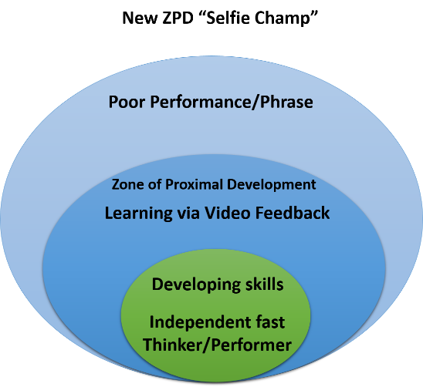
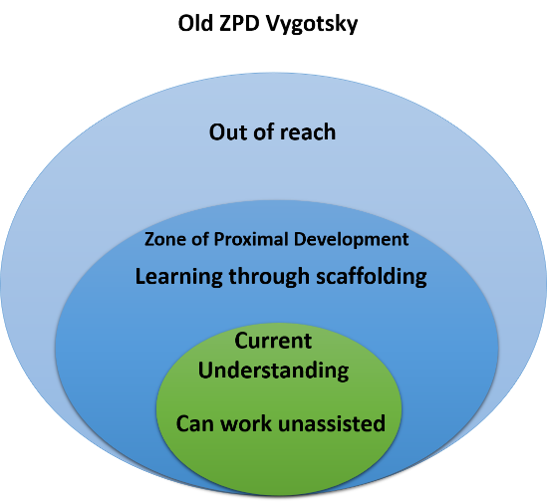
Figure 4: Old and New ZPD

Chapter V: Research Conclusions

The pedagogical vision of the "Selfie Champ" intervention program included, among others, an overlook that improving spoken abilities may influence later writing abilities. The current research was carried out in a regular elementary school in Israel, results may be different if this research would have been carried out in other schools locally and world-wide. Smart devices are commonly owned by people including teachers all over the world. Therefore, it is possible to imply this program in other school locally and world-wide. An important conclusion derived from this current research is that it is possible to enhance oral communication performance skill of young pupils by forming a program that requires very little and non-costly means. Programs such as "Selfie Champ" may rely on the rapid on-growing use of smart devices in today's reality in general and in education in particular.
V.1 Factual Conclusions
The statistic results showed a positive difference between trial group and control group. Since both groups were from the same school, one of the factual conclusions may indicate that "Selfie Champ" succeeded in accomplishing the first aim declared at the beginning: to contribute to the enhancement of oral communication performance skills. Research hypothesis 1 was: systematic use of smart-device’s video camera by "Selfie Champ" can contribute significantly to the development of first grade pupils' oral communication performance skills.
V.2 Conceptual Conclusions
This research examined and found significant differences in oral communication presentation skills in front of the instructor's video camera. It may be concluded out of these findings that without a systematic pedagogical focus on these skills and creating a special learning environment such as the use of smart-device’s video camera like “Selfie Champ”, the mere regular time in first grade class having learning curricula of reading and writing alone i.e. instruction without special treatment to the spoken language and presentation, may not create the expected change.
V.3 Research Contribution to Knowledge
This study attempts to suggest an innovative pedagogical coping method to address first grade pupils' phrasing and performance difficulties using a common, cheap and available instrument which is the instructor's video of his/her own smart device.
Researched population age: while many studies conducted on the effect of video activity with high-school students and adults, the researcher did not find any inquiry that studied this effect on the oral communication performance skills of the age of first grade and on pupils admitting school for the first time in their lives. Therefore, this study may throw a light on some possible ways of educating such an age in an innovative method enhancing oral communication skills.
One other contribution to knowledge may be seen in one of the most important assessing methods used in the program: the co-constructed rubric. This educational transparent action was very new to the pupils of the trial group. They did not believe at the beginning of the intervention program that they were given the power to be responsible for their assessment as well as their peers' assessment. Penetrating a systematic co-construction of a rubric to create transparency in assessment process in such an age is another part in the contribution to knowledge suggested by this study.
V.4 Further Research
Since the intervention program's extension was only 22 sessions, further research may inquire the results of more extended program and its contribution to the oral communication performance skills of pupils from the beginning of school till higher classes. It is recommended to operate a longitudinal research on the effects of such a program for a longer period. It may be very interesting in further research to see what would happen with a pupil starting first grade and comparing his/her abilities at the end of elementary school. What progress can be observed in the amount of the pupils' independency, phrasing and speech delivery. Further research may set other goals deriving from parameters of communication that were set by the current research. Moreover, further research may add some other parameters of communication to the tests of the intervention program. The second hypothesis of this research was partially confirmed as phrasing was not examined directly. Further research can address the phrasing and all its aspects in a more directive approach.
The current research put an emphasis on feedback and its divisions as a major action taken in several dyads of instructor-pupils. Those dyads occurred in feedback sessions and video outcome analysis done by the instructor together with the pupils between two tryouts in the mid and end term tests. In order to verify whether the feedback was a real influencing factor, further research may explore a program that has three groups: first trial group - "Selfie Champ" program with feedback sessions, second trial group - "Selfie Champ" program without feedback sessions and a control group.
Having that a number of researches elaborating on the connection between spoken language and writing in early education (Siffrinn & Lew, 2018), Further research may be examining the influence of the elevation of spoken language and oral communication performance skills on later pupils' writing abilities. That in order to check the pupils' phrasing abilities in writing. At the beginning of the research one of the reasons to commence it was the need to train pupils in high mannered phrasing in writing. One of the assumptions was that speaking well may lead to writing well. That aspect should be further researched.

References
Anderson, C. (2016). TED talks: The official TED guide to public speaking. New-York/Boston: Houghton Mifflin Harcourt. ‏
Anning, A. (2008). Learning to draw and drawing to learn. Journal of
Art and Design Education, 18(2), 163–172.
Bandura, A. (1986). Social foundations of thought and action. Englewood Cliffs, NJ: Prentice-Hall.
Bandura, A. (1997). Self-efficacy: The exercise of control. New York: Freeman.
Bandura, A. (1999). Social cognitive theory: An agentic perspective. Asian Journal of Social Psychology. 2, 21–41.
Biesta, G., & Tedder, M. (2006). How is agency possible? Towards an ecological understanding of agency-as achievement. Exeter: University of Exeter.
Brook, M. (2009). What Vygotsky can teach us about young children drawing. International Art in Early Childhood Research, 1(1), 1–13.
Chang, N. (2007). Embracing drawings in instruction and learning of young children on a scientific concept: A grounded theory Chicago, IL: Paper presented at the meeting of the American Educational Research Association.
Chang, N. nchang@iusb. ed., & Cress, S. (2014). Conversations about Visual Arts: Facilitating Oral Language. Early Childhood Education Journal, 42(6), 415–422.
Chassiakos, Y. R., Radesky, J., Christakis, D., Moreno, M. A., & Cross, C. (2016). Children and adolescents and digital media. Pediatrics, 138(5), 2-18.
content/uploads/2016/02/KEEN-Frameworks-2016.pdf
Dewey, J. (1916/2011). Democracy and Education–Simon & Brown Edition.
Dickinson, D. K., & Neuman, S. B. (Eds.) (2006). Handbook of early literacy research, vol. 2. New York: Guilford Press.
Fukkink, R. G., Trienekens, N., & Kramer, L. J. C. (2011). Video feedback in education and training: Putting learning in the picture. Educational Psychology Review, 23(1), 45-63.
Gee, J. P. (2004). Situated language and learning: A critique of traditional schooling. London: Routledge.
Gee, J. P. (2008a). Decontextualized language and the problem of school failure. In C. Compton-Lilly (Ed.), Breaking the silence: Recognizing the social and cultural resources students bring to the classroom (pp. 24–33). Newark, DE: International Reading Association.
Gee, J. P. (2008b). Getting over the slump: Innovation strategies to promote children’s learning. New York: The Joan Ganz Cooney Center.
Gee, J. P., & Hayes, E. R. (2011). Language and learning in the digital age. London & New York: Routledge.
generated drawing: Literature review and synthesis. Educational Psychology Review, 17(4), 285–325.
Gwee, S., & Toh-Heng, H. L. (2015). Developing student oral presentation skills with the help of mobile devices. International Journal of Mobile and Blended Learning (IJMBL), 7(4), 38-56.
Hart, T., & Risely, B. (1995). Meaningful differences in the early experience of young American children. Baltimore: Brookes.
Hopperstad, M. H. (2010). Studying meaning in children’s drawings. Journal of Early Childhood Literacy, 10(4), 430–452.
http://www.cbs.gov.il/reader/newhodaot/hodaa_template.html?hodaa=201711335.
Iorio, J. M. (2006). Rethinking conversations. Contemporary Issues in Early Childhood, 7(3), 281–289.
Israeli central bureau of statistics (2017). Announcement to the media 15 November 2017.Retrieved from:
Kelly, P. (2008). Towards global sapiens: Transforming learners in higher education. Rotterdam: Sense Publishers.
Kern Entrepreneurial Engineering Network [KEEN]. (2016). KEEN frameworks Poster. Retrieved from http://engineeringunleashed.com/keen/wp-
Kress, G. (2010). Multimodality. A social semiotic approach to contemporary communication. London: Routledge.
Kress, G. R., & van Leeuwen, T. (2006). Reading images: The grammar of visual design. New York, NY: Routledge.
Kulik, J. A., & Kulik, C.-L. C. (1988). Timing of feedback and verbal learning. Review of Educational Research, 58(1), 79–97.
Lesgold, A. M., Levin, J. R., Shimron, J., & Guttmann, J. (1975). Pictures and young children’s learning from oral prose. Journal of Educational Psychology, 67(5), 636–642.
Liao, C. C., Lee, Y. C., & Chan, T. W. (2013). Building a self-generated drawing environment to improve children's performance in writing and storytelling. Research & Practice in Technology Enhanced Learning, 8(3).
Lucchetti, A. E., Phipps, G. L., & Behnke, R. R. (2009). Trait anticipatory public speaking anxiety as a function of self-efficacy expectations and self-handicapping strategies. Communication Research Reports, 20(4), 348–356.
Madsen, J. (2013). Collaboration and learning with drawing as a tool. Teaching and Teacher Education, 34, 154–161.
McConnell, S. (1993). Talking drawings: A strategy for assisting learners. Journal of Reading, 36(4), 260–269.
Mercer, N., & Dawes, L. (2008). The value of exploratory talk. In N. Mercer, & S. Hodgkinson (Eds.), Exploring talk in school (pp. 55e72). Los Angeles: Sage Publisher.
Miller, P. H. (2011) Theories of developmental psychology. ‏ New York: Worth Publishers.
Morreale, S. P., & Pearson, J. C. (2008). Why communication education is important: The centrality of the discipline in the 21st century. Communication Education, 57(2), 224–240.
Morreale, S. P., Osborn, M. M., & Pearson, J. C. (2000). Why communication is important: A rationale for the centrality of the study of communication. Journal of the Association for Communication Administration, 29, 1–25.
Nicolaidou, I. (2013). E-portfolios supporting primary students’ writing performance and peer feedback. Computers & Education, 68, 404–415.
Norris, E., Mokhtari, K., & Reichard, C. (1998). Children’s use of drawing as a pre-writing strategy. Journal of Research in Reading, 21(1), 69–74.
Otto, B. (2008). Literacy development in early childhood: Reflective teaching for birth to age eight (Vol. 3). Upper Saddle River, NJ: Pearson Education Inc.
Ouellette, G. P. (2006). What’s meaning go to do with it: The role of vocabulary in reading and reading comprehension. Journal of Educational Psychology, 98(3), 554–566.
Pajares, F., & Valiante, G. (1999). Grade level and gender differences in the writing self-beliefs of middle school students. Contemporary Educational Psychology, 24, 390-405.
Paquette, K. R., Fello, S. E., & Jalongo, M. R. (2007). The talking drawings strategy:
Quigley, B. L., & Nyquist, J. D. (1992). Using video technology to provide feedback to students in performance courses. Communication Education, 41(3), 324-334.‏
Reutzel, R. D. (2003). Teaching children to read: Putting the pieces together. New York: Prentice Hall.
Schleppegrell, M. (2004). The language of schooling: A functional linguistics perspective. Mahwah, NJ: Lawrence Erlbaum.
Siffrinn, N. E., & Lew, S. (2018). Building disciplinary language and literacy in elementary teacher training. Reading Teacher, 72(3), 325–341.
Thatcher, K. L., Fletcher, K., & Decker, B. (2008). Communication disorders in the school perspectives on academic and social success an introduction. Psychology in the Schools, 45, 579–581.
Tzuriel, D. (1998). Mental Modification: Dynamic Assessment of Learning Efficacy (pp. 25-38). Tel Aviv: Sifriyat Hapoalim. (In Hebrew).
Using primary children’s illustrations and oral language to improve comprehension of expository text. Early childhood education journal, 35(1), 65-73.
Valsiner, J., & van der Veer, R. (2000). The social mind: Construction of the idea. Cambridge: Cambridge University Press.
van Meter, P., & Garner, J. (2005). The promise and practice of learner-
Vygotsky, L. S. (1986). Thought and language. Cambridge, MA: MIT Press.
Xiaodong, L. S., Dweck, C. S., & Cohen. G. L. (2016). Instructional interventions that motivate classroom learning. Journal of Educational Psychology, 108(3), 295-299.

Appendix 1. Assessment grid checklist for non-biased assessor
1-Not at all 2-Very little 3-Somewhat 4-Quite a lot 5-Constantly
Assessor No. 1 / 2
clip code: ______________

Clarity of delivery and speech
1 | Number fillers used while presenting (Ah…Ah…Er … Um … Ok, ok, ok …Yah …, etc.) .
2 | The pupil is speaking clearly enough | 1 | 2 | 3 | 4 | 5
3 | The pupil is speaking loudly enough | 1 | 2 | 3 | 4 | 5
4 | The pupil is varying his/her tone | 1 | 2 | 3 | 4 | 5
5 | The pupil is speaking at an appropriate pace and not too fast/too slow | 1 | 2 | 3 | 4 | 5
6 | The pupil is standing straight and looking confident | 1 | 2 | 3 | 4 | 5
Active thinking abilities
7 | The pupil is depended on teacher's leading questions to transfer the idea of what he/she has to say to the camera. | 1 | 2 | 3 | 4 | 5
Accuracy in following Instructions
8 | The pupil is following given instruction accurately | 1 | 2 | 3 | 4 | 5
Awareness of Audience and camera
9 | The pupil is maintaining eye contact with the camera/audience. | 1 | 2 | 3 | 4 | 5
10 | The pupil is showing signs of fear of audience. | 1 | 2 | 3 | 4 | 5
11 | The pupil is silent between words or short sentence. | 1 | 2 | 3 | 4 | 5

