
“Babeș-Bolyai” University
Faculty of Chemistry and Chemical
Engineering
Department of Chemical Engineering

Artificial Neural Network Modelling of Parametrized Photo-Induced Generation of Gold Nanoparticles and their Temperature Dynamics

PhD Student
Ana Maria Mihaela Gherman

Scientific Advisor:
Prof. Dr. Ing. Paul Serban Agachi

Cluj-Napoca
2018

Table of Contents
Abbreviations and Nomenclature 4
General Information 8
Thesis motivation 8
Thesis objectives 8
Thesis structure 9
1. Introduction 10
1.1 Nanotechnology 10
1.2 Nanoparticles 11
1.3 Gold Nanoparticles 13
1.3.1 Gold Nanoparticle Properties 13
1.3.2 Gold Nanoparticle Synthesis 19
1.3.3 Nucleation and growth 30
1.3.4 Applications 31
2. Part A – Synthesis, characterization and modeling of the gold nanoparticles photochemical generation process 35
2.1 Introduction 35
2.2 Experimental 37
2.2.1 Chemicals 37
2.2.2 Instrumentation 37
2.2.3 Sample preparation 38
2.2.4 Characterization technique 39
2.2.5 The influence of the scanning velocity and irradiation power on the sample color 40
2.2.6 The influence of the scanning velocity and irradiation power on the LSPR absorption maxima 41
2.3 AuNP size determination 47
2.4 Modeling the AuNP size with ANN 50
2.4.1 The ANN model - 2 hidden Layer 53
2.4.1.1 Statistical assessment of ANN model 54
2.4.1.2 ANN model Predictions 55
2.4.2 Assessment of the input variables importance 58
2.4.3 The ANN model - 1 hidden Layer 58
2.4.3.1 Statistical assessment of ANN model 59
2.4.3.2 The relative impact of each process parameter on the particle size 61
2.5 Conclusions Part A 62
3. Part B - Gold Nanoparticles in Laser Fields: Heat Generation and Heat Transfer 64
3.1 Introduction 64
3.2 Temperature dynamics of a system that contains one spherical AuNP embedded in a polymer (PSS) matrix – the influence of AuNP size 68
3.2.1 Methods 68
3.2.2 Results and discussions 71
3.3 Temperature dynamics of a system that contains an ensemble of spherical AuNPs embedded in a polymer (PSS) matrix – the influence of the AuNP distribution 75
3.3.1 Methods 75
3.3.2 Results and discussions 77
3.4 Temperature dynamics of a system that contains an ensemble of spherical AuNPs embedded in a polymer (PSS) matrix – the influence of the interfacial thermal conductance 83
3.4.1 Methods 83
3.4.2 Results and discussions 85
3.5 Near field effects and temperature dynamics of laser irradiated gold nanoparticles 89
3.5.1 AuNPs in a cross-type geometry - 2D model 91
3.5.1.1 Methods 91
3.5.1.2. Results and discussions 94
3.5.2 3D Model - The influence of near field interactions on the AuNP temperature 98
3.5.2.1 Methods 98
3.5.2.2 Results and discussions 99
3.5.3 The influence of AuNPs distance on the AuNP heat generation and their maximum temperature. Comparison between two modelling approaches. 103
3.5.3.1 Methods 103
3.5.3.2 Results and discussions 104
3.6 Conclusions Part B 107
General conclusions 111
References 116

Key Words: gold nanoparticle, artificial neural network, photochemical synthesis, direct light writing, laser irradiation, heat transfer, temperature distribution, near-field effects

General Information

Thesis motivation
Gold nanoparticles are extensively studied because of their size dependent optical, electronic and photo-thermal properties, but also due to their excellent biocompatibility and large effective surface area. Because of these unique characteristics, gold nanoparticles have applications in sensing, imaging, propagation of light, catalysis, drug delivery, photothermal therapy or bubble technology. Due to these large number of applications, various gold nanoparticles synthesis methods have been developed. One of the most advantageous synthesis methods is the photochemical generation, technique which is known for its potential to generate gold nanoparticles in various media and, additionally, to control the reduction process in situ.
The challenge of all synthesis techniques is obtaining control over the size and shape of the metallic nanoparticles, process which implies knowing the influence of the reaction’s chemical and physical parameters on the AuNPs morphology.
Regarding the photochemical synthesis process, one of the parameters that can influence the gold nanoparticles generation process is the temperature increase. This phenomenon is caused by the photothermal effect produced by already formed nanoparticles, and is responsible for the AuNPs size diminish, but also for undesirable processes such as thin film deterioration, or in some cases ablation.

Thesis objectives
Within this work, a direct light writing method is used to photochemically generate thick film gold nanoparticles which are characterized using optical microscopy and spectroscopy as well as transmission electron microscopy investigations.
To control the gold nanoparticles diameter, an artificial neural network that considers all the important parameters that influence the formation of gold nanoparticles is developed. Thus, based on physical and chemical process parameters this mathematical model can reliably predict the gold nanoparticles dimension. Moreover, correlations between the predicted metallic nanoparticle dimensions and the essential process parameters are investigated. Also, a hierarchy of the artificial neural network input parameters in terms of their influence over the gold nanoparticles size is studied.
A better control of the gold nanoparticles generation process also implies a temperature control management, which can be done only by investigating the factors that influence the gold nanoparticles temperature rise and determining the temperature dynamics in such systems. Therefore, the temperature dynamics in various systems that are irradiated with UV light is studied by means of mathematical modelling. The influence of particle size, number and their displacement in the surrounding matrix but also the influence of the interfacial thermal conductance on the gold nanoparticles temperature dynamics is studied. In addition, the effect of gold nanoparticles near-field interactions, their orientation regarding the electric field polarization and the gold nanoparticles distance on their heat generation and maximum temperature is investigated. Last, but not least, the impact of the modelling approaches on the gold nanoparticles heat generation is considered.

Thesis structure
The thesis is structured in three parts. The first part – Introduction – includes an overview of the gold nanoparticle synthesis methods and applications and the theoretical background needed to understand the gold nanoparticle optical and photothermal properties. The second part – Part A – presents the gold nanoparticles synthesis method, their size predictions based on the developed artificial neural network and. Also, the hierarchy of the artificial neural network input parameters in terms of their influence over the gold nanoparticles size is studied. The third part – Part B – focuses on the gold nanoparticles photothermal effect and studies the temperature dynamics in various systems that are irradiated with UV light, considering the propagation effects.

2. Part A – Synthesis, characterization and modeling of the gold nanoparticles photochemical generation process

2.1 Introduction
One of the difficulties with modelling the AuNPs size distribution is that scientist have different opinions with respect to the formation mechanism. Regarding the chemical synthesis, LaMer model and its modifications is being commonly accepted but recent articles, which use time resolved experimental investigations, suggest that the formation mechanisms depends on the used reducing agent. In addition, the formation mechanism for photochemical generation of AuNPs or other types of synthesis methods are not well studied, so that the influence of parameters like irradiation power, irradiation time, or polymer concentration on the formation mechanism is not well known.
Thereby, from my knowledge, there is no mathematical model that considers all the parameters that influence the formation of AuNP. In addition, a general trial and error approach is applied for obtaining AuNPs of a desired size.
The importance of developing a model that is able to predict the metallic NPs dimension is demonstrated by the numerous size dependent AuNP applications. In this view, the artificial neural networks (ANNs) are one of the tools that are designed for prediction purposes and can model such complex and nonlinear problems. Moreover, these high-speed mathematical models require no mathematical expressions for describing the explored phenomena, being developed based on a finite number of input-output experimental data pairs.
The aim of this subsection is to develop an artificial neural network that, based on the most influential AuNP synthesis parameters, is capable to predict the particles dimension. Moreover, the correlation between these parameters and the NPs size is presented. Also, a hierarchy of the ANN input parameters in terms of their influence over the AuNPs size is studied. The AuNPs are generated in a thick film of poly 4-styrenesulfonic acid (PSS) by a direct light writing method that implies the use of a photo-induced process with stable as well as controllable chemical and physical process parameters.

2.2 Experimental
A solution that contains tri-sodium citrate trihydrate, poly 4-styrenesulfonic acid and tetrachloroauric acid is prepared and then applied onto a glass slide to obtain a uniformly spread thick film. The prepared samples are placed in the DLW set-up, which consists of an inverted microscope, equipped with dry fluorite objectives (10X, 20X and 40X magnifications) and an XYZ Piezo Stage System. For these experiments 12 scanning velocities of 2, 3, 5, 8, 10, 15, 20, 25, 30, 40, 60 and 80 μm/s are used along with a radiation power of 100 W (P1) and 50 W (P2). The light focused in the sample has a spot diameter that depends on the objectives magnification as follows: 557 µm (10X), 281 µm (20X), and 139 µm (40X).
The process takes place at the sample’s focal plan, in a limited volume and occurs under ambient conditions.
For the AuNPs characterization UV-Vis absorption spectra and TEM measurements are used.

2.2.5 The influence of the scanning velocity and irradiation power on the sample color
The color of the generated gold patters can give quantitative information about the influence of process parameters such as scanning velocity or irradiation power (Figure 1).
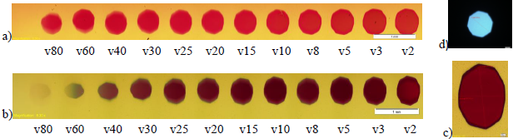
Figure 1. MIA optical microscopy images of two series of thread-like patterns containing gold nanoparticles, recorded in BF at 6.3x magnification, obtained by DLW at increasing scanning velocities from 2 to 80 μm/s from right to left at different powers: a) P1=100 W; b) P2=50 W; c) detail recorded at 12.6x magnification. d) Fluorescence optical image of the light spot focused in the sample at magnification 6.3x (557 μm).
The results presented in Figure 1 indicate that in case of the same velocity, the gold patterns color progresses from Chili Red for P1 power (Figure 1a) to a darker shade Sangria for the lower irradiation power P2 (Figure 1b). Even though the color has a uniform distribution inside the generated structure, for scanning velocity greater than 15 µm/s the color tends to decreas in intensity at the travel path end. This behavior is especially highligted in Figure 1b, where the gold patterns color changes from a darker to a ligther shade of red or even a grey color.

2.2.6 The influence of the scanning velocity and irradiation power on the local surface plasmon resonance (LSPR) absorption maxima
The absorption maxima spectroscopic investigation is one of the measurable parameters that is used to monitor the changes inside the irradiated areas. The obtained peaks are in the range of 531-604 nm and are specific to gold nanoparticles LSPR. The UV-vis absorption spectra that are presented here are recorded for the citrate:Au³⁺ concentration ratio, for similar scanning velocities, but for P1 and P2 powers, respectively (Figure 2).
a) 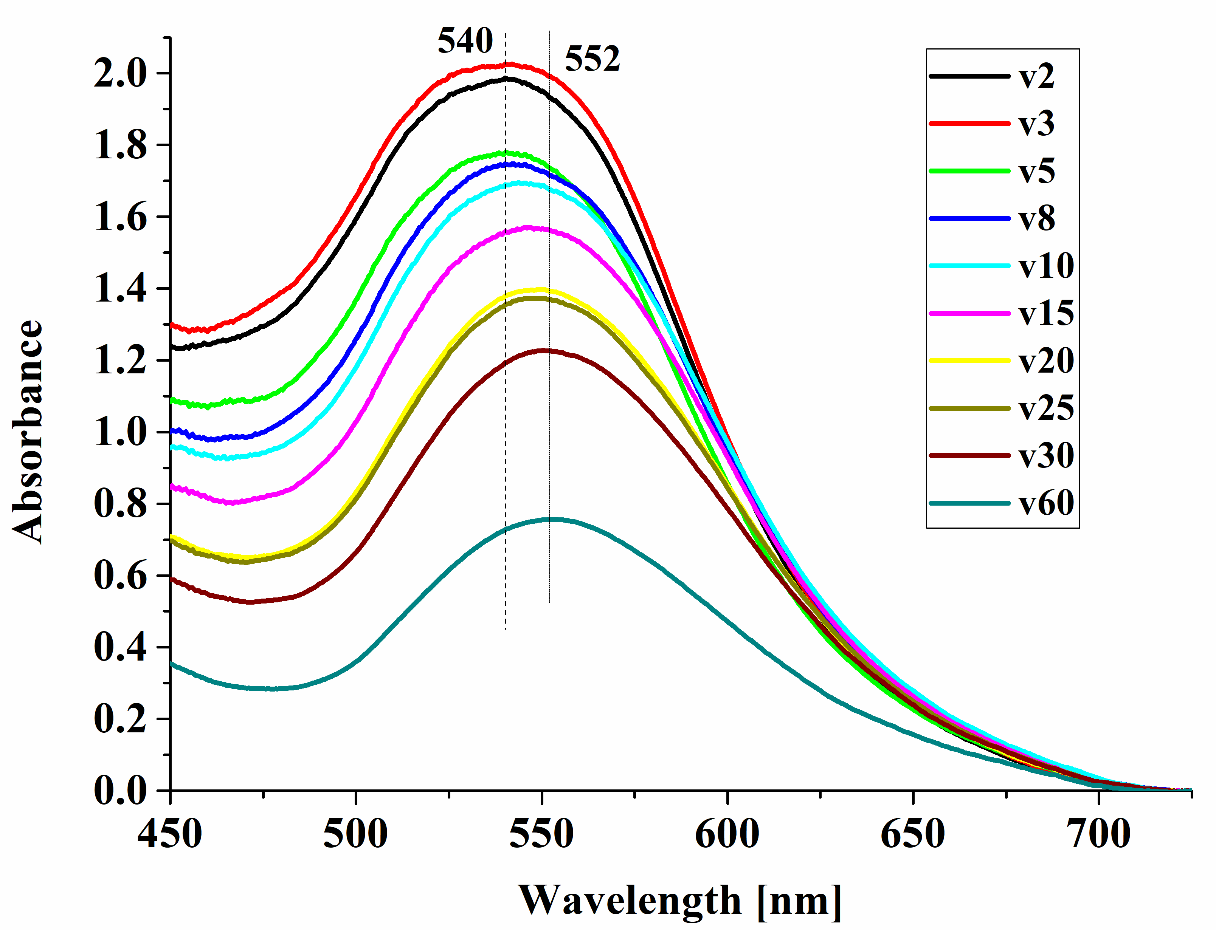 | b)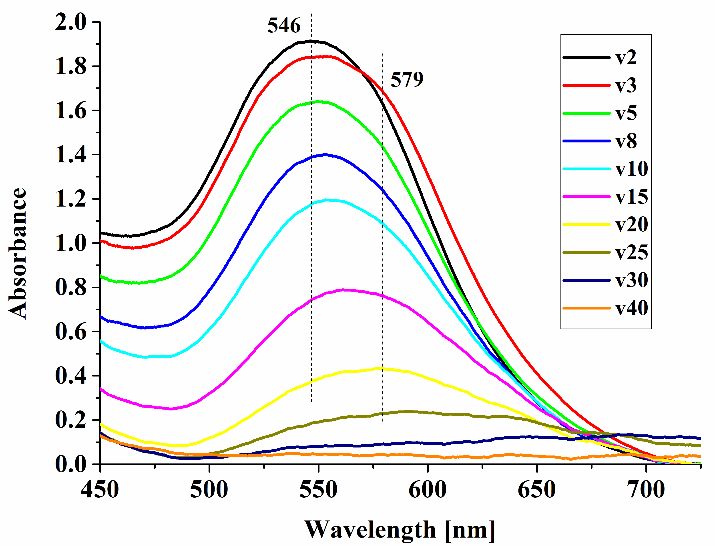
Figure 2. UV-Vis spectra recorded in thick films for two series of gold nanoparticulate patterns obtained at similar scanning velocities, citrate:gold(III) ratio c2 and 6.3x magnification but different intensities: a. 4.11e4 W/cm² (P1); b. 2.055e4 W/cm² (P2).
The results indicate that for the same citrate:Au³⁺ ratio and irradiation power, the absorption maxima gradually increase along with increasing the scanning velocity.
Also, one can see that the difference between the two powers P1 and P2 is that, for P2 higher absorption maxima are measured: 546-579 nm (for P2) compared to 540-552 nm (for P1).
The influence of scanning velocity, citrate:Au³⁺ ratio, magnification and radiation power are highlighted in Figure 3.a,b and c.
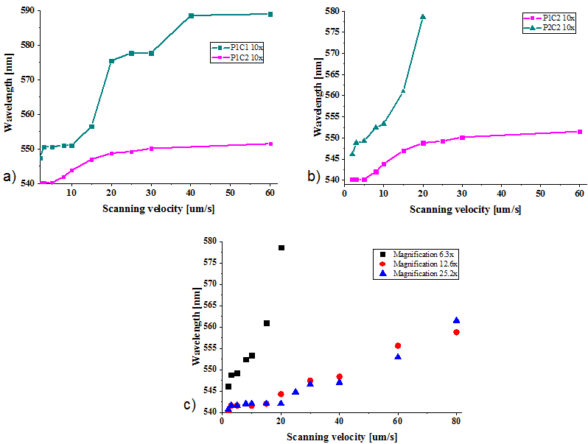
Figure 3. Dependence of the patterns absorption maxima on scanning velocity at: a) increasing citrate:gold(III) ratios (c1 and c2) at the same intensity (4.11e4 W/cm²); b) decreasing intensities (4.11e4 and 2.055 W/cm²) at the same c2 citrate:gold(III) ratio; c) increasing magniffications (6.3x, 12.6x, 25.2x) at the same power (P2) and c2 citrate:gold(III) ratio.
From Figure 3a one can observe that an increase of the scanning velocity leads to an increase in the LSPR absorption maxima. Also, maintaining the same power of 100 W, a higher citrate:Au³⁺ ratio induces a dramatic decrease of the LSPR absorption peak and, for scanning velocities that are above 20 µm/s, the presence of a “terrace” is noticeable. This behavior confirms the fact that the citrate anions play the important role of stabilizing the AuNPs against agglomeration.
The radiation intensity depends on the irradiation power or on the objective magnification. The influence of the radiation intensity on the LSPR absorption peak is highlighted in Figure 3 b and c. One can see that the decrease in the irradiation power leads to an almost exponential increase of the LSPR absorption maxima (Figure 3b) and that by increasing the magnification the absorption maxima decreases. However, a significant LSPR absorption maxima decrease of 34 nm is observed for 6.3x magnification and 12.6x magnifications, whereas a further increase to 25.2x magnification leads to insignificant absorption maxima increase.

2.3 AuNP size determination
The AuNPs size is analyzed by TEM for six samples that are prepared by the same DLW technique, so that the LSPR absorption maxima to be well spread in the studied range. In order to determine the AuNPs real diameter, a correlation between the TEM measured mean diameters from the six samples and their absorption maxima that had well distributed values in the studied range has been done. An exponential function is chosen to fit the LSPR absorption maxima as a function of the AuNP size (Figure 4).
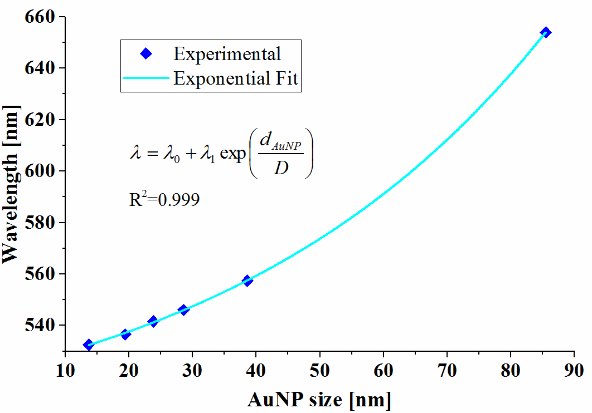
Figure 4. Correlation of the absorption maxima wavelength with the TEM measured mean diameters of DLW generated gold nanoparticles in thick films for experimental along with the fitted curve.
Knowing the localized LSPR absorption maxim values, the metallic nanoparticles diameter (d_{AuNP}) can be determined using the following equation:
 | 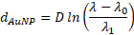 | (1)
where λ₁ (31.55), D (52.14) and λ₀ (491.36) are the fitting parameters for a correlation factor of 0.999.

2.4 Modeling the AuNP size with ANN
The three main chemical and physical process parameters that influence the LSPR absorption maxima are the citrate:Au³⁺ ratio, the scanning velocity and the radiation intensity. Thus, the ANN is constructed to have three inputs (the citrate:Au³⁺ ratio, the scanning velocity and the radiation intensity) and one output (LSPR absorption maxima).
The data set on which the ANN is based on consists of the 118 experiments that are described in subsection 2.2.
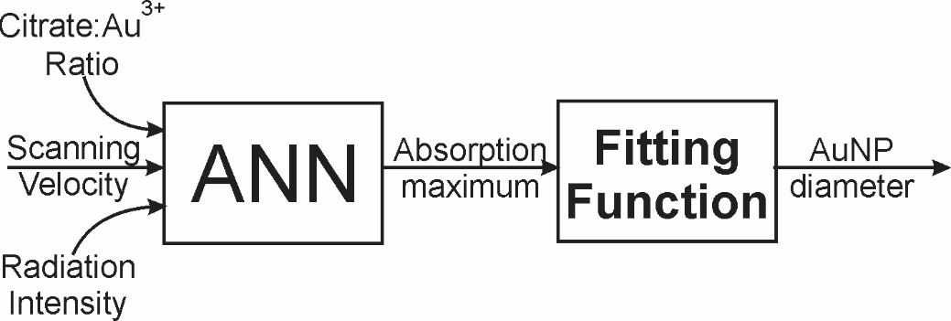
Figure 5. Schematic representations of the artificial neural network and associated fitting function
In order to design the best ANN, the LSPR absorption maxima prediction capabilities were compared for two multilayer feedforward ANN that differ in structure, having thus one hidden layer (ANN I) and two hidden layers (ANN II), respectively. Additionally, the number of neurons in the hidden layers is found by systematically testing the ANN performance. Both ANNs use the backpropagation training algorithm to compute the weights and biases and the Levenberg-Marquart learning algorithm for training the network. Also, the networks adjust their weights and biases such that to minimize the mean square error (MSE) objective function.
The performance of the two ANNs are evaluated considering the highest Pearson correlation coefficient and the lowest neural network relative error.
2.4.1 The ANN model - 2 hidden Layer

2.4.1.1 Statistical assessment of ANN model
The best designed and trained ANN has 3 neurons in the first hidden layer and 7 neurons in the second hidden layer, having a good correlation between the predicted and experimental data which is proved by the high values (R>0.95) of the Pearson correlation factor. The ANN mean and maximum relative errors along with the Pearson correlation factors for the training, validation and testing data sets are presented in Table 1.
Table 1. ANN II - The mean and maximum relative errors (in absolute value) determined for the training, validation and testing data sets
 | Mean Relative Error [%] | Maximum Relative Error [%] | Pearson Correlation Factor
Training data set | 0.2 | 1.21 | 0.992
Validation data set | 0.33 | 1.35 | 0.980
Testing data set | 0.53 | 2.62 | 0.959

The high correlation factors and the low relative errors demonstrate that the ANN predicted absorption maxima, directly connected with AuNPs diameter, is in good correlation with the experimentally measured value.

2.4.1.2 ANN model predictions
As a consequence of the high ANN performance, new values of the input parameters, that are different from those obtained in experiments, are further used to predict the AuNPs size. Specifically, the influence of the scanning velocity, radiation intensity, and citrate:Au³⁺ ratio on the AuNPs dimension is studied.
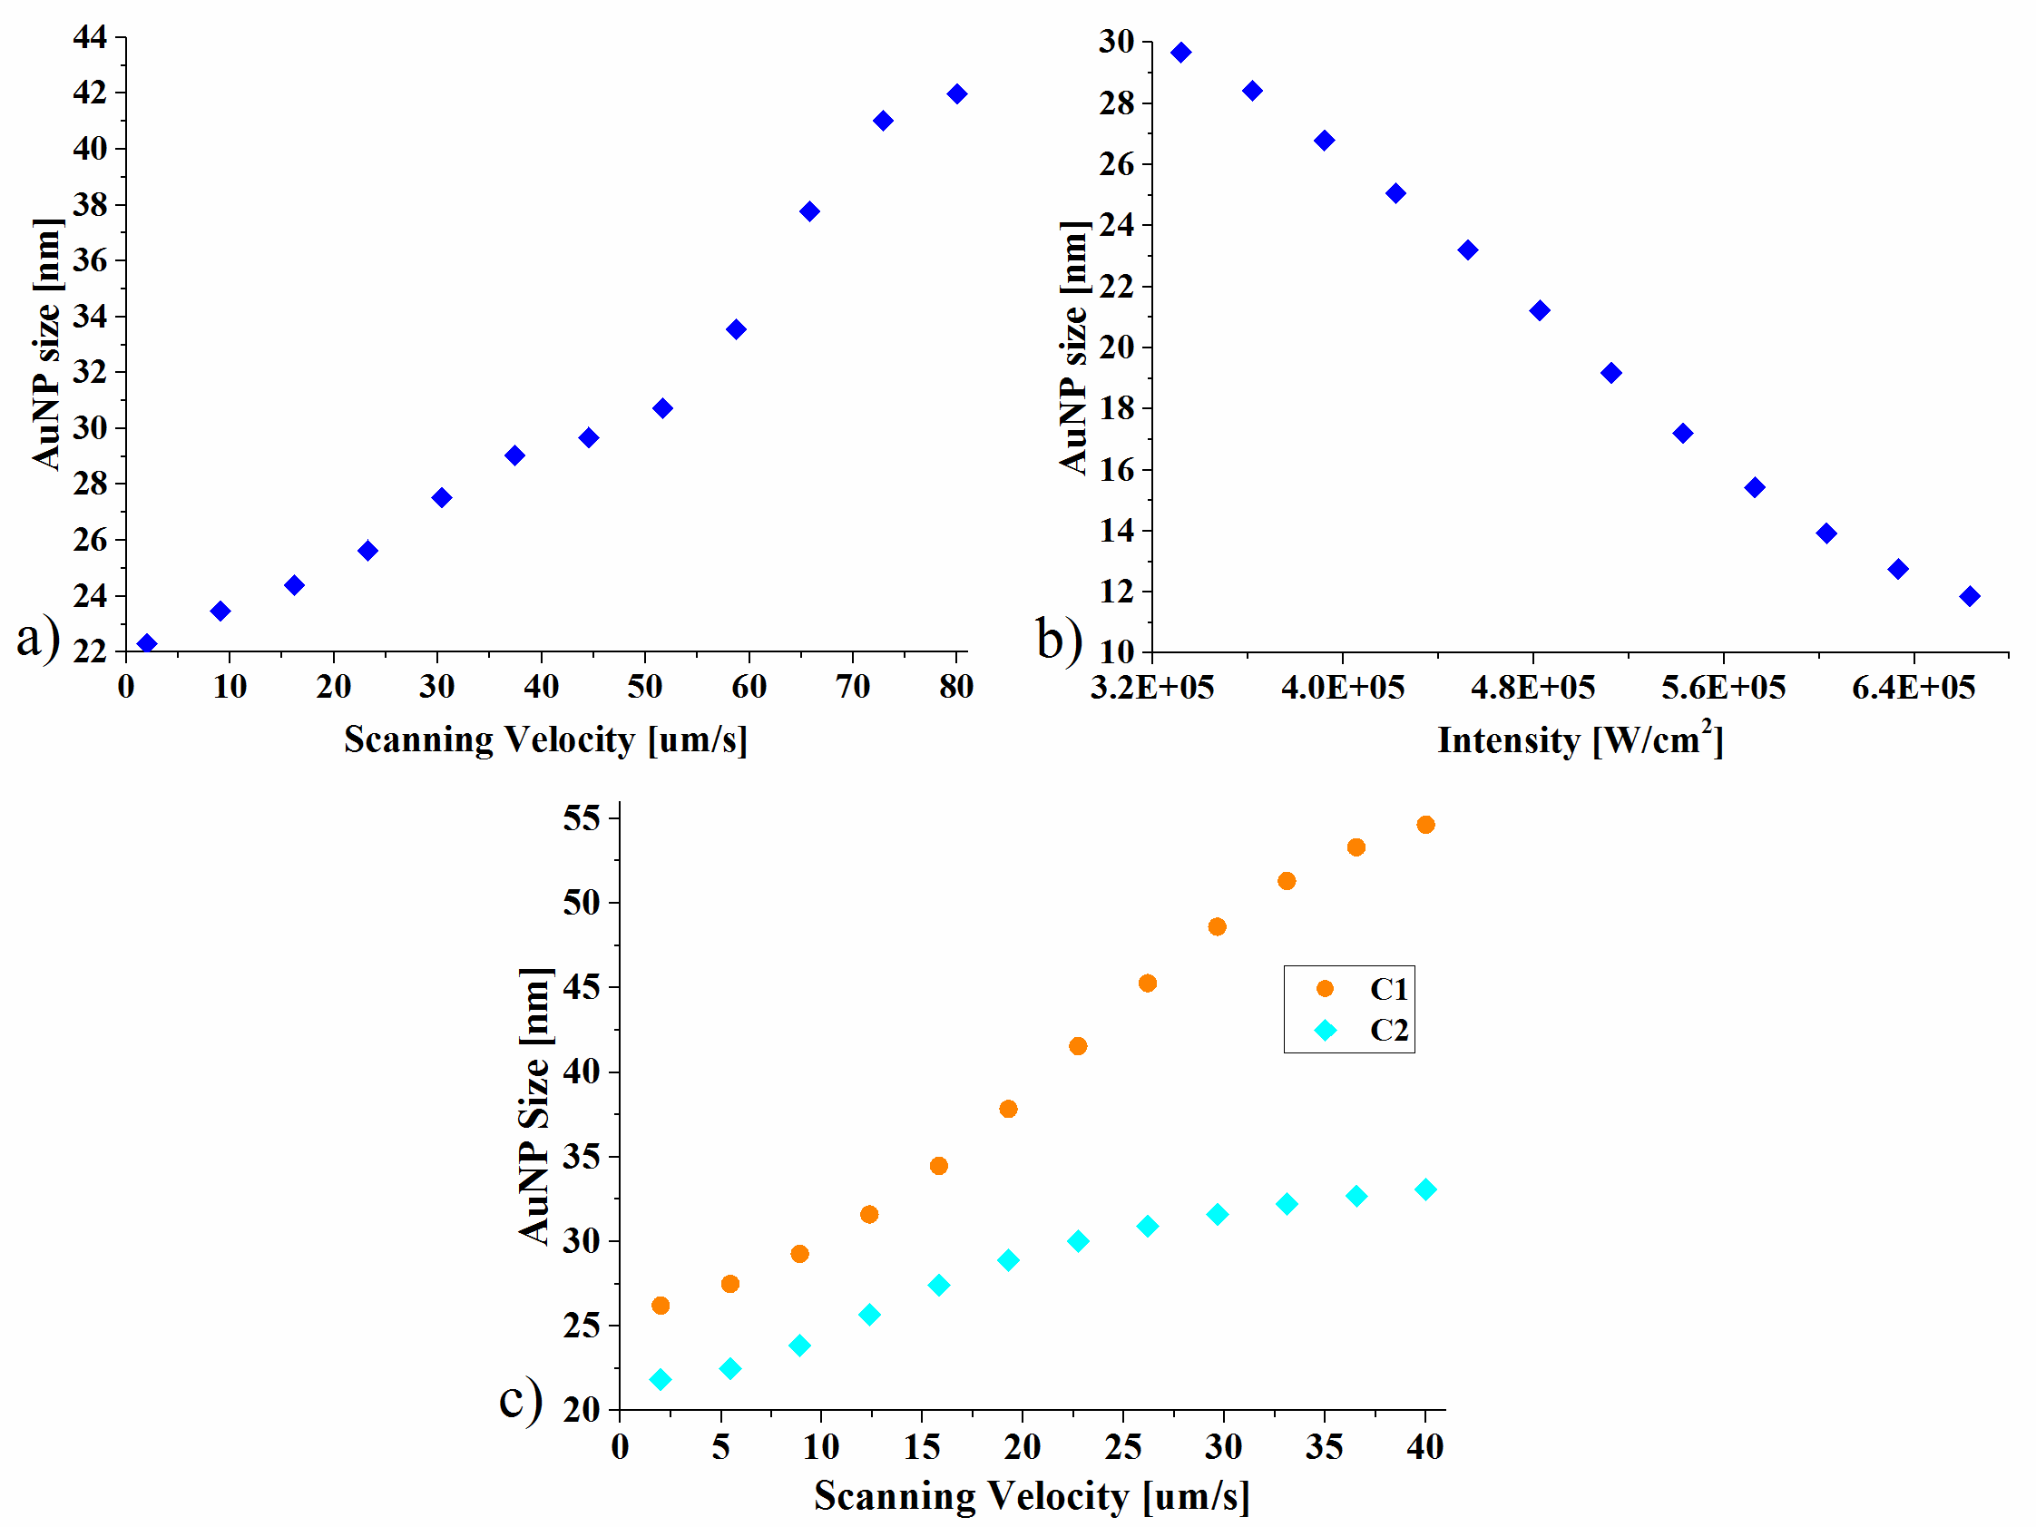
Figure 6. ANN predictions on AuNPs size showing the: a) effect of scanning velocity when ANN is simulated for c2 citrate:gold(III) ratio and an intensity of 3.419e5 W/cm2(P1), b) effect of intensity when ANN is simulated for c2 citrate:gold(III) ratio and a scanning velocity of 40 μm/s, and c) trend in AuNP size when citrate:gold(III) ratio changes (c1 and c2), both ANN predictions having an input intensity of 5e4 W/cm²

The results indicate that the AuNPs size increases with the increase of the scanning velocity, effect which is more noticeable at higher velocities. Also, higher citrate:Au³⁺ ratios lead to bigger AuNPs, implying that higher Au³⁺concentrations result in a decrease of the AuNPs dimension. This phenomenon can be explained by an increase in the colloidal stability due to the distribution of the stabilizer around the gold nanoparticle which overcomes their agglomeration [78].
Figure 6b reveals the fact that the AuNPs dimension is also strongly influenced by the radiation intensity whose increase leads to a decrease of the AuNPs size. This phenomenon can be explained by the fact that, at higher irradiation powers, the number of nucleation centers rises, thus resulting in AuNPs size reduction. The decrease of the nanoparticles dimension can also be explained considering that already formed AuNPs are excited and further subjected to an ablation process [99].
In addition to the model predictions, the trained ANN also has the ability to perform interpolations, property that is demonstrated in Figure 7.
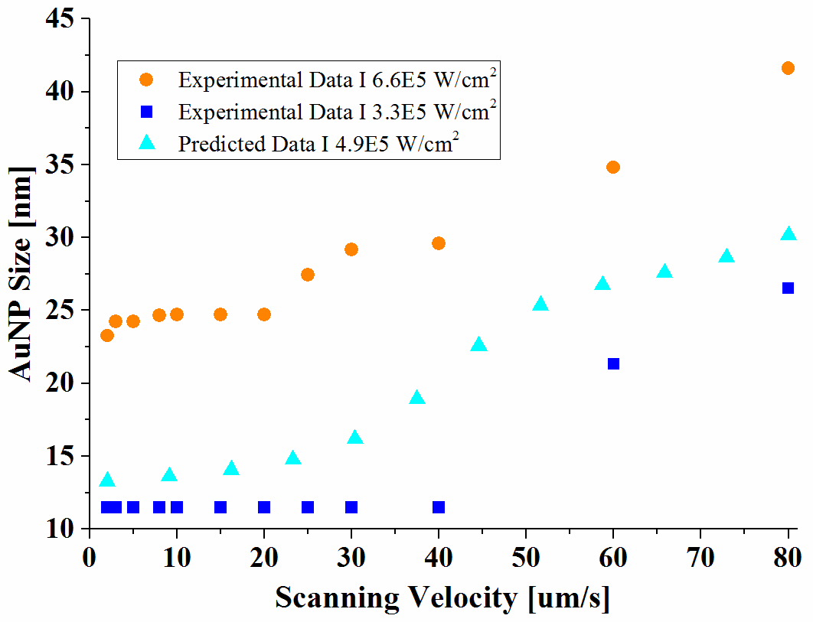
Figure 7. ANN II - predictions showing the interpolation capability of the trained ANN; the predicted data are obtained for c2 ratio and an intensity of 4.9e5 W/cm2.

2.4.2 Assessment of the input variables importance
One of the methods through which the importance of the ANN input variables can be assessed is the use of a feature selection algorithm. This approach finds the subsets of features that optimally predict the experimental data and reveals the features that significantly influence the output.
Based on this algorithm, the ANN inputs are ordered according to their importance as follows: the most influential input is the radiation intensity, followed by the scanning velocity and the citrate:Au³⁺ ratio.

2.4.3 The ANN model - 1 hidden Layer
2.4.3.1 Statistical assessment of ANN model
The best designed and trained ANN has 18 neurons in the hidden layer, having an acceptable correlation between the predicted and experimental data which is proved by the high values (R>0.9) of the Pearson correlation factor.
Table 2. ANN I - The mean and maximum relative errors (in absolute value) determined for the training, validation and testing data sets
 | Mean Relative Error [%] | Maximum Relative Error [%] | Pearson Correlation Factor
Training data set | 0.077 | 0.81 | 0.998
Validation data set | 0.93 | 3.34 | 0.919
Testing data set | 0.57 | 3.039 | 0.962

Comparing the ANN I and ANN II models, in terms of performance, one can observe that the best results are obtained for the two hidden layers ANN. Thus, for the ANN I modeling, the influence of the input parameters on the AuNPs size will not be further investigated. However, the process parameters relative impact on the AuNPs dimension is assessed in the following subsection (2.4.7).

2.4.3.2 The relative impact of each process parameter on the particle size
The relative impact of each process parameter on the particle size is evaluated by using the Garson and Goh method [94,100]. Based on this method, the relative importance (RI) of ANN input variables is determined as follows:
 | 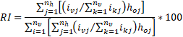 | (2),
where i_{j} is the absolute value of connection weights between the input and the hidden layers, n_{υ} and n_{h} are the number of neurons in the input and hidden layer, ho_{j} is the absolute value of connection weights between the hidden and the output layers [94,100].

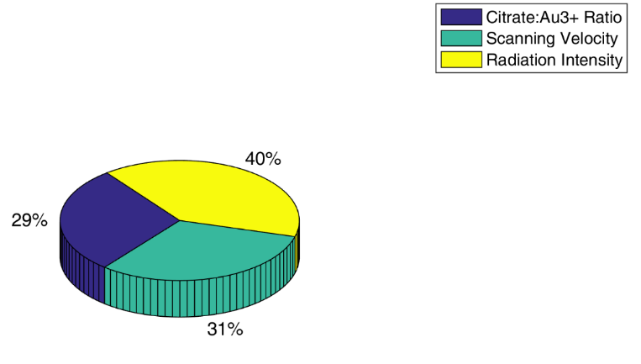
Figure 8. Pie chart showing the relative impact of each process parameter on the AuNPs size
As shown in Figure 8, the radiation intensity has a relative importance of 40%, thus being the factor that most influences the AuNPs size. The scanning velocity and the citrate:Au³⁺ ratio have a similar relative importance, the scanning velocity having a slightly higher value of 31% in comparison with the citrate:Au³⁺ ratio which has a value of 29%. These results are consistent with those obtained in subsection two, where the same hierarchy regarding the input variables influence is determined.

3. Part B - Gold Nanoparticles in laser fields: Heat Generation and Heat Transfer

3.1 Introduction
The AuNPs have the property to generate heat when irradiated with visible light, phenomenon that leads to a temperature increase both in the nanoparticle and in its surrounding medium. The electric field of the incident radiation polarizes the AuNPs conduction electrons, which generates surface charges that alternatively accumulate on opposite ends of the nanoparticle (phenomenon denoted as LSPR). Because of the NPs oscillating polarization, a restoring force results from the generated electric field that opposes the excitation field. One of the ways by which the oscillation is damped is through heat generation [26–28]. Thus, heat can be seen as an incoherent set of vibrations, which in solids is supported by phonons [27].
The AuNPs and their surrounding medium temperature are determined using both experimental and mathematical modelling methods. The few experimental methods that can estimate the AuNPs temperature are Raman spectroscopy, white light scattering spectroscopy and photoacoustic imaging.
The fact that after the AuNP irradiation the temperature increase takes place only on a nanometric scale range makes mathematical modelling the most suitable method for NP temperature determination [107]. Furthermore, non-invasive imaging techniques are limited by low sensitivity, penetration or contrast and, in addition, the temperature fields may have an inadequate dynamic mapping temporal resolution [106].
In the past several years, mathematical modelling is used to investigate various factors that influence the AuNP temperature such as the AuNP size, the laser pulse profile, temperature dependent material parameters or the existence of an interface between the AuNP and its surrounding medium. However, recent studies suggest that if laser irradiated AuNPs have the inter-particle distance less than four or five times their diameter [118] the AuNPs heat generation can have a huge enhancement due to the near-field enhancement effect which is observed at the NPs external surface. This local field enhancement is given by the sum of the incident and scattered vector fields on the same surface [121] and depends on the distance between the NPs and on the electric field polarization [122,123].
Most existing mathematical models restrict their study to only one gold nanoparticle that has water as a surrounding medium. The influence of the AuNPs distance on the heat generation is studied only in a two-dimensional geometry, model that can produce unrealistic results. Also, the AuNPs and their surrounding medium temperature dynamics is not yet studied in case of agglomerated NPs where the near-field enhancement effect is present. Moreover, there is no comparison regarding the AuNPs temperature between the models that are used to calculate the AuNP heat generation.
In this view, Part B of the thesis aims to mathematically model the temperature dynamics in a laser irradiated system that consists of many AuNPs surrounded by a polymer matrix. The influence of particle size, number and the displacement of particles in the surrounding matrix on the gold nanoparticles temperature dynamics is studied. A comparison between the large infinite system that has AuNPs dispersed in a random geometry and the one that contains only one AuNP is also performed. Furthermore, we investigated the non-perfect contact between the AuNPs and the surrounding medium as well as the near-field effects, NP orientation with respect to the electric field polarization and the influence of the distance between AuNP on the heat generation and maximum temperature. Last, but not least, the impact of the modelling approaches on the gold nanoparticles heat generation is considered.
As general features, the space/time evolution of the temperature inside the investigated systems is numerically modeled using the finite element method (FEM) which is implemented in Comsol software. Additionally, the irradiation source is considered to be a Nd:YAG nanosecond laser that has a Gaussian pulse of 12 ns at FWHM, 532 nm wavelength, a waist radius that is twice the wavelength and an intensity of 3.95E+05 W/cm².

3.2 Temperature dynamics of a system that contains one spherical AuNP embedded in a polymer (PSS) matrix – the influence of AuNP size

3.2.1 Methods
In this subsection, the space-time temperature evolution in a laser irradiated system (denoted as System I) that contains a spherical AuNP embedded in a polymer polystyrene sulfonic acid (PSS) matrix is determined. The influence of the AuNP size is investigated for particles that have a radius (r_{AuNP}) of 10, 15 and 20 nm, whereas the entire system has a radius (Rs) of 380 nm in all three cases. It can be observed that this system has a spherical symmetry so, for solving the model, a 2D Axysimetry geometry along with the Heat Transfer in solids module is chosen. The heat transfer equations that describe this system are:
 | , [W/m³] | (3),
inside the NP, and
 | , [W/m³] | (4),
in the surrounding medium. Here ρ is density, Cp is specific heat, k is thermal conductivity, T/(⁰C) is the temperature and Q/(W/m³) is the heat generated by the AuNP. The AuNP and PSS subscripts refer to the gold nanoparticle and the polystyrene sulfonic matrix.
The heat generated by the AuNP is modeled in Comsol software as a heat source and it is determined based on the following equation:
 | , [W/m³] | (5),
where K_{abs} is the absorption efficiency, I/(W cm⁻²) is the laser intensity, r_{AuNP}/(m) is the nanoparticle radius and f(t) is the laser pulse time profile and is described by a Gaussian:

 | 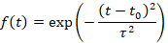 | (6),
where τ=12 ns FWHM is the Gaussian pulse duration and t₀ is the position of the center of the peak.
It is assumed that both the AuNP and its surrounding matrix have an initial temperature of 293.15 K. Regarding the boundary conditions, it is assumed that the system is isolated and, at the AuNP surface, there is a continuity of heat flux and temperature.

3.2.2 Results and discussions
A laser intensity of 3.95e05 W/cm² is chosen based on a parametric scan, performed for all three AuNP dimensions. This value is selected such that, in case of all three simulations, the matrix maximum temperature is below 100 ⁰C.

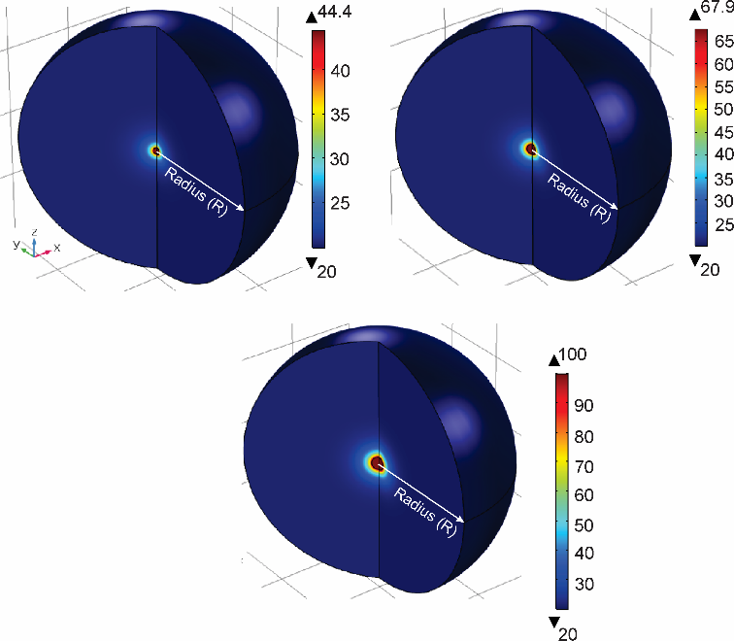
Figure 9. System I temperature at 19 ns and 3.95×10⁵ W/cm² intensity for a) 20 nm AuNP b) 30 nm AuNP and c) 40 nm AuNP
The results confirm that the heat generated by the AuNP remains in its proximity. Also, it is demonstrated that an increase of the AuNP diameter determines a rise of the AuNP temperature, a rise of heated surrounding medium volume, and, implicitly, the rise of the entire system temperature. The NP temperature rise determines an increase in the necessary time to reach the systems thermal equilibrium.
These effects are correlated to both an increase in the spherical NP generation of heat and a decrease in the heat diffusion volume.

3.3 Temperature dynamics of a system that contains an ensemble of spherical AuNPs embedded in a polymer (PSS) matrix – the influence of the AuNP distribution
Most articles that deal with the heating of metallic NPs due to laser irradiation consider a system similar to the one described in subsection 3.2. However, in large (infinite) systems the cumulative effects and the configurations in which the AuNP can occur may be important parameters that are worth studying.
The aim of this subsection is to mathematically model the temperature evolution in time and space in a system (denoted System II) that consists of an ensemble of AuNPs that are embedded in a PSS matrix.

3.3.1 Methods
To demonstrate the influence of AuNPs distribution on the system’s temperature, 100 spherical AuNPs are arranged in four distributions inside a cuboid polymer matrix that has a width and length of 200 nm and a height of 1000 nm. The four distributions are denoted array distribution, concentric distribution, radial distribution and random distribution.
The temperature dynamics in System II is modeled using Equations 3 and 4. As initial conditions it is assumed that both the AuNP and its surrounding matrix have an initial temperature of 293.15 K. The infinite system is simulated due to imposing periodic boundary conditions at the cuboids lateral limits. Moreover, at the top and bottom of the cuboid it is assumed that the system is isolated and, at the AuNP surface, there is a continuity of heat flux and temperature.

3.3.2 Results and discussions
For all four distributions, the point that has the maximum temperature along with its associated moment in time are presented in Table 3.
Table 3. System II – the point in space and the moment in time in which the maximum temperature is reached
 | Point (x,y,z) [nm] | Maximum Temperature [⁰C] | Time [ns]
Array distribution | In each NP from layer 2 situated at 70 nm on z direction | 120.5 | 27
Radial distribution | Pt1 (100, 109.23, 73.82) | 163.4 | 23
Concentric distribution | Pt2 (100, 109.23, 73.82) | 151.35 | 25
Random distribution | Pt3 (116.07, 105.58, 122.61) | 138.85 | 24

This comparative analysis reveals the fact that the radial geometry hast the highest maximum temperature and this value is greater than the one in the concentric, random and array distribution with 12 degrees, 24 degrees and 42.8 degrees, respectively. These results are also confirmed in Figure 10, where additionally one can see that the highest temperatures are detected in areas where the spherical NPs are most agglomerated (the central area in case of the radial and concentric distribution).
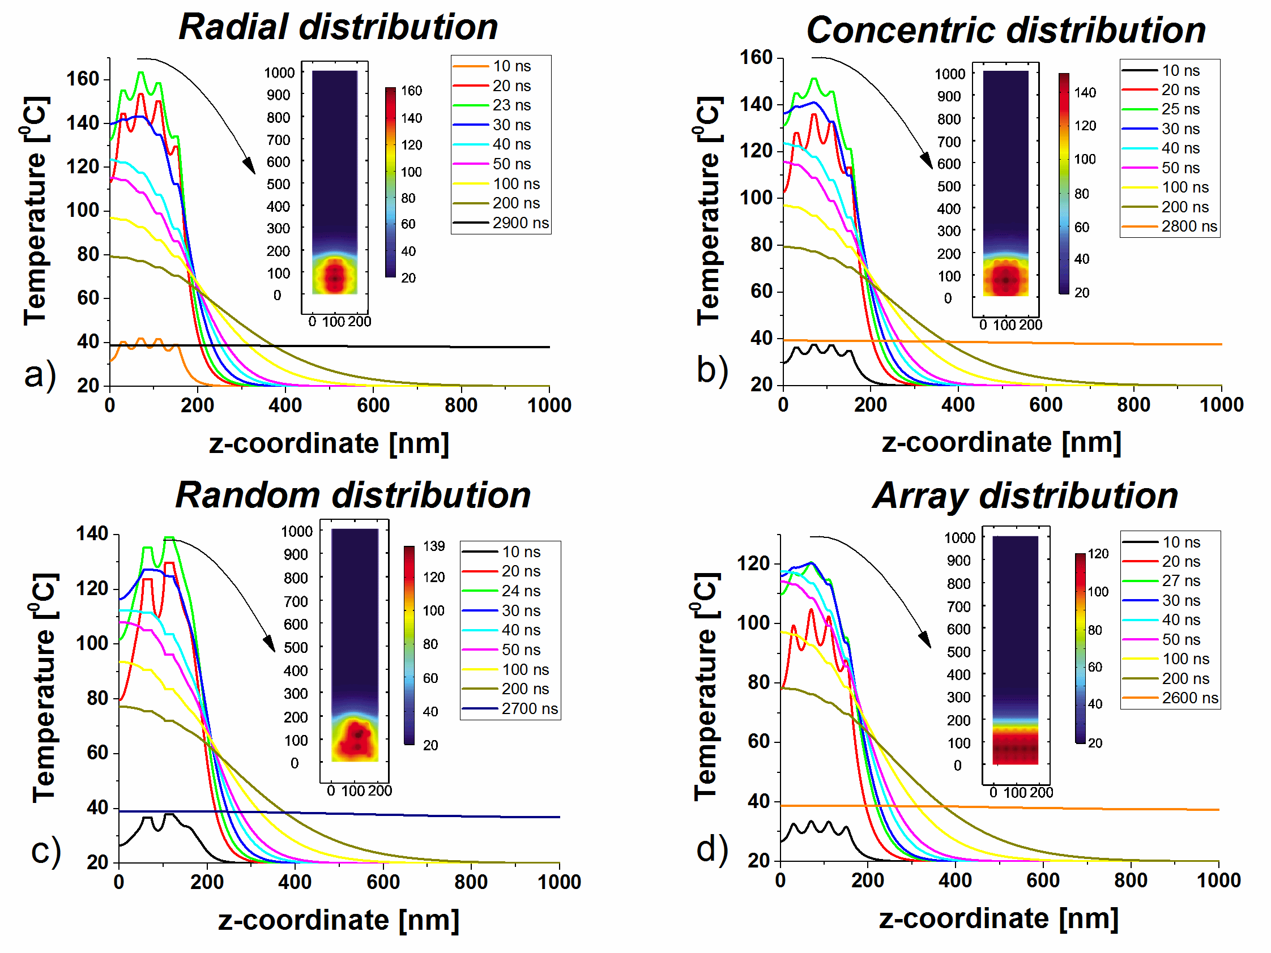
Figure 10. System II – Temperature variation with x and z coordinate at different moments in time for: a) array distribution, b) radial distribution, c) concentric distribution, d) random distribution.
Besides the fact that the AuNP distribution influences the system’s temperature, it also influences the necessary time to reach the thermal equilibrium. The shortest time is 2600 ns and is achieved in case of the array distribution. The random distribution reaches the thermal equilibrium in 2700 ns, followed by the concentric distribution with 2800 ns and finally by the radial distribution with 2900 ns.
The different arrangements of the NPs in the polymer matrix play a significant role in the temperature distribution and in the dynamics of the system towards reaching thermal equilibrium. The more agglomerated the AuNPs are the higher the temperature near that area and the longer the time to reach the thermal equilibrium.
To emphasize the importance of simulating a large system that reflects a real AuNP distribution rather than limiting to only one AuNP, the comparison between System I and System II (the random distribution) is presented in Figure 11.
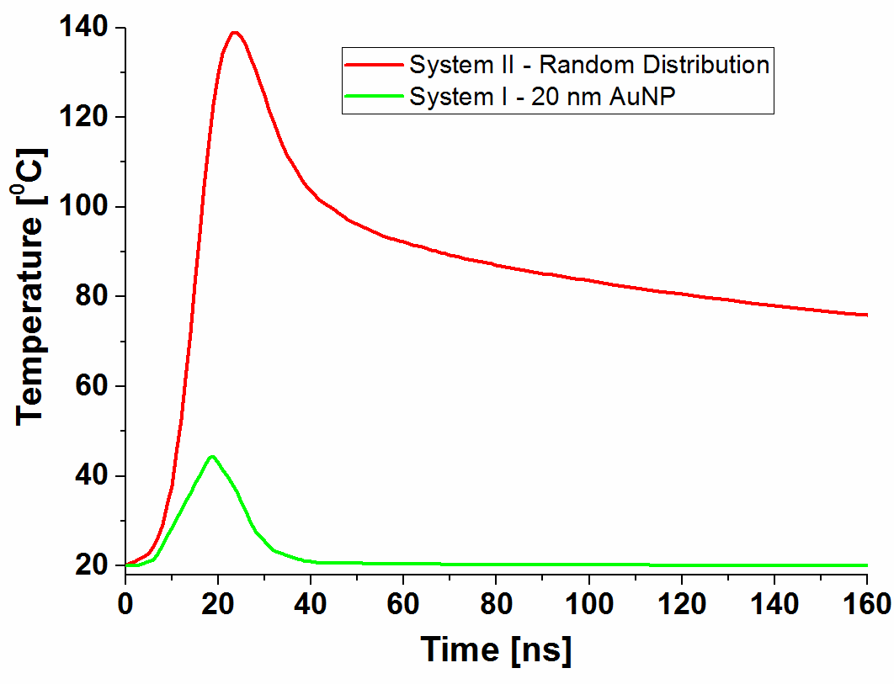
Figure 11. Temperature evolution in time in case of System I (in the center of the AuNP) and System II (the center of the AuNP that has the highest temperature)
This comparative study highlights the fact that the collective effects that are present in the infinite system are responsible for higher temperatures that are reached in longer periods of time (the difference between the two systems is 44.5 ⁰C). Additionally, a significant difference when comparing the necessary time to reach the thermal equilibrium is observed: the random distribution needs 2700 ns to reach the thermal equilibrium, whereas the single AuNP only needs 109 ns.

3.4 Temperature dynamics of a system that contains an ensemble of spherical AuNPs embedded in a polymer (PSS) matrix – the influence of the interfacial thermal conductance

3.4.1 Methods
The thermal property mismatch between two different materials leads to an interfacial resistance known as the Kapitza resistance. In case of the heat transfer between the two materials, the material interface is characterized by an interface thermal conductance (G) that has to be taken into account only if G is much smaller than a critical interface thermal conductance (G_{c}) [120].
 | 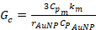 , [Wm⁻²K⁻¹] | (7),
where C_{pm} and C_{pAuNP} are the heat capacities of medium and the AuNP, respectively, k_{m} is the medium conductivity and r_{AuNP} is the AuNP radius.
Using Equation 7, the critical interface thermal conductance of 165 MW/m²K is calculated in case of a 20 nm AuNP immersed in an aqueous PSS solution. Comparing this value with the interface thermal conductance of 105 MW/m²K [112] it is observed that G_{c} is not much higher than G, the difference being of 60 MW/m²K. However, due to the fact that the interface thermal conductance can have a significant impact on the NPs thermal decay, the aim of this subsection is to determine the temperature evolution in time and space in a large system that consists of AuNPs embedded in an aqueous PSS matrix when the interface thermal conductance is considered.
The spherical AuNPs of 20 nm diameter are modeled as heat sources and their heat generation is calculated using Equation 5. Equation 3 and Equation 4 describe the heat transfer equations for System II, whereas at the boundary between the AuNP and the polymer matrix, a thermal contact boundary condition with a gap conductance of 105 MW/(m²K) [112] is imposed.

3.4.2 Results and discussions
For better understanding the influence of the interfacial thermal conductance on the system’s temperature, we performed a comparison between the four AuNP distributions in which G is not considered (Simulation 1) and this last case in which the interface thermal conductance is used as a boundary condition at the interface between the AuNP and the polymer matrix (Simulation 2).
Array Distribution  a)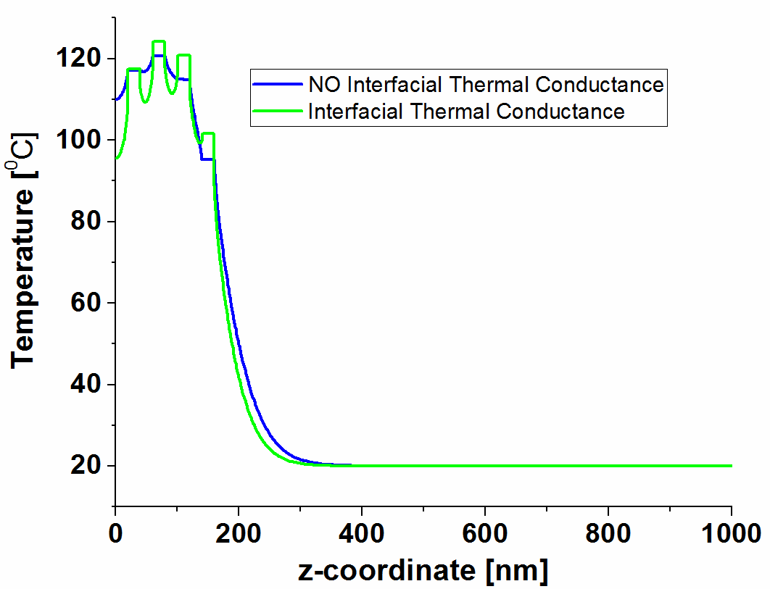 | Radial Distribution  b)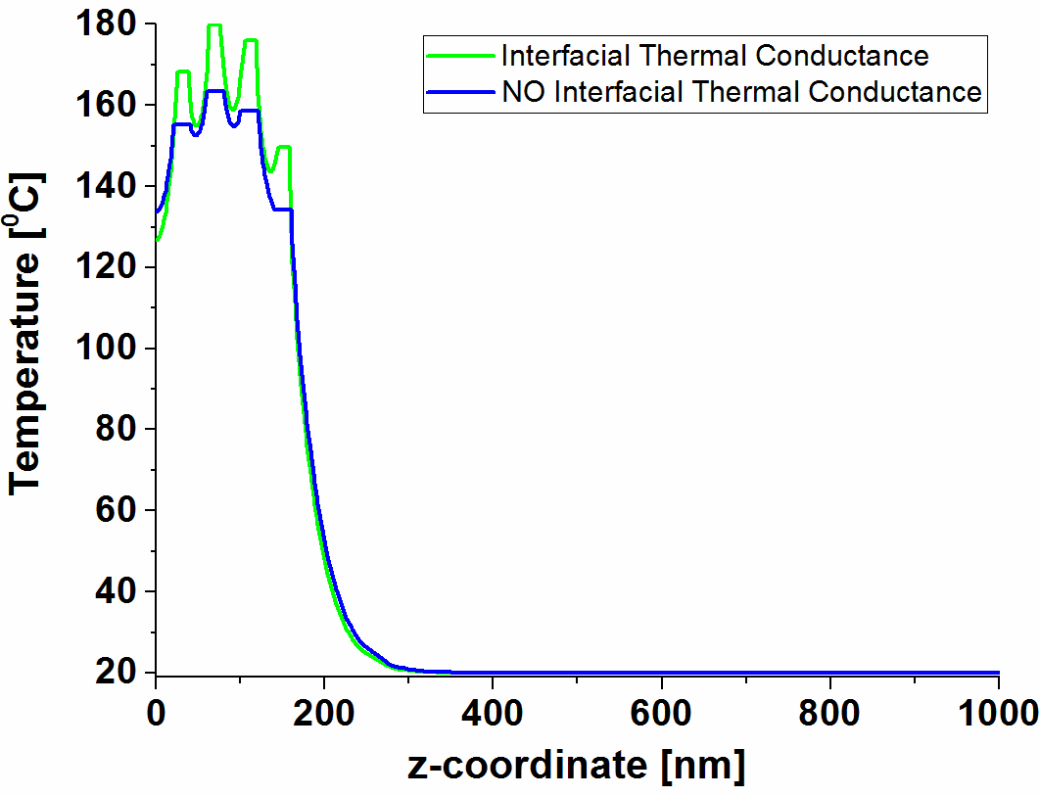
Concentric Distribution  c)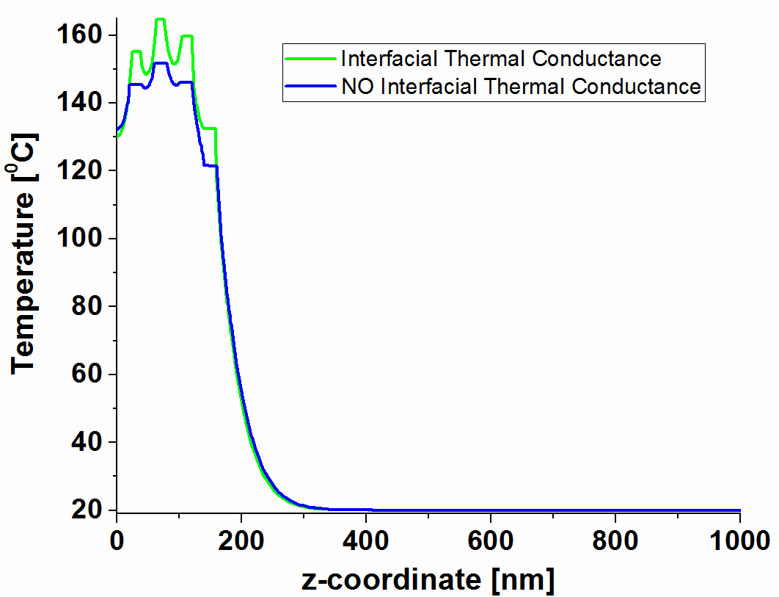 | Random Distribution  d)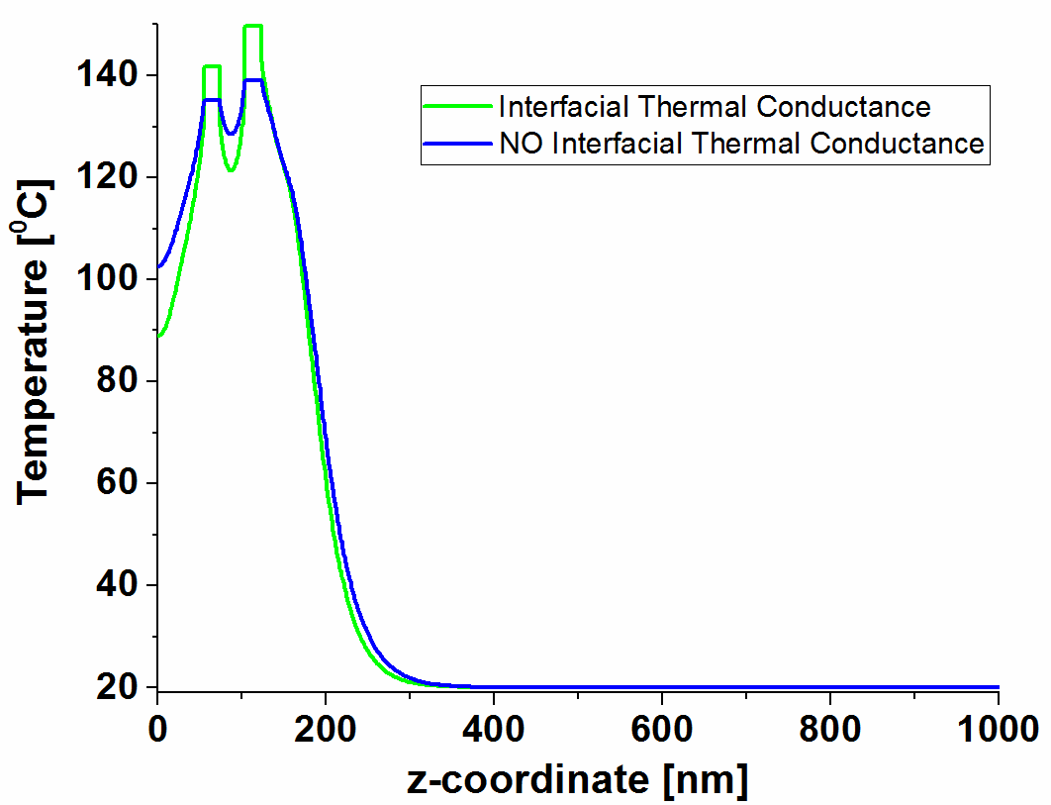
Figure 12. Temperature variation with z coordinate at the time when the system reaches its maximum temperature - Comparison between the Simulation I and Simulation II for: a) array distribution b) radial distribution, c) concentric distribution, d) random distribution

The results indicate that the simulations that consider the interface thermal conductance reach higher temperatures mainly in the AuNPs. The temperature differences for the four distributions are: i) 4.2 ⁰C for the array distribution, ii) 10.85 ⁰C for the random distribution, iii) 13.27 ⁰C for the concentric distribution and iiii) 16.1 ⁰C for the radial distribution. The time needed to reach the AuNP maximum temperature suffers practically no modification (a slight decrease - 1 ns drop) in the simulations that consider the interfacial thermal conductance.

3.5 Near field effects and temperature dynamics of laser irradiated gold nanoparticles
3.5.1 AuNPs in a cross-type geometry - 2D model
3.5.1.1 Methods
In this subsection the heat accumulated by the metal NPs due to near-field interactions along with the system’s temperature evolution in time and space is investigated.
The laser irradiated system consists of nine spherical AuNPs that have a radius of 10 nm, are arranged in a cross-type geometry with 40 nm distance (D) between each two AuNPs and have a sufficiently large amount of water as a surrounding medium. The cross-type geometry was chosen having in mind the possible electric field effects along the propagation direction as well as along the polarization direction of the laser field.
The electric field enhancement effect, the heat generated by the irradiated AuNPs and the system’s time and space temperature evolution are modeled in a two-dimensional geometry. The system’s near-field interactions and the AuNPs heat generation are modeled using the “Wave Frequency Domain” module (Simulation I), whereas the temperature dynamics is modeled in the “Time Dependent Heat Transfer in Solids” module (Simulation II).
The wave equation is given by:
(8)
(9),
where E is the electric field that is polarized in x direction, k₀ is the wavenumber (k₀=2πn_{H2O}/λ₀), n and k are the real and imaginary parts of the refractive index and are obtained from Johnson and Christy for AuNPs [128] and from Hale and Querry for water [129].
The heat generated by the AuNPs is equal to the total power dissipation energy (Q_{t}) which is given by:
 | , [W/m³] | (10),
where Q_{ml} are the magnetic losses (Q_{ml} = 0), J/[A/m²] is the current density and E*/[V/m] is the complex conjugate of the electric field vector.
The temperature dynamics model consists of solving the following equations:
 | , [W/m³] | (11)
 | , [W/m³] | (12)
where ρ is density, Cp is specific heat, k is thermal conductivity, T/(⁰C) is the temperature, τ=12 ns FWHM is the Gaussian pulse duration and t₀ is the position of the center of the peak.

3.5.1.2. Results and discussions
The results indicate that the AuNPs layout with respect to both the polarization of the electric field and the beam propagation direction plays an important role in establishing the propagated field and the heat generation. The AuNPs that are aligned with the polarization of the electric field exhibit a strong electric field enhancement at the AuNPs surface and in its proximity. However, in case of the y oriented AuNPs, an electric field decrease is observed. Regarding the central AuNP, even though we expect it to have the highest electric field, this particle has a slightly diminished value, due to the interactions with the y chain of AuNPs.
The metallic particles heat generation and thus the system’s temperature are determined based on the electric field enhancement that is developed on the AuNPs surface. The influence of the near-field interactions on the AuNPs heat can be observed in Figure 13.
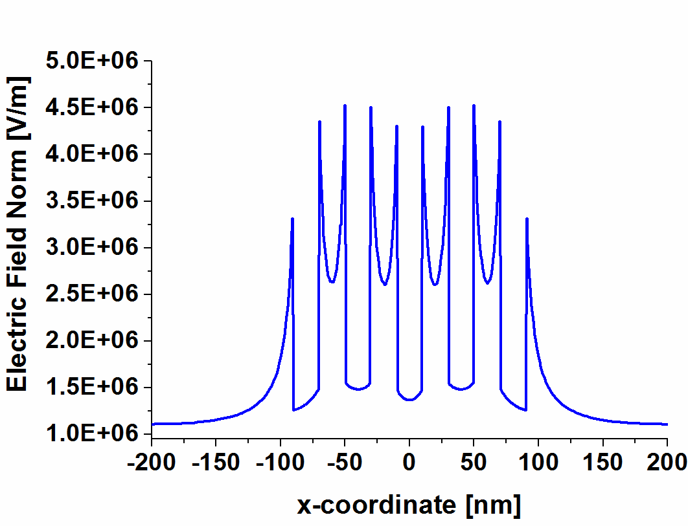 | 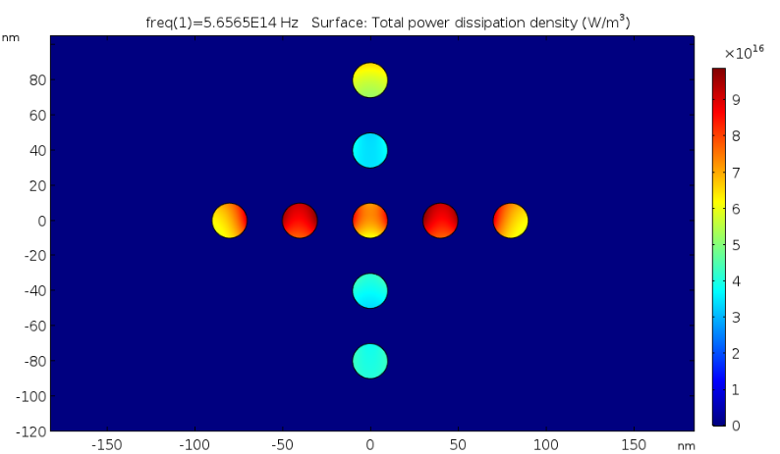
Figure 13. a) Electric field distribution in the y=0 along the x coordinate; b) Zoom-in of the calculated AuNPs heat generation for the laser irradiated system
Based on the calculated AuNPs heat generation, the system’s temperature in space and time is modeled. Figure 14 shows that even though the heat generated by the center AuNP is lower than that of its x chain neighbouring particles, only for the first 1-5 ns interval its temperature has lower values. In fact, its temperature gradually grows until 20 ns when it reaches 38.7 ⁰C (Figure 14).

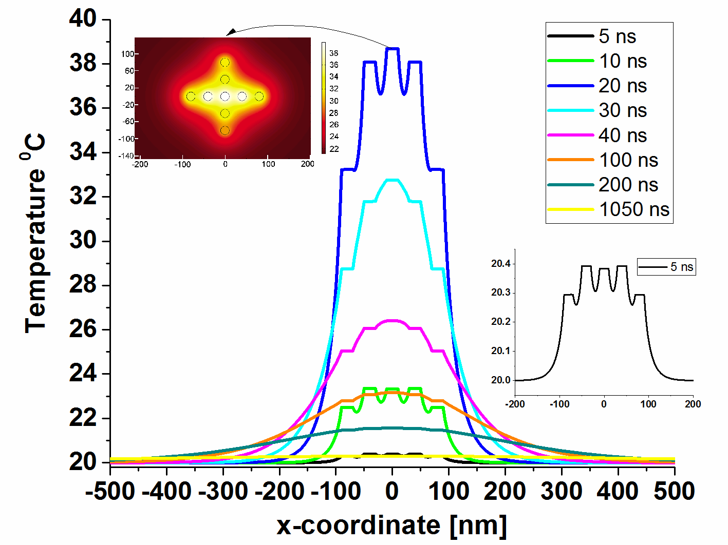
Figure 14. Temperature variation with time and x coordinate at an intensity of 3.95E05 W/cm²
It can also be seen that the water is significantly heated near the AuNPs, on a radius of 400 nm and that the system reaches the thermal equilibrium after 1050 ns.

3.5.2 3D Model - The influence of near field interactions on the AuNP temperature

3.5.2.1 Methods
The influence of the AuNPs distance on the electric field enhancement and its impact on the system temperature is studied for a three-dimensional geometry that consists of water embedded 20 nm spherical AuNPs. The following three systems are studied: 1) the first system (System III) has three AuNPs that are arranged along the beam polarization 2) the second system (System IV) has three AuNPs that are arranged perpendicular to the beam polarization and 3) the third system (System V) contains nine spherical AuNPs that are arranged in the xz plane in a cross-type geometry.
Regarding the AuNPs heat generation, the same equation (Equation 10) as in the 2D model is used. As initial condition a zero electric field is chosen and a PML that absorbs all the radiative waves with small reflections is chosen as a boundary condition.
Equations 11 and 12 that describe the system’s temperature dynamics (AuNPs temperature increase and its transfer through conduction to the surrounding medium) are also applied for the 3D model. In terms of initial and boundary conditions, the model assumes that the system has an initial temperature of 20 ⁰C, at the exterior boundary the system is isolated and, at the AuNP surface there is a continuity of heat flux and temperature.

3.5.2.2 Results and discussion

3.5.2.2.1 Influence of AuNP distance for 3 AuNPs embedded in water
For the case in which the AuNP chain is oriented along the electric field polarization, the results are presented in Figure 15. It is demonstrated that the highest generated heat and, therefore, the highest temperature is reached in the center AuNP, when the distance between the NPs centers is 1.25 times higher than their diameter. The AuNP heat decreases with the increase of the distance between the NPs, and reaches a similar heat when the distance is greater than four times their diameter. On the other hand, when the distance is smaller than 1.25 their diameter, due to the shielding effects, the AuNPs heat drastically decreases. In respect to the AuNP temperature, we mention that it follows the same trend as the heat generation.
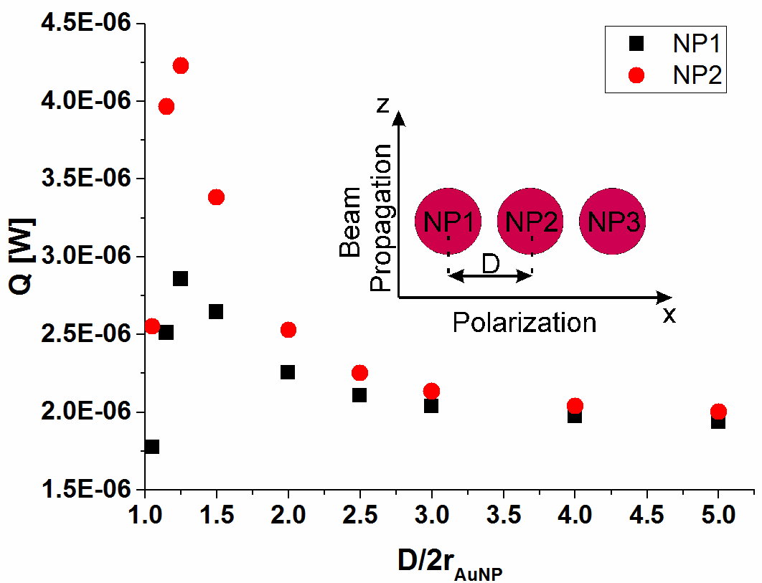 | 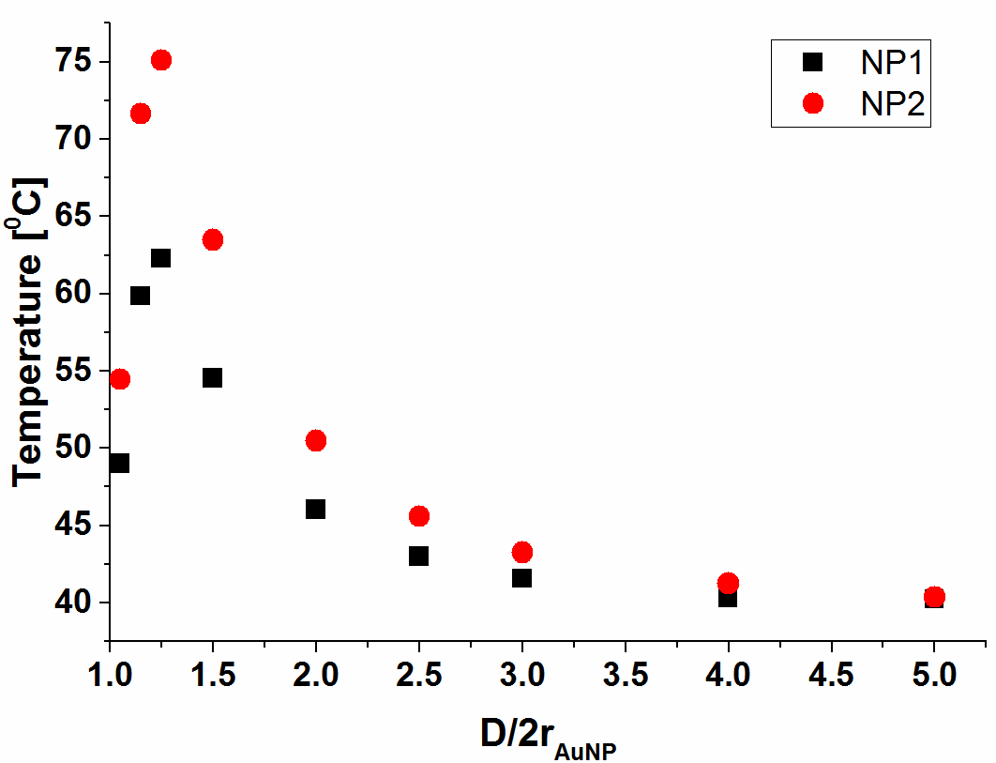
Figure 15. System III a) The influence of the D/d_{AuNP} ratio on the AuNP heat generation and b) The influence of the D/d_{AuNP} ratio on the AuNP maximum temperature
In the system that has the AuNP chain oriented perpendicular to the electric field polarization (Figure 16), the highest generated heat develops in the first particle situated in the direction of beam propagation. Also, for all AuNP distances, the center AuNP has the lowest heat generation values. Furthermore, the heat generation for all three particles increases with the NP distance increase, having a more pronounced rise for NP distances that range between 1 and 1.5 times the NP diameter. For this AuNP arrangement, the temperature increase does not follow the heat generation trend. For all three NPs, the temperature increases until distances that are 1.5 times the AuNPs diameter, whereas for greater NP distances, the metallic NP temperature decreases. Also, the center AuNP and the one that is firstly situated in the beam propagation direction have similar temperatures.
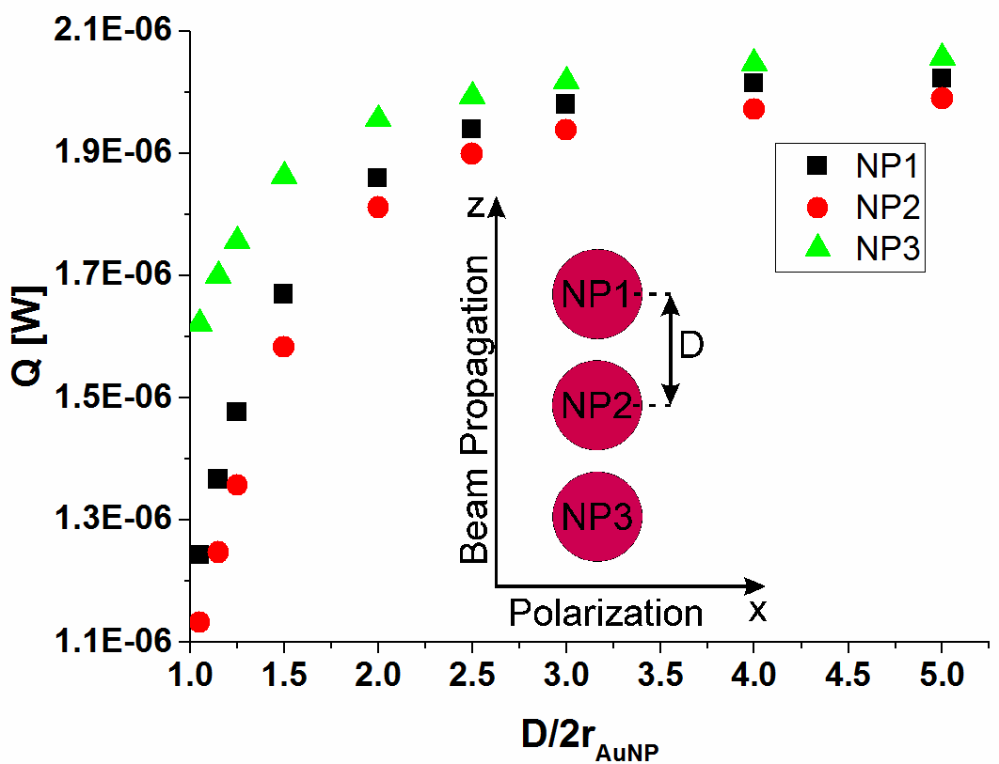 | 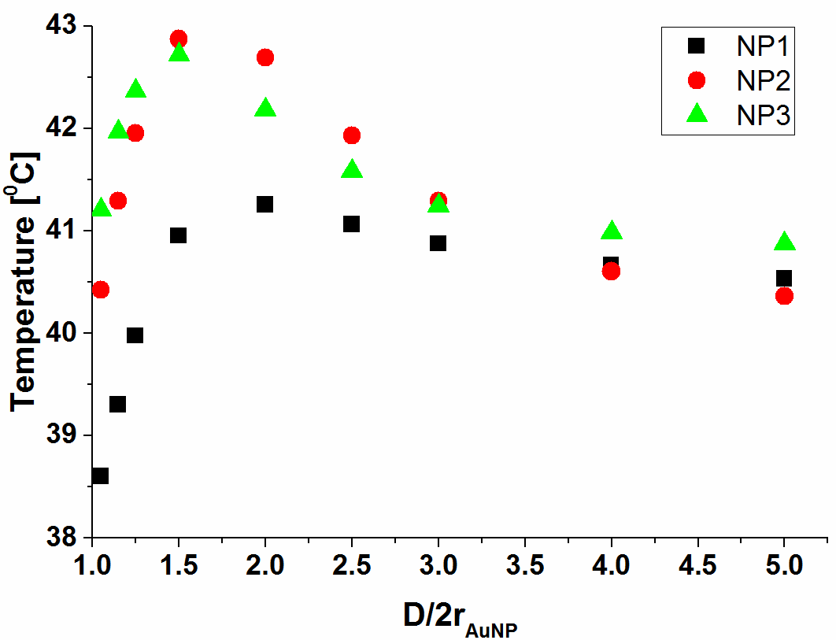
Figure 16. System IV - a) The influence of the D/d_{AuNP} ratio on the AuNP heat generation and b) The influence of D/d_{AuNP} ratio on the AuNP temperature
In terms of the AuNP maximum temperature, the AuNPs oriented parallel to the electric field polarization have higher temperatures than those oriented perpendicular to the electric field polarization. Therefore, we may conclude that the electric field polarization has a significant influence on the AuNPs temperature.
Regarding the cross-type geometry (Figure 17), the AuNP heat generation has a steep growth until the AuNP distance is equal to 1.5 times the NP diameter. For greater distances, the heat generation diminishes until the AuNPs distance reaches a value of four times their diameter. This is the distance from which the near-field interactions and the shielding effects no longer influence the generated heat and consequently the AuNP temperature.
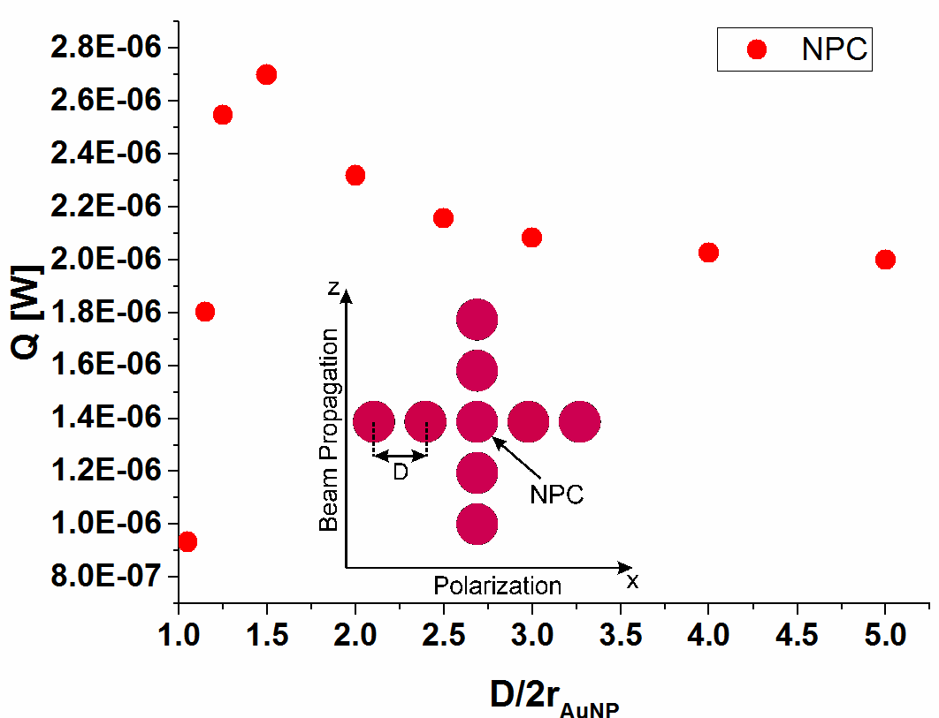 | 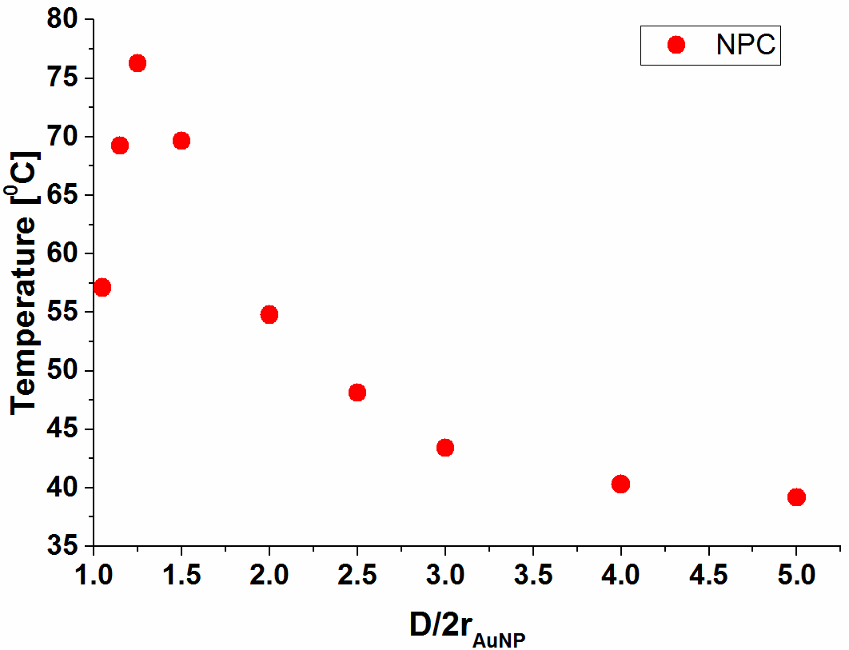
Figure 17. System 5 - a) The influence of the D/d_{AuNP} ratio on the AuNP heat generation and b) The influence of the D/d_{AuNP} ratio on the AuNP temperature

In conclusion, depending on the AuNP distance, the NPs heat generation is influenced by the shielding effects and near-field effects. In addition to these effects, the AuNPs maximum temperature is also influenced by geometry effects.

3.5.3 The influence of AuNPs distance on the AuNP heat generation and their maximum temperature. Comparison between two modelling approaches.
3.5.3.1 Methods
The two generally used models that tackle the AuNPs heat generation are: i) a model in which the near-field interactions are considered (model A) and ii) a model that determines the AuNP heat generation based on the absorption efficiency (model B).
In this subsection, for System III, System IV and System V, the results regarding the AuNPs heat generation and temperature dynamics modeled which are obtained based on model A, are compared with the results obtained by using model B. In order to compare the results obtained for the two models the same geometry, laser parameters, heat transfer equation and the same initial and boundary conditions are used for both approaches.
The difference between the two models consists of the heat transfer calculation. Model A solves the wave equation for a homogeneous dielectric and assumes that the generated AuNP heat is proportional to the real part of the product between the current density and the electric field complex conjugate (Equation 13). Model B assumes that the generated AuNP heat is only proportional to the absorption efficiency and the laser intensity (Equation 14).
Model  A | , [W/m³] | (13)
where J/Am⁻² is the current density, E* is the complex conjugate, t/[s] is time, t0/[s] is the Position of the center of the pulse peak and τ/[s] is the Gaussian pulse duration.
Model  B | 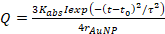 , [W/m³] | (14)
where K_{abs} is the absorption efficiency, I/[W/m²] is the intensity and r_{AuNP}/[m] is the gold nanoparticle radius.

3.5.3.2 Results and discussion
The impact of the two modelling approaches on the AuNP maximum temperature is studied for various AuNPs distances, considering the cross-type AuNPs arrangement. The differences between the two models are presented only for the center AuNP, this case being the one that most closely resembles to the displacement of particles in a real system. The two models have almost identical maximum temperatures only for AuNP distances that are greater than three times the particle diameter. In an aqueous AuNP solutions this AuNP distance corresponds to a concentration of 3.7e16 particles/m³. Therefore, the model that takes into account the absorption cross section is valid only for aqueous AuNP solutions that have a AuNP concentration greater than 3.7e16 particles/m³.
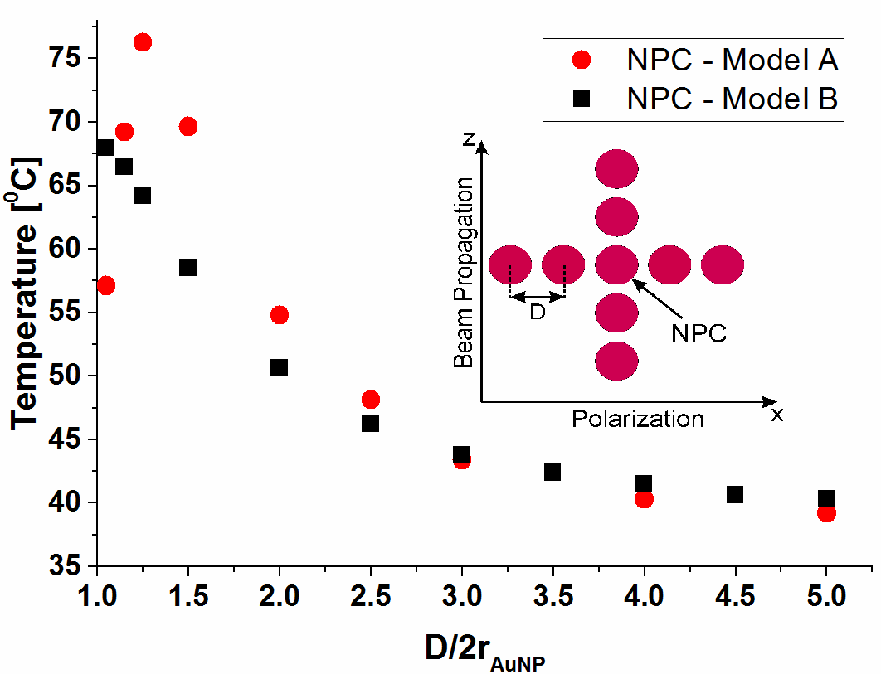 | 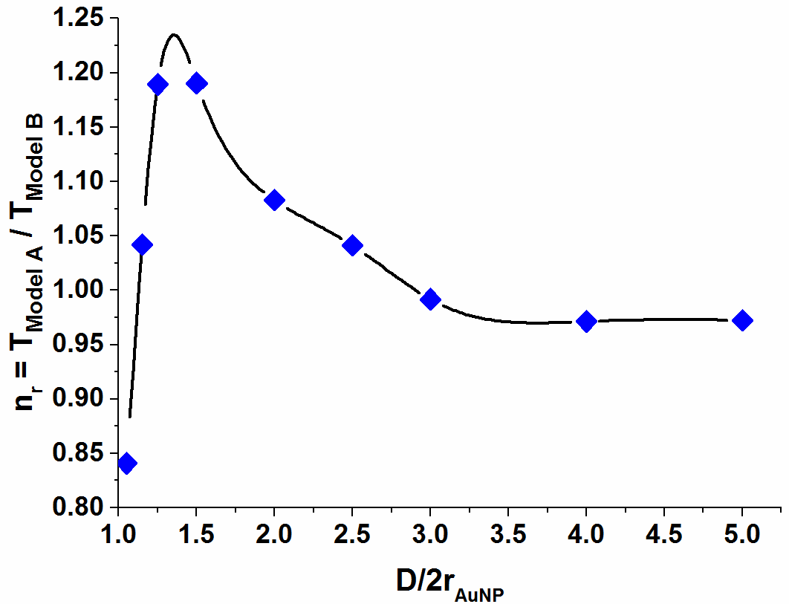
Figure 18. System 5 – a) Model A (red dots) and model B (black dots) calculated temperatures for different D/d_{AuNP} ratios; b) The influence of AuNP distance on the ratio between the temperature calculated with model A and model B, respectively.
In consequence, due to the fact that the model that calculates the system temperature based on the nanoparticle absorption cross section is easier to implement and necessitates less memory requirements, a relation for determining a more accurate AuNP temperature is deduced.
(13)

General conclusions
In this work, original results that concern two aspects of the photochemical generation of AuNPs, are presented: 1) the synthesis and modeling of the gold nanoparticles photochemical generation process and 2) the heat generation and heat transfer of the laser irradiated AuNPs that are embedded in polymer and aqueous matrixes.
For obtaining these results both experimental and theoretical methods were applied. The thesis main original contributions to the AuNPs generation process and their heat generation are presented as follows:
- Stable and reproducible AuNPs in thick polymer films are photochemically generated by using a direct light writing method and the main factors that influence the AuNPs dimension are determined to be: the citrate:Au³⁺ ratio, radiation intensity and scanning velocity.
- The real dimension of the embedded AuNPs is estimated using an exponential fit that is obtained based on the TEM measured AuNPs mean diameters and their corresponding localized SPR absorption maxima measured in thick film.

- For the first time, an ANN is developed to predict the AuNPs diameter. Based on this model the influence of the citrate:Au³⁺ ratio, radiation intensity and scanning velocity on the AuNPs diameter is investigated. Thus, it is demonstrated that the AuNPs size increases with the increase of the scanning velocity and a decrease in the radiation intensity. Also, higher citrate:Au³⁺ ratios lead to bigger AuNPs, implying that higher Au ³⁺ concentrations result in a decrease of the AuNPs dimension.

- Using the Garson and Goh method that relies on the ANN model, the relative impact of each process parameter on the particle size is evaluated. It is determined that the radiation intensity has a relative importance of 40%, being thus the factor that most influences the AuNPs size. The scanning velocity and the citrate:Au³⁺ ratio have a similar relative importance, the scanning velocity having a slightly higher value of 31% in comparison with the citrate:Au³⁺ ratio which has a value of 29%.

- The ANN input variable importance is also examined using a feature selection algorithm that finds the subsets of features which optimally predict the measured data, revealing the features that are most influential. The same ordering as for the Garson and Goh method is determined.

- The space/time evolution of the temperature inside systems that consist of AuNPs embedded in a polymer matrix is mathematically modeled using the finite element method. The temperature distribution in time and space is calculated with Comsol software, in a 3D geometry, by solving the heat diffusion equations with appropriate initial and boundary conditions. An infinite system (macro system) that has four different AuNPs distributions is simulated by imposing periodic boundary conditions.

- It is demonstrated that for describing the temperature evolution in such a system is important to take into consideration the macro system, not just one NP. The AuNPs size and distribution can also drastically influence the system’s temperature dynamics.

- The macro system with the four AuNPs distributions is compared with a model that is adapted to consider the thermal property mismatch. It is determined that this material mismatch cannot be neglected in the radial, concentric and random AuNP distributions, where the interfacial thermal conductance mostly influences the AuNPs temperature.

- The 3D mathematical model is also adapted to calculate the temperature dynamics of an aqueous solution of AuNPs. The AuNPs are displaced in a cross-type system and, a less complicated systems that has a chain of three AuNPs oriented parallel and perpendicular to the electric field polarization. The temperature distribution in time and space is calculated by solving both the wave equation for an electromagnetic pulse propagating in an optically inhomogeneous medium and the heat diffusion equations with appropriate initial and boundary conditions.

- For the cross-type and chain of AuNPs systems it is determined that the AuNPs temperature is influenced by: i) the AuNPs distance, ii) the electric field polarization and iii) the AuNPs displacement.

- For the first time it is demonstrated that the distance between the AuNPs influences their temperature through three effects: the shielding effect, the near field effect and the AuNPs displacement regarding the beam propagation (geometry effect). It is determined that the shielding effect is encountered at NPs distances that are less than 1.5 times their diameter and is responsible for the drastic decrease of the AuNPs temperature. The near field effects are encountered at NPs distances that are less than 4 times their diameter and, depending on the polarization, are responsible for either decreasing or drastically increasing the AuNPs temperature. The AuNPs displacement regarding the beam propagation is also important due to the fact that, in a row of particles, the first NP that interact with the laser beam will have the highest temperature.

- It is determined that the three effects drastically influence the AuNPs temperature only for distances that are lower than 4 times the AuNPs diameter. In consequence it is demonstrated that, in an aqueous solution of 20 nm spherical AuNPs, the shielding effect, the near field effect and the geometry effect influence the system’s temperature only for AuNPs concentrations that are less than 3.7e16 particles/m³.

- For the cross-type geometry the model that solves only the heat equation and the one that solves both the wave and heat equations are compared. It is observed that the model that only solves the heat equations is easier to implement and necessitates less memory requirements. It is found that, for AuNPs concentrations that are less than 3.7e16 particles/m³, the model that also solves the wave equation is more realistic.

- As a result of the two-model comparison, a relation for determining a more accurate AuNP temperature with the model that only solves the heat equation is deduced.

We appreciate the generated DLW gold nanoparticulate patterns can represent the starting point for the design of different types of materials with interesting properties, opening new solutions in AuNPs size dependent applications such as optical filters as well as substrates for biosensing detection.
We also appreciate that instead of the usual trial and error approach for generating the desired nanoparticles dimension, the fast and easy method to predict the AuNP size can be used. Moreover, knowing the influence and relative impact of each process parameter on the AuNPs size can lead to a better understanding and control of the NPs generation process.
The modeled thermal behavior of the laser irradiated AuNPs provides crucial information about the temperature distribution control and can prevent undesirable processes such as film deterioration, or in some cases ablation.
We appreciate that this thesis helps in understanding the DLW photochemical synthesis of AuNPs and can be a starting point for controlling this process.
The results listed above are presented in two ISI articles, three conferences and one summer school participations.
ISI Articles:
A. M. M. Gherman, N. Tosa, M. V. Cristea, V. Tosa, S. Porav and P. S. Agachi, Artificial neural networks modelling of the parameterized gold nanoparticles generation through photo-induced process, Materials Research Express 5 (2018), 085011, 1-13.
A. M. M. Gherman, N. Tosa, D. N. Dadarlat, V. Tosa, M. V. Cristea, and P. S. Agachi, Temperature dynamics of laser irradiated gold nanoparticles embedded in a polymer matrix, Thermochimica Acta, 656 (2017), 25-31.
Conferences:
A.M.M. Gherman, N.Tosa, D.Dadarlat, M.Cristea, V.Tosa, P.S. Agachi, "Time Dependent Temperature Evolution in Laser Irradiated Gold Nanoparticles Doped Matrix", Applied Nanotechnology and Nanoscience International Conference, 5-7 November 2015 - poster
A.M.M. Gherman, V.Tosa, N. Tosa, P.S Agachi, "Near field effects and temperature dynamics of laser irradiated gold nanoparticles", 15th UK Heat Transfer Conference, 4-5 Septembrie 2017, London, UK, Proceeding Paper and Poster
A.M.M. Gherman, N.Tosa, N.D Dadarlat, V. Tosa, M.V. Cristea, P.S. Agachi, Nanosecond Laser PhotoInduced Heating of Gold Nanoparticles Embedded in a Polymer Matrix - the Influence of Interface Conductance, Processes in Isotopes and Molecules Conference, 27-29 September 2017, ClujNapoca, Romania.
Summer School:
A.M.M. Gherman, N. Tosa, D. Dadarlat, V. Tosa, P.S. Agachi, "Temperature Evolution in a Laser Irradiated System of one/a periodic array of Gold Nanoparticles Embedded in a Polymer Matrix", 5th International School Lasers in Materials Science, Isola di San Servolo, Venetia, 10-17 July, 2016 -Poster

Selective References:
[26] Vincenzo Amendola and Roberto Pilot and Marco Frasconi and Onofrio M Maragò and Maria A Iatì, Surface plasmon resonance in gold nanoparticles: a review, J. Phys. Condens. Matter. 29 (2017) 203002.
[27] C. Louis, O. Pluchery, Gold nanoparticles for physics, chemistry and biology, Imperial College Press, 2012.
[28] S.A. Maier, Plasmonics: Fundamentals and Applications, Springer Science+Business Media LLC, 2007.
[78] J. Polte, Fundamental growth principles of colloidal metal nanoparticles – a new perspective, CrystEngComm. 17 (2015) 6809–6830. doi:10.1039/C5CE01014D.
[94] P. Shabanzadeh, R. Yusof, K. Shameli, Artificial neural network for modeling the size of silver nanoparticles’ prepared in montmorillonite/starch bionanocomposites, J. Ind. Eng. Chem. 24 (2015) 42–50. doi: 10.1016/j.jiec.2014.09.007.
[99] A. Falamas, N. Tosa, V. Tosa, J. Of, Q. Spectroscopyradiative, Dynamics of laser excited colloidal gold nanoparticles functionalized with cysteine derivatives, J. Quant. Spectrosc. Radiat. Transf. 162 (2015) 207–212. doi: 10.1016/j.jqsrt.2015.03.011.
[100] J.D. Olden, M.K. Joy, R.G. Death, An accurate comparison of methods for quantifying variable importance in artificial neural networks using simulated data, Ecol. Modell. 178 (2004) 389–397. doi: 10.1016/j.ecolmodel.2004.03.013.
[106] F.J.O. Landa, X.L. Deán-Ben, R. Sroka, D. Razansky, Volumetric Optoacoustic Temperature Mapping in Photothermal Therapy, Sci. Rep. 7 (2017) 1–8. doi:10.1038/s41598-017-09069-5.
[107] A.M.M. Gherman, N. Tosa, D.N. Dadarlat, V. Tosa, M.V. Cristea, P.S. Agachi, Temperature dynamics of laser irradiated gold nanoparticles embedded in a polymer matrix, Thermochim. Acta. 656 (2017) 25–31. doi: 10.1016/j.tca.2017.08.008.
[112] A. Plech, V. Kotaidis, S. Grésillon, C. Dahmen, G. Von Plessen, Laser-induced heating and melting of gold nanoparticles studied by time-resolved x-ray scattering, Phys. Rev. B - Condens. Matter Mater. Phys. 70 (2004) 1–7. doi:10.1103/PhysRevB.70.195423.
[118] G. Baffou, P. Berto, E. Bermúdez Ureña, R. Quidant, S. Monneret, J. Polleux, H. Rigneault, Photoinduced heating of nanoparticle arrays, ACS Nano. 7 (2013) 6478–6488. doi:10.1021/nn401924n.
[120] O.M. Wilson, X. Hu, D.G. Cahill, P. V. Braun, Colloidal metal particles as probes of nanoscale thermal transport in fluids, Phys. Rev. B - Condens. Matter Mater. Phys. 66 (2002) 2243011–2243016. doi:10.1103/PhysRevB.66.224301.
[121] S. Bruzzone, M. Malvaldi, Local field effects on laser-induced heating of metal nanoparticles, J. Phys. Chem. C. 113 (2009) 15805–15810. doi:10.1021/jp9003517.
[122] X. Wang, P. Gogol, E. Cambril, B. Palpant, Near- and Far-Field E ff ects on the Plasmon Coupling in Gold Nanoparticle Arrays, J. Phys. Chem. C. 116 (2012) 24741–24747.
[123] W. Rechberger, A. Hohenau, A. Leitner, J.R. Krenn, B. Lamprecht, F.R. Aussenegg, Optical properties of two interacting gold nanoparticles, Opt. Commun. 220 (2003) 137–141. doi:10.1016/S0030-4018(03)01357-9.
[129] G.M. Hale, M.R. Querry, Optical Constants of Water in the 200-nm to 200-microm Wavelength Region., Appl. Opt. 12 (1973) 555–563. doi:10.1364/AO.12.000555.

